**Fifth Sunday in Lent**

**April 6, 2025**

**9:30am**

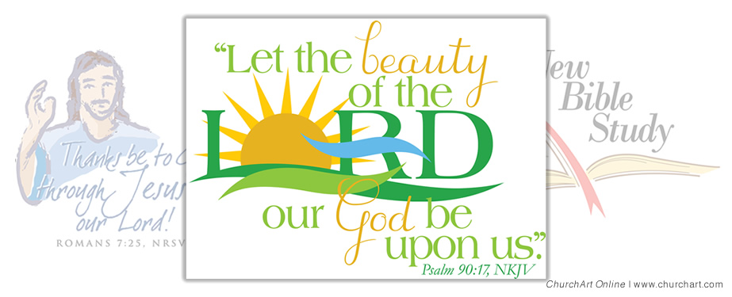

**Christ Lutheran Church**

6500 E. Stearns Street

Long Beach, California 90815

Phone 562-598-2433

www.christlutheranlb.com

Preschool 562-594-6117

[www.clplb.com](http://www.clplb.com/)

**Welcome to worship! We’re glad you’re here!**

To assist in your worship:

**bold** print means we respond together

**\*** meansrise in body or spirit,

+ you may make the sign of the cross should you so desire.

**It is our joy to worship with your whole family!**

We encourage everyone of all ages and abilities to worship together.

We offer a “pray-ground” located in the back left of the Sanctuary for those with littles to have some room for movement and activity. The Narthex (gathering space at the entry) also has some resources for families, including activity bags filled with crayons, paper and storybooks. These supplies can be used in the Narthex or brought into the Sanctuary. For those that find themselves in the Narthex, there is a speaker with which you can still hear the service. Lastly, a changing table is located in the restroom off the Narthex. Please ask an usher if you need any assistance.

**TODAY’S worship THEME**

**The need for beauty**

We all need consumable resources like food, clothing, and shelter, but beauty feeds the human spirit. Every culture develops expressions of beauty, and humans experience beauty across our senses. The scriptures point to the central importance of beauty in our devotion to God, too. God gives us the means to experience and produce beautiful things. Beauty dignifies us, and we, in turn, use beauty when we worship.

Worship services for Christ Lutheran Church- Long Beach

are live-streamed and archived to YouTube.

By entering the sanctuary and by your presence here,

you consent to be photographed,

filmed, and/or otherwise recorded.

Please alert an usher if this is of concern to you.

Our liturgy is taken from:

Sundays and Seasons.com. Copyright 2024 Augsburg Fortress. All rights reserved.

Reprinted by permission under Augsburg Fortress Liturgies Annual License #20338.

Reprinted by permission under CCLI license # 230154. All rights reserved.

Reprinted by permission under © 2024 One License #A-706154. All rights reserved. *All We Need* © 2025 Barn Geese Worship. Used by permission. [Adapted by Pastor Nikki.]

Kyrie, Holy Holy Holy, and Lamb of God, written by Rev. Steve Beckham.

**PRELUDE** Roger Halvorson

**WELCOME AND ANNOUNCEMENTS**

**GATHERING**

*The Holy Spirit calls us together as the people of God._____________________*

**\*DIALOGUE**

People of God, what do you need today?

**A world with more beauty than brokenness.**

Then come, let us worship God,

**who brings water to parched places, who translates weeping into joy, who does great things for us.**

We worship in the name of our triune God, our great Creator, our new start, our endless inspiration.

**Amen.**

**\*CONFESSION AND FORGIVENESS**

Blessed be the holy Trinity, ☩ one God, who forgives all our sin, whose mercy endures forever.

**Amen.**

Let us return to God, confessing our sin in the assurance of God’s abiding love.

*Silence is kept for reflection.*

Compassionate One,

**you are slow to anger and abounding in steadfast love,** **but our lives do not always reflect you** **and your love for the world.** **We do not show others the tender compassion** **you have shown to us.** **We do not welcome others with the radical hospitality** **you grant to all people.** **We oppress others,** **even though you have set us free again and again.** **We squander the abundant gifts of the earth.** **Transform our lives** **and guide us again in the way of the cross.** **Amen.**

Beloved in Christ, God’s arms are always stretched open wide to welcome the wandering ones home. In ☩ Christ your sins are forgiven. You have a place in God’s house forever. **Amen.**

**\*GATHERING SONG** *Gather Us In ELW #532*

*(verses 1, 2, 4)*

**\*GREETING**

The grace of our Lord Jesus Christ, the love of God,and the communion of the Holy Spirit be with you all. **And also with you.**

**\*KYRIE**

**\*pRAYER OF THE DAY**

Let us pray together,

**Beautiful Savior, your extravagant grace waters our parched souls like rivers in the wilderness. Lead us by Mary’s example to turn and offer your grace to beautify and dignify the poor, the ignored, and the oppressed. Amen.**

**WORD**

*God speaks to us in scripture reading, preaching, and song.______________________*

**MUSIC MAKERS** Preschool children led by Mrs. Fitzpatrick

**JOINT ANTHEM** *All I Really Need* Music Makers & Chancel Choir

**CHILDREN’S CHAT**

*After this time, children will be invited to Sunday school. They will return during the passing of the peace.*

**FIRST READING** Isaiah 43:16-21 Pew Bible Old Testament Pg.746

### **SECOND READING** Philippians 3:4b-14 Pew Bible Old Testament Pg.211

Word of God, Word of Life**. Thanks be to God.**

**\*GOSPEL ACCLAMATION** *Jesus, Name Above All Names W&P #77*

Jesus, name above all names  
Beautiful Saviour, Glorious Lord  
Emmanuel, God is with us  
Blessed Redeemer, Living Word

**\*GOSPEL** John 12:1-8Pew Bible New Testament Pg. 109

The Gospel comes from John the 12th chapter. **Glory to you, O Lord.**

The reading concludes: The Gospel of the Lord. **Praise to you, O Christ.**

**SERMON** Pastor Nikki Fielder

**\*SERMON HYMN**  *For the Beauty of the Earth ELW #879*

*(Verses 1, 3, 5)*

**\*APOSTLES’ CREED**

**I believe in God, the Father almighty, creator of heaven and earth.**

**I believe in Jesus Christ, God’s only Son, our Lord, who was conceived by the Holy Spirit, born of the virgin Mary, suffered under Pontius Pilate, was crucified, died, and was buried; he descended to the dead. On the third day he rose again; he ascended into heaven, he is seated at the right hand of the**

**Father, and he will come to judge the living and the dead.**

**I believe in the Holy Spirit, the holy catholic church, the communion of saints, the forgiveness of sins, the resurrection of the body, and the life everlasting. Amen.**

**PRAYERS OF THE CHURCH**

Led by the Spirit, let us turn to God in prayer for the church, the world, and all those in need.

*A brief silence.*

God in your mercy, **receive our prayer.**

Receive the prayers of your people and draw all things together in your love, in the name of Jesus, who leads us from death to life. **Amen.**

**\*SHARING OF PEACE**

The peace of Christ be with you always.

**And also with you.**

**OFFERTORY** Roger Halvorson and Tom Philips

**\*OFFERTORY RESPONSE** *Majesty W&P #94*

Majesty, worship his majesty  
Unto Jesus be all glory, power and praise  
Majesty, kingdom authority flow from his throne  
Unto his own his anthem raise  
So exalt lift up on high the name of Jesus  
Magnify, come glorify Christ Jesus the king  
Majesty, worship his majesty  
Jesus who died now glorified  
King of all kings.

**\*OFFERTORY PRAYER**

Let us pray together,

**Gracious Provider, you set your immense treasures among us, opening your heart to the world. As we prepare to feast on your bountiful love, deepen our commitment to sharing those treasures with others, through our Savior, Jesus Christ. Amen.**

**MEAL**

*God feeds us with the presence of Jesus.*

**\*THE GREAT THANKSGIVING**

The Lord be with you. **And also with you.**

Lift up your hearts. **We lift them to the Lord,**

Let us give thanks to the Lord our God. **It is right to give our thanks and praise.**

It is not only right, but even needful for us to thank you, God…and so we join the echoing song:

**\*HOLY, HOLY, HOLY**

**\*THANKSGIVING AT THE TABLE**

Heaven and earth are full of your glory, O God…

All honor and glory is yours, O God, who is both Giver and Gift, with the Holy Spirit,

in your holy church, now and forever. **Amen.**

**\*LORD’S PRAYER**

**Our Father in heaven, hallowed be your name, your kingdom come, your will be done, on earth as in heaven. Give us today our daily bread. Forgive us our sins** **as we forgive those who sin against us. Save us from the time of trial and deliver us from evil. For the kingdom, the power, and the glory are yours, now and forever.** **Amen.**

**DISTRIBUTION OF HOLY COMMUNION**

We believe that this is Jesus' table. All are welcome and invited to commune.  We serve communion by “intinction”; receive the bread and dip it in the chalice of red wine. Currently we are offering individual communion cups as an alternative to intinction if you so desire. Both wine and grape juice (white) are offered in the tray. Gluten free wafers are available; let your server know. Should you choose not to commune, you are invited to come forward to receive a blessing. Please cross your arms across your chest to let us know to give you that blessing.

**\*INVITATION TO COMMUNION**

All who are hungry, come! The feast of grace is spread.





**lamb of god**

**COMMUNION SONG** *In the Singing ELW #466*

**\*POST COMMUNION BLESSING**

The body and blood of our Lord Jesus Christ strengthen you and keep you in his grace. **Amen.**

**\*PRAYER AFTER COMMUNION**

Let us pray together,

**Generous Host, you have shared your feast with us and made us new. Send us now to set tables of love and grace in our communities, that your liberating love might nourish the world into freedom, in the name of the crucified one, Jesus Christ our Lord. Amen.**

**SENDING**

*God blesses us and sends us in mission to the world.______________________*

**\*BLESSING**

Now may God, bless you and sustain you. Today God has answered your need, and now the Spirit sends you out to answer the world’s need.

**Amen.**

**\*SENDING** ***SONG*** *Take My Life, That I May Be ELW #583*

**\*DISMISSAL**

Go in peace. Care for others as God cares for you.

**Thanks be to God!**

**POSTLUDE** Roger Halvorson

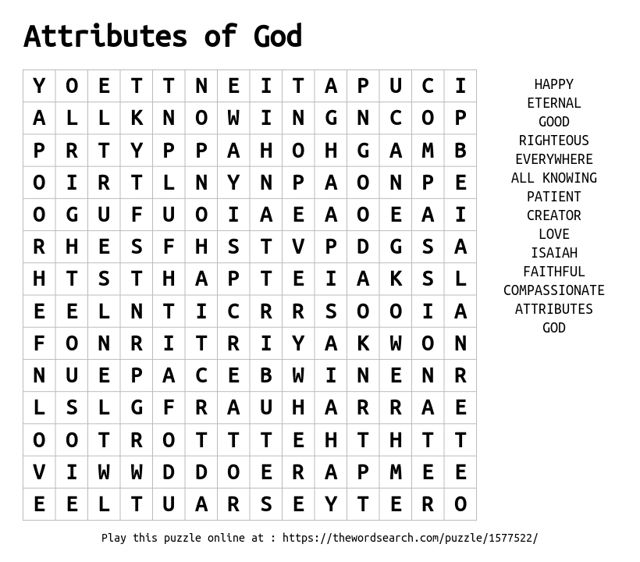

**CHRIST LUTHERAN CHURCH STAFF**

**Pastor**  Rev. Nikki Fielder, pastor@christlutheranlb.com

**Office Manager** Kim Croes, [officemanager@christlutheranlb.com](mailto:officemanager@christlutheranlb.com)

**Preschool Director** Lisa Clinton, info@clplb.com

**Choir Director** Kim Philips, kimsings@msn.com

**Accompanist** Roger Halvorson

**A/V Technicians** Brad Croes and Josh Baker

**Missionary to Colombia** Linda Gawthorne

**Mission Statement**

Living by Christ’s example, we welcome, serve, and love all through God’s grace.

**Vision Statement**

Embracing the truth that God’s love and grace is for all, Christ Lutheran Church is a vibrant and active community spreading the good news through acceptance, action, and benevolence.

**Our Position**

Christ is ALIVE!

**Reconciling in Christ (RIC) Welcome Statement**

Christ Lutheran Church is a congregation who joyfully welcomes everyone who enters our doors. We recognize that each of us is a unique creation made in the image of God. We celebrate and give thanks for the many diverse gifts that God has bestowed on us. We proclaim ourselves to be an open and affirming congregation to all of God's children, welcoming into our ministry persons of every race, culture, age, gender identity, gender expression, sexual orientation, ability, and economic status. We commit ourselves to the work of anti-racism and creating an anti-racist space. We believe that through our openness we all grow in our faith through Christ's teaching to love one another as God loves us.

**LIKE** us on **Facebook** at [www.facebook.com/christlutheranlb](http://www.facebook.com/christlutheranlb)

Write a review of Christ Lutheran Church on **YELP**