**Resurrection of Our Lord**

**April 20, 2025**

**9:30am**



**Christ Lutheran Church**

6500 E. Stearns Street

Long Beach, California 90815

Phone 562-598-2433

www.christlutheranlb.com

Preschool 562-594-6117

www.clplb.com

**Welcome to worship! We’re glad you’re here!**

To assist in your worship:

**bold** print means we respond together

**\*** meansrise in body or spirit,

+ you may make the sign of the cross should you so desire.

**It is our joy to worship with your whole family!**

We encourage everyone of all ages and abilities to worship together.

We offer a “pray-ground” located in the back left of the Sanctuary for those with littles to have some room for movement and activity. The Narthex (gathering space at the entry) also has some resources for families, including activity bags filled with crayons, paper and storybooks. These supplies can be used in the Narthex or brought into the Sanctuary. For those that find themselves in the Narthex, there is a speaker with which you can still hear the service. Lastly, a changing table is located in the restroom off the Narthex. Please ask an usher if you need any assistance.

**TODAY’S worship THEME**

**The need to rejoice**

Death is inevitable, even for Jesus. On Easter, we recognize that God turns this inevitability into a new possibility. Those raised from the dead must rejoice, because there is simply no alternative. And, as Jesus reminded us during his triumphal entry just one week earlier, if the hard-hearted humans will not rejoice, the rocks around us will.

Worship services for Christ Lutheran Church- Long Beach

are live-streamed and archived to YouTube.

By entering the sanctuary and by your presence here,

you consent to be photographed,

filmed, and/or otherwise recorded.

Please alert an usher if this is of concern to you.

Our liturgy is taken from:

Sundays and Seasons.com. Copyright 2025 Augsburg Fortress. All rights reserved.

Reprinted by permission under Augsburg Fortress Liturgies Annual License #20338.

Reprinted by permission under CCLI license # 230154. All rights reserved.

Reprinted by permission under © 2025 One License #A-706154. All rights reserved.

*All We Need* © 2025 Barn Geese Worship. Used by permission. [Adapted by Pastor Nikki.]

Kyrie, Holy Holy Holy, and Lamb of God, written by Rev. Steve Beckham.

**PRELUDE** *Crown Him King of Kings*

**CALL TO WORSHIP** *Crown Him with Many Crowns* Chancel Choir

Christ is Risen!

**He is risen indeed!**

**WELCOME AND ANNOUNCEMENTS**

**GATHERING**

*The Holy Spirit calls us together as the people of God.*

**\*DIALOGUE**

People of God, what do you need today?

**To rejoice!**

Then come, let us worship God,

**who broke the power of death, who rolled the stone from the tomb, who has risen from the grave!**

We worship in the name of God who created us, Christ who rose from the dead, and the Spirit he breathed upon his followers.

**Amen!**

**\*THANKSGIVING FOR BAPTISM**

Alleluia! Christ is risen.

**Christ is risen, indeed. Alleluia!**

In the name of ☩ the One who was, who is, and who is to come.

**Amen.**

Baptized into Christ’s death and resurrection, and called to live the baptized life, let us give thanks for the gifts of baptism.

Holy God, we give you thanks for the waters of baptism, waters that make a people your own, that restore to wholeness, and empower us to be witnesses in your name.

Baptized into you, O Living One,

**make us one as you are one.**

We give you thanks for the waters of baptism, waters that strengthen believers and give new life to beloved servants of your church; waters that extend your boundless love

and cross barriers of our own making. Baptized into you, O Living One,

**make us one as you are one.**

We give you thanks for the waters of baptism, waters that open the hearts of believers

and give a voice in the night to those in captivity; waters that set your people on a new path, rejoicing in the Spirit’s power. Baptized into you, O Living One,

**make us one as you are one.**

Grant us grace, love, and life, O Living One, that our every day is shaped by these waters that give us our very lives in you. We ask this in the name of Jesus, the Crucified and Risen One.

**Amen.**

**\*GATHERING SONG**  *Jesus Christ Is Risen Today ELW #365*

*(Verses 1, 2, & 4)*



**\*GREETING**

The grace of our Lord Jesus Christ, the love of God,and the communion of the Holy Spirit be with you all.

**And also with you.**

**\*PRAYER OF THE DAY**

Let us pray together,

**Risen Christ, you have shattered the power of the grave! Fill us with the joy of resurrection life and lead us into the world to share the joy and hope of Easter with a whole creation in need. Amen.**

**WORD**

*God speaks to us in scripture reading, preaching, and song.______________________*

**CHILDREN’S CHAT**

**psalm** psalm 118:1-2,14-17,22-24 PewBible Old Testament Pg. 625

 1O give thanks to the LORD, for he is good; his steadfast love endures forever!  
**2Let Israel say, "His steadfast love endures forever."** 14The LORD is my strength and my might; he has become my salvation.  
**15There are glad songs of victory in the tents of the righteous: "The right hand of the LORD does valiantly;** 16the right hand of the LORD is exalted; the right hand of the LORD does valiantly."  
**17I shall not die, but I shall live, and recount the deeds of the LORD.** 22The stone that the builders rejected has become the chief cornerstone.  
**23This is the LORD's doing; it is marvelous in our eyes.**  
 24This is the day that the LORD has made; let us rejoice and be glad in it.

**SCRIPTURE READING** Acts 10:34-43 Pew Bible New Testament Pg.134

Word of God, Word of Life. **Thanks be to God.**

**\*GOSPEL ACCLAMATION** *Amazing Love W&P #8*

Amazing Love, O what sacrifice, The Son of God giv’n for me;

My debt He pays and my death He dies, that I might live, that I might live.

**\*GOSPEL** Luke 24:1-12  Pew Bible New Testament Pg. 91

The Holy Gospel according to Luke the 24th chapter. **Glory to you, O Lord.**

The reading concludes: The Gospel of the Lord. **Praise to you, O Christ.**

**SERMON** Pastor Nikki Fielder

**\*SERMON HYMN** *Now the Green Blade Rises ELW #379*

**\*APOSTLES’ CREED**

**I believe in God, the Father almighty, creator of heaven and earth.**

**I believe in Jesus Christ, God’s only Son, our Lord, who was conceived by the Holy Spirit, born of the virgin Mary, suffered under Pontius Pilate, was crucified, died, and was buried; he descended to the dead. On the third day he rose again; he ascended into heaven, he is seated at the right hand of the Father, and he will come to judge the living and the dead.**

**I believe in the Holy Spirit, the holy catholic church, the communion of saints, the forgiveness of sins, the resurrection of the body, and the life everlasting. Amen.**

**PRAYERS OF THE CHURCH**

God of resurrection and new life, we come before you in prayer for the church, the world, and all who are in need.

*A brief silence.*

God of grace,

**hear our prayer.**

We commend these and all our prayers to you, O God, trusting that you are always with us; in the name of Jesus Christ, our risen Savior.

**Amen.**

**\*SHARING OF PEACE**

The peace of Christ be with you always. **And also with you.**

**OFFERTORY** Chancel Choir

**\*OFFERTORY RESPONSE** *Majesty W&P #94*

Majesty, worship his majesty  
Unto Jesus be all glory, power and praise  
Majesty, kingdom authority flow from his throne  
Unto his own his anthem raise  
So exalt lift up on high the name of Jesus  
Magnify, come glorify Christ Jesus the king  
Majesty, worship his majesty  
Jesus who died now glorified  
King of all kings.

**\*OFFERTORY PRAYER**

Let us pray together**, Risen One, you have gathered us around your table of grace along with these gifts we bring. Come among us again, breathe your life into us, and enliven us with this meal, that we may live as your risen body in the world. Amen.**

**MEAL**

*God feeds us with the presence of Jesus.*

**\*THE GREAT THANKSGIVING**

The Lord be with you. **And also with you.**

Lift up your hearts. **We lift them to the Lord,**

Let us give thanks to the Lord our God. **It is right to give our thanks and praise.**

It is not only right, but even needful for us to thank you, God…and so we join the echoing song:

**\*HOLY, HOLY, HOLY**

**\*THANKSGIVING AT THE TABLE**

Heaven and earth are full of your glory, O God…

All honor and glory is yours, O God, who is both Giver and Gift, with the Holy Spirit,

in your holy church, now and forever. **Amen.**

**\*LORD’S PRAYER**

**Our Father in heaven, hallowed be your name, your kingdom come, your will be done, on earth as in heaven. Give us today our daily bread. Forgive us our sins**

**as we forgive those who sin against us. Save us from the time of trial and deliver us from evil. For the kingdom, the power, and the glory are yours, now and forever.** **Amen.**

**DISTRIBUTION OF HOLY COMMUNION**

We believe that this is Jesus' table. All are welcome and invited to commune.  We serve communion by “intinction”; receive the bread and dip it in the chalice of red wine. Currently we are offering individual communion cups as an alternative to intinction if you so desire. Both wine and grape juice (white) are offered in the tray. Gluten free wafers are available; let your server know. Should you choose not to commune, you are invited to come forward to receive a blessing. Please cross your arms across your chest to let us know to give you that blessing.

**INVITATION TO COMMUNION**

Come to the table of grace. Receive the gift of new life.





**lamb of god**

**COMMUNION SONG** *I Know It Was the Blood TFF #75*





**\*POST COMMUNION BLESSING**

The body and blood of our Lord Jesus Christ strengthen you and keep you in his grace. **Amen.**

**\*PRAYER AFTER COMMUNION**

Let us pray**,**

**Living One, in this feast you have made yourself known to us. Send us now to tell of your wonders, sing of your glory, and proclaim your risen life to a wounded and weary world. Amen.**

**SENDING**

*God blesses us and sends us in mission to the world.*

**\*BLESSING**

The triune God, who was, who is, and who is to come, Sovereign, ☩ Savior, and Spirit,

light your way with resurrection dawn,now and always.

**Amen.**

**\*SENDING HYMN** *Alleluia! Sing to Jesus* ELW #392

(Verses 1, 3, & 4)



**\*Dismissal**

Alleluia! Christ is risen.

**Christ is risen indeed. Alleluia!**

Go in peace. In Christ you are made new. Alleluia! Alleluia!

**Thanks be to God. Alleluia! Alleluia!**

**POSTLUDE** Roger Halvorson

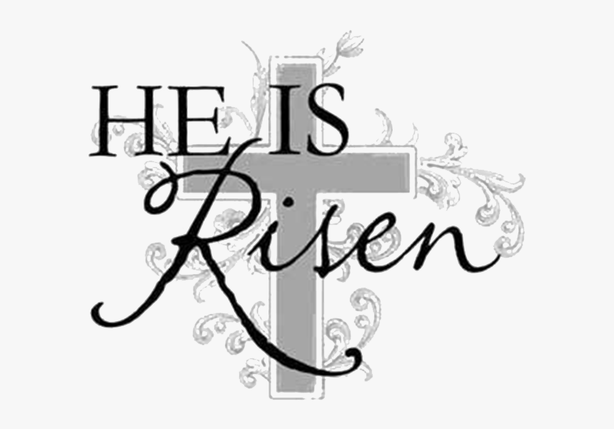

**CHRIST LUTHERAN CHURCH STAFF**

**Pastor**  Rev. Nikki Fielder, pastor@christlutheranlb.com

**Office Manager** Kim Croes, [officemanager@christlutheranlb.com](mailto:officemanager@christlutheranlb.com)

**Preschool Director** Lisa Clinton, info@clplb.com

**Choir Director** Kim Philips, kimsings@msn.com

**Accompanist** Roger Halvorson

**A/V Technicians** Brad Croes and Josh Baker

**Missionary to Colombia** Linda Gawthorne

**Mission Statement**

Living by Christ’s example, we welcome, serve, and love all through God’s grace.

**Vision Statement**

Embracing the truth that God’s love and grace is for all, Christ Lutheran Church is a vibrant and active community spreading the good news through acceptance, action, and benevolence.

**Our Position**

Christ is ALIVE!

**Reconciling in Christ (RIC) Welcome Statement**

Christ Lutheran Church is a congregation who joyfully welcomes everyone who enters our doors. We recognize that each of us is a unique creation made in the image of God. We celebrate and give thanks for the many diverse gifts that God has bestowed on us. We proclaim ourselves to be an open and affirming congregation to all of God's children, welcoming into our ministry persons of every race, culture, age, gender identity, gender expression, sexual orientation, ability, and economic status. We commit ourselves to the work of anti-racism and creating an anti-racist space. We believe that through our openness we all grow in our faith through Christ's teaching to love one another as God loves us.

**LIKE** us on **Facebook** at [www.facebook.com/christlutheranlb](http://www.facebook.com/christlutheranlb)

Write a review of Christ Lutheran Church on **YELP**