Ash Wednesday

March 5, 2025



Christ Lutheran Church
6500 E. Stearns Street
Long Beach, California 90815
Phone 562-598-2433 www.christlutheranlb.com
Christ Lutheran Preschool
Preschool 562-594-6117
www.clplb.com

Welcome to worship! We’re glad you’re here!

To assist in your worship:
bold print means we respond together
* means rise in body or spirit,
+ you may make the sign of the cross should you so desire.

It is our joy to worship with your whole family!

We encourage everyone of all ages and abilities to worship together.
We offer a “pray-ground” located in the back left of the Sanctuary for those with littles to have some room for movement and activity. The Narthex (gathering space at the entry) also has some resources for families, including activity bags filled with crayons, paper and storybooks. These supplies can be used in the Narthex or brought into the Sanctuary. For those that find themselves in the Narthex, there is a speaker with which you can still hear the service. Lastly, a changing table is located in the restroom off the Narthex. Please ask an usher if you need any assistance.

TODAY’S worship THEME
On Ash Wednesday we begin our forty-day journey toward Easter with a day of fasting and repentance. Marking our foreheads with dust, we acknowledge that we die and return to the earth. At the same time, the dust traces the life-giving cross indelibly marked on our foreheads at baptism. While we journey through Lent to return to God, we have already been reconciled to God through Christ. We humbly pray for God to make our hearts clean while we rejoice that “now is the day of salvation.” Returning to our baptismal call, we more intentionally bear the fruits of mercy and justice in the world.
Worship services for Christ Lutheran Church- Long Beach
are live-streamed and archived to YouTube.
By entering the sanctuary and by your presence here,
you consent to be photographed,
filmed, and/or otherwise recorded.

Please alert an usher if this is of concern to you.

Our liturgy is taken from:
Sundays and Seasons.com. Copyright 2025 Augsburg Fortress. All rights reserved.
Reprinted by permission under Augsburg Fortress Liturgies Annual License #20338.
Reprinted by permission under CCLI license # 230154. All rights reserved
Reprinted by permission under © 2025, One License #A-706154. All rights reserved
All We Need © 2025 Barn Geese Worship. Used by permission. [Adapted by Pastor Nikki.]
Kyrie, Holy Holy Holy, and Lamb of God, written by Rev. Steve Beckham.

GATHERING
The Holy Spirit calls us together as the people of God.

PRELUDE Roger Halvorson

WELCOME AND ANNOUNCEMENTS
*GATHERING SONG Our Father, We Have Wandered ELW #606
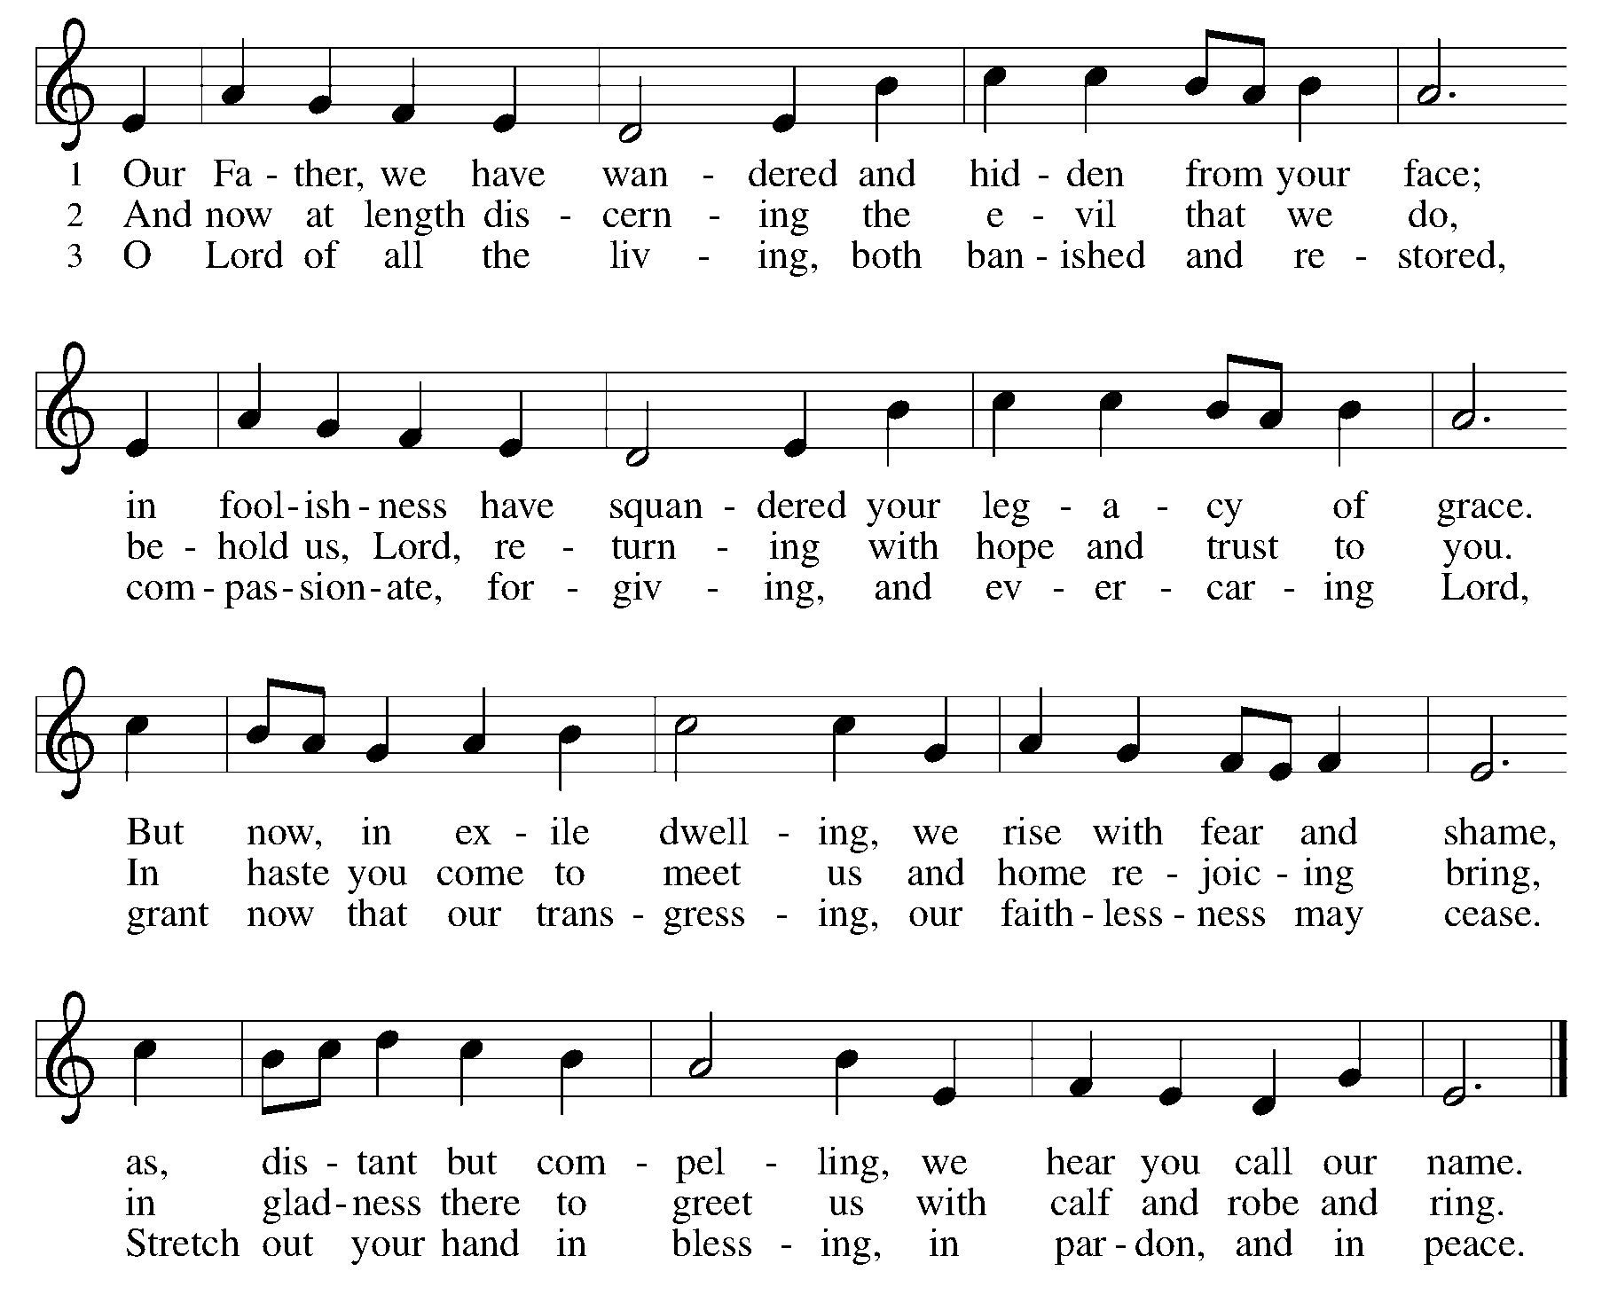

*GREETING

The grace of our Lord Jesus Christ, the love of God and the communion of the Holy Spirit be with you all. And also with you.

*PRAYER OF THE DAY

Let us pray together.
Almighty and ever-living God, you hate nothing you have made, and you forgive the sins of all who are penitent. Create in us new and honest hearts, so that, truly repenting of our sins, we may receive from you, the God of all mercy, full pardon and forgiveness through your Son, Jesus Christ, our Savior and Lord, who lives and reigns with you and the Holy Spirit, one God, now and forever. Amen.

WORD
God speaks to us in scripture reading, preaching, and song.

CHILDREN’S CHAT

SCRIPTURE READING: Joel 2:1, 12-17 Pew Bible Old Testament Pg. 943

The Word of the Lord. Thanks be to God

RESPONSIVE PSALM: Psalm 51:1-4, 9-12 Pew Bible Old Testament Pg. 574

¹Have mercy on me, O God, according to your steadfast love; according to your abundant mercy blot out my transgressions.
²Wash me thoroughly from my iniquity, and cleanse me from my sin.
³For I know my transgressions, and my sin is ever before me.
⁴Against you, you alone, have I sinned, and done what is evil in your sight, so that you are justified in your sentence and blameless when you pass judgment.
⁹Hide your face from my sins, and blot out all my iniquities.
¹⁰Create in me a clean heart, O God, and put a new and right spirit within me.
¹¹Do not cast me away from your presence, and do not take your holy spirit from me.
¹²Restore to me the joy of your salvation, and sustain in me a willing spirit.

*GOSPEL VERSE Jesus, Name Above All Names W&P #77

Jesus, name above all names
Beautiful Saviour, Glorious Lord
Emmanuel, God is with us
Blessed Redeemer, Living Word

*GOSPEL: Matthew 6:1-6, 16-21 Pew Bible New Testament Pg. 5

The Holy Gospel according to Matthew the 6th chapter. Glory to you, O Lord.

The reading concludes: The Gospel of the Lord. Praise to you, O Christ.

SERMON Pastor Nikki Fielder

*SERMON HYMN Be Thou My Vision ELW #793
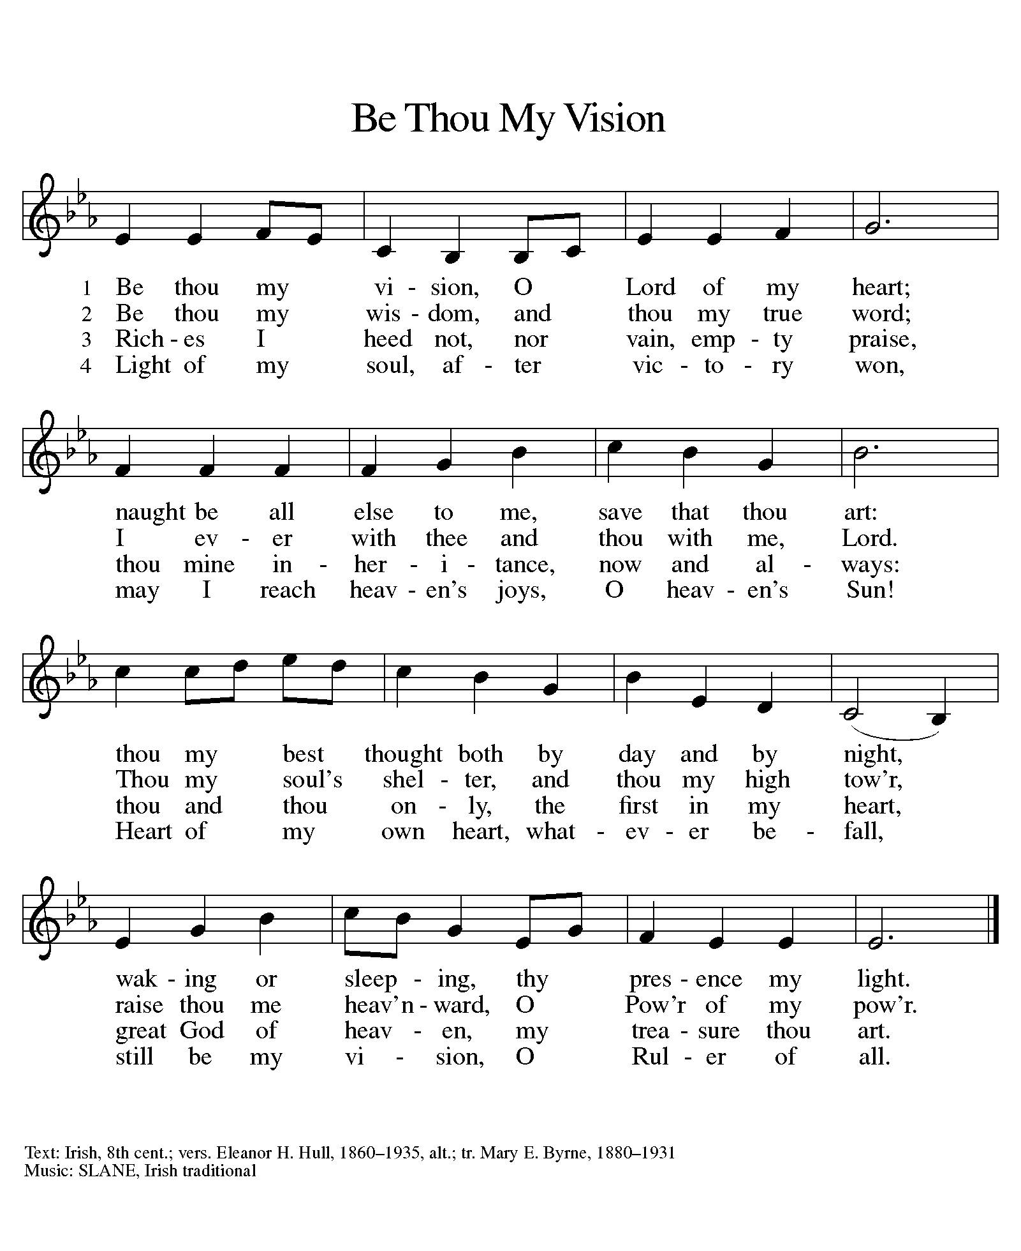

*INVITATION TO THE LENTEN DISCIPLINE

Friends in Christ, today with the whole church we enter the time of remembering Jesus’ passover from death to life, and our life in Christ is renewed…

*CONFESSION OF SIN

Let us confess our sin in the presence of God and of one another.

(pause for silent reflection)

Most holy and merciful God,
we confess to you and to one another, and before the whole company of heaven, that we have sinned by our fault, by our own fault, by our own most grievous fault, in thought, word, and deed, by what we have done and by what we have left undone.

We have not loved you with our whole heart, and mind, and strength. We have not loved our neighbors as ourselves. We have not forgiven others as we have been forgiven.
Have mercy on us, O God.

We have shut our ears to your call to serve as Jesus served us. We have not been true to the mind of Christ. We have grieved your Holy Spirit.
Have mercy on us, O God.

Our past unfaithfulness, the pride, envy, hypocrisy, and apathy that have infected our lives, we confess to you.
Have mercy on us, O God.

Our self-indulgent appetites and ways, and our exploitation of other people, we confess to you.
Have mercy on us, O God.

Our negligence in prayer and worship, and our failure to share the faith that is in us, we confess to you.
Have mercy on us, O God.

Our neglect of human need and suffering, and our indifference to injustice and cruelty, we confess to you.
Have mercy on us, O God.

Our false judgments, our uncharitable thoughts toward our neighbors, and our prejudice and contempt toward those who differ from us, we confess to you.
Have mercy on us, O God.

Our waste and pollution of your creation, and our lack of concern for those who come after us, we confess to you.
Have mercy on us, O God.

Restore us, O God, and let your anger depart from us.
Hear us, O God, for your mercy is great.

*IMPOSITION OF ASHES

Almighty God, you have created us out of the dust of the earth. May these ashes be a sign of our mortality and penitence, reminding us that only by the cross of our Lord Jesus Christ are we given eternal life; through the same Jesus Christ, our Savior and Lord. Amen.

People may come forward to receive the ashes.

SPECIAL MUSIC Sign Us With Ashes Chancel Choir

Accomplish in us, O God, the work of your salvation,
that we may show forth your glory in the world.
By the cross and passion of your Son, our Savior,
bring us with all your saints to the joy of his resurrection.
Almighty God have mercy on us, forgive us all our sins through our Lord Jesus Christ, strengthen us in all goodness, and by the power of the Holy Spirit keep us in eternal life.
Amen.

PRAYERS OF THE CHURCH

Led by the Spirit, let us turn to God in prayer for the church, the world, and all those in need.

God, in your mercy,
receive our prayer.

Receive the prayers of your people and draw all things together in your love, in the name of Jesus, who leads us from death to life.
Amen.

SHARING OF THE PEACE

The peace of the Lord be with you always.
And also with you.

OFFERTORY Roger Halvorson

*OFFERTORY RESPONSE Majesty W&P #94

Majesty, worship his majesty
Unto Jesus be all glory, power and praise
Majesty, kingdom authority flow from his throne
Unto his own his anthem raise
So exalt lift up on high the name of Jesus
Magnify, come glorify Christ Jesus the king
Majesty, worship his majesty
Jesus who died now glorified
King of all kings.

OFFERING PRAYER

Let us pray together,
Gracious Provider, you set your immense treasures among us, opening your heart to the world. As we prepare to feast on your bountiful love, deepen our commitment to sharing those treasures with others, through our Savior, Jesus Christ. Amen.

MEAL
God feeds us with the presence of Jesus.

*THE GREAT THANKSGIVING

The Lord be with you. And also with you.
Lift up your hearts. We lift them to the Lord,
Let us give thanks to the Lord our God. It is right to give our thanks and praise.
It is not only right, but even needful for us to thank you, God…and so we join the echoing song:

*HOLY, HOLY, HOLY

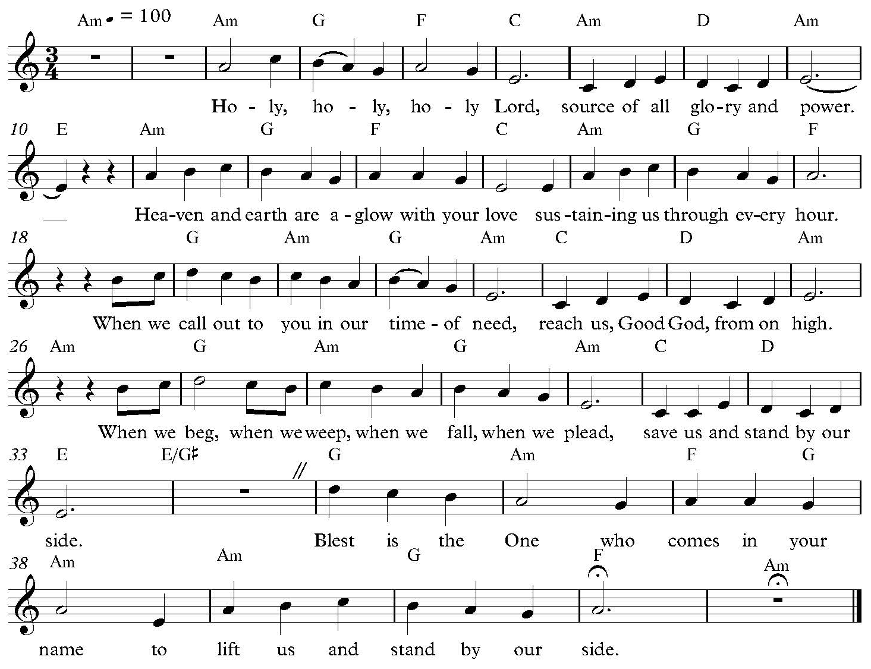

*THANKSGIVING AT THE TABLE

Heaven and earth are full of your glory, O God…

All honor and glory is yours, O God,
who is both Giver and Gift,
with the Holy Spirit,
in your holy church,
now and forever.
Amen.

*LORD’S PRAYER

Our Father in heaven, hallowed be your name, your kingdom come, your will be done, on earth as in heaven. Give us today our daily bread. Forgive us our sins
as we forgive those who sin against us. Save us from the time of trial and deliver us from evil. For the kingdom, the power, and the glory are yours, now and forever. Amen.

DISTRIBUTION OF HOLY COMMUNION
We believe that this is Jesus' table. All are welcome and invited to commune. We serve communion by “intinction”; receive the bread and dip it in the chalice of red wine. Currently we are offering individual communion cups as an alternative to intinction if you so desire. Both wine and grape juice (white) are offered in the tray. Gluten free wafers are available; let your server know. Should you choose not to commune, you are invited to come forward to receive a blessing. Please cross your arms across your chest to let us know to give you that blessing.

INVITATION TO COMMUNION
All who are hungry, come! The feast of grace is spread.

LAMB OF GOD

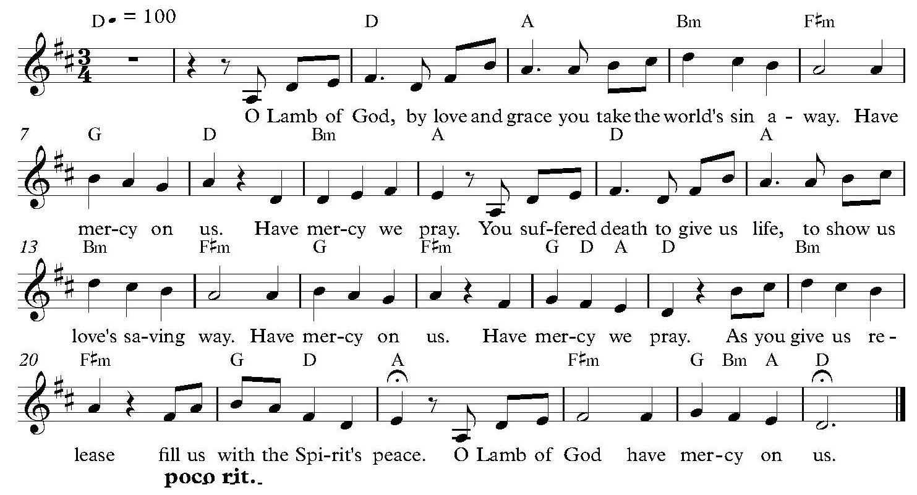

COMMUNION SONG Now We Join in Celebration ELW #462

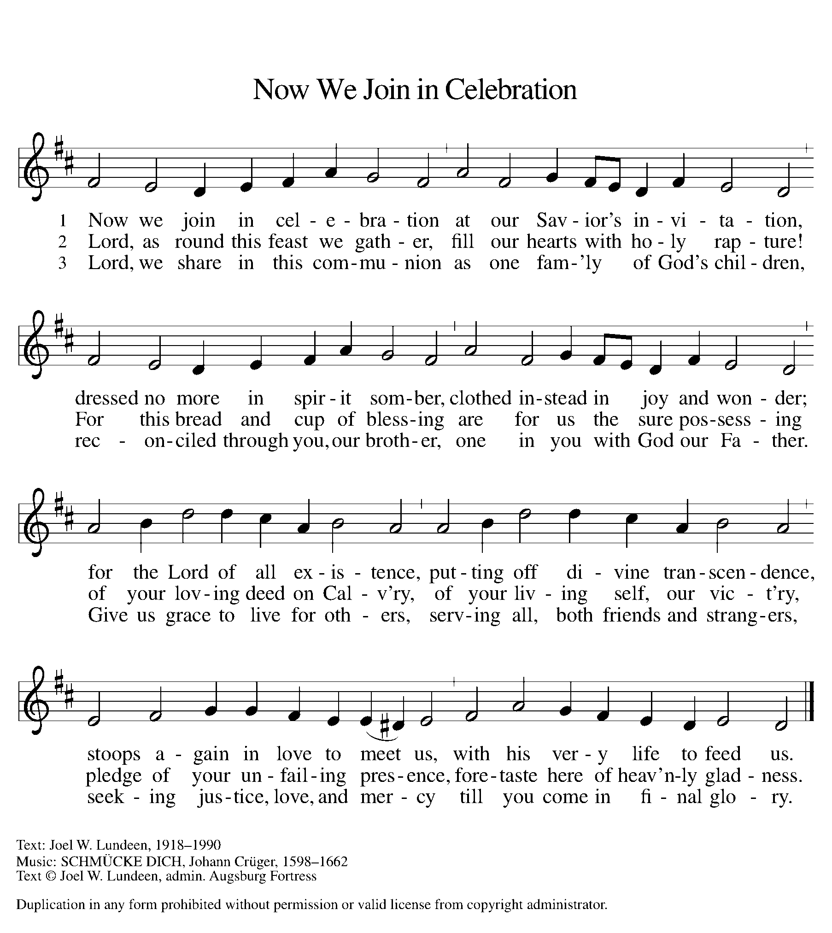
*POST COMMUNION BLESSING
The body and blood of our Lord Jesus Christ strengthen you and keep you in his grace. Amen.

*PRAYER AFTER COMMUNION
Let us pray together.
Generous Host, you have shared your feast with us and made us new. Send us now to set tables of love and grace in our communities,
that your liberating love might nourish the world into freedom, in the name of the crucified one, Jesus Christ our Lord. Amen.

SENDING
God blesses us and sends us in mission to the world.

*BLESSING
God our tender parent, God the crucified one, God the reconciling Spirit, ☩ bless you now and forever.
Amen.

*SENDING HYMN I Want Jesus to Walk with Me ELW #325
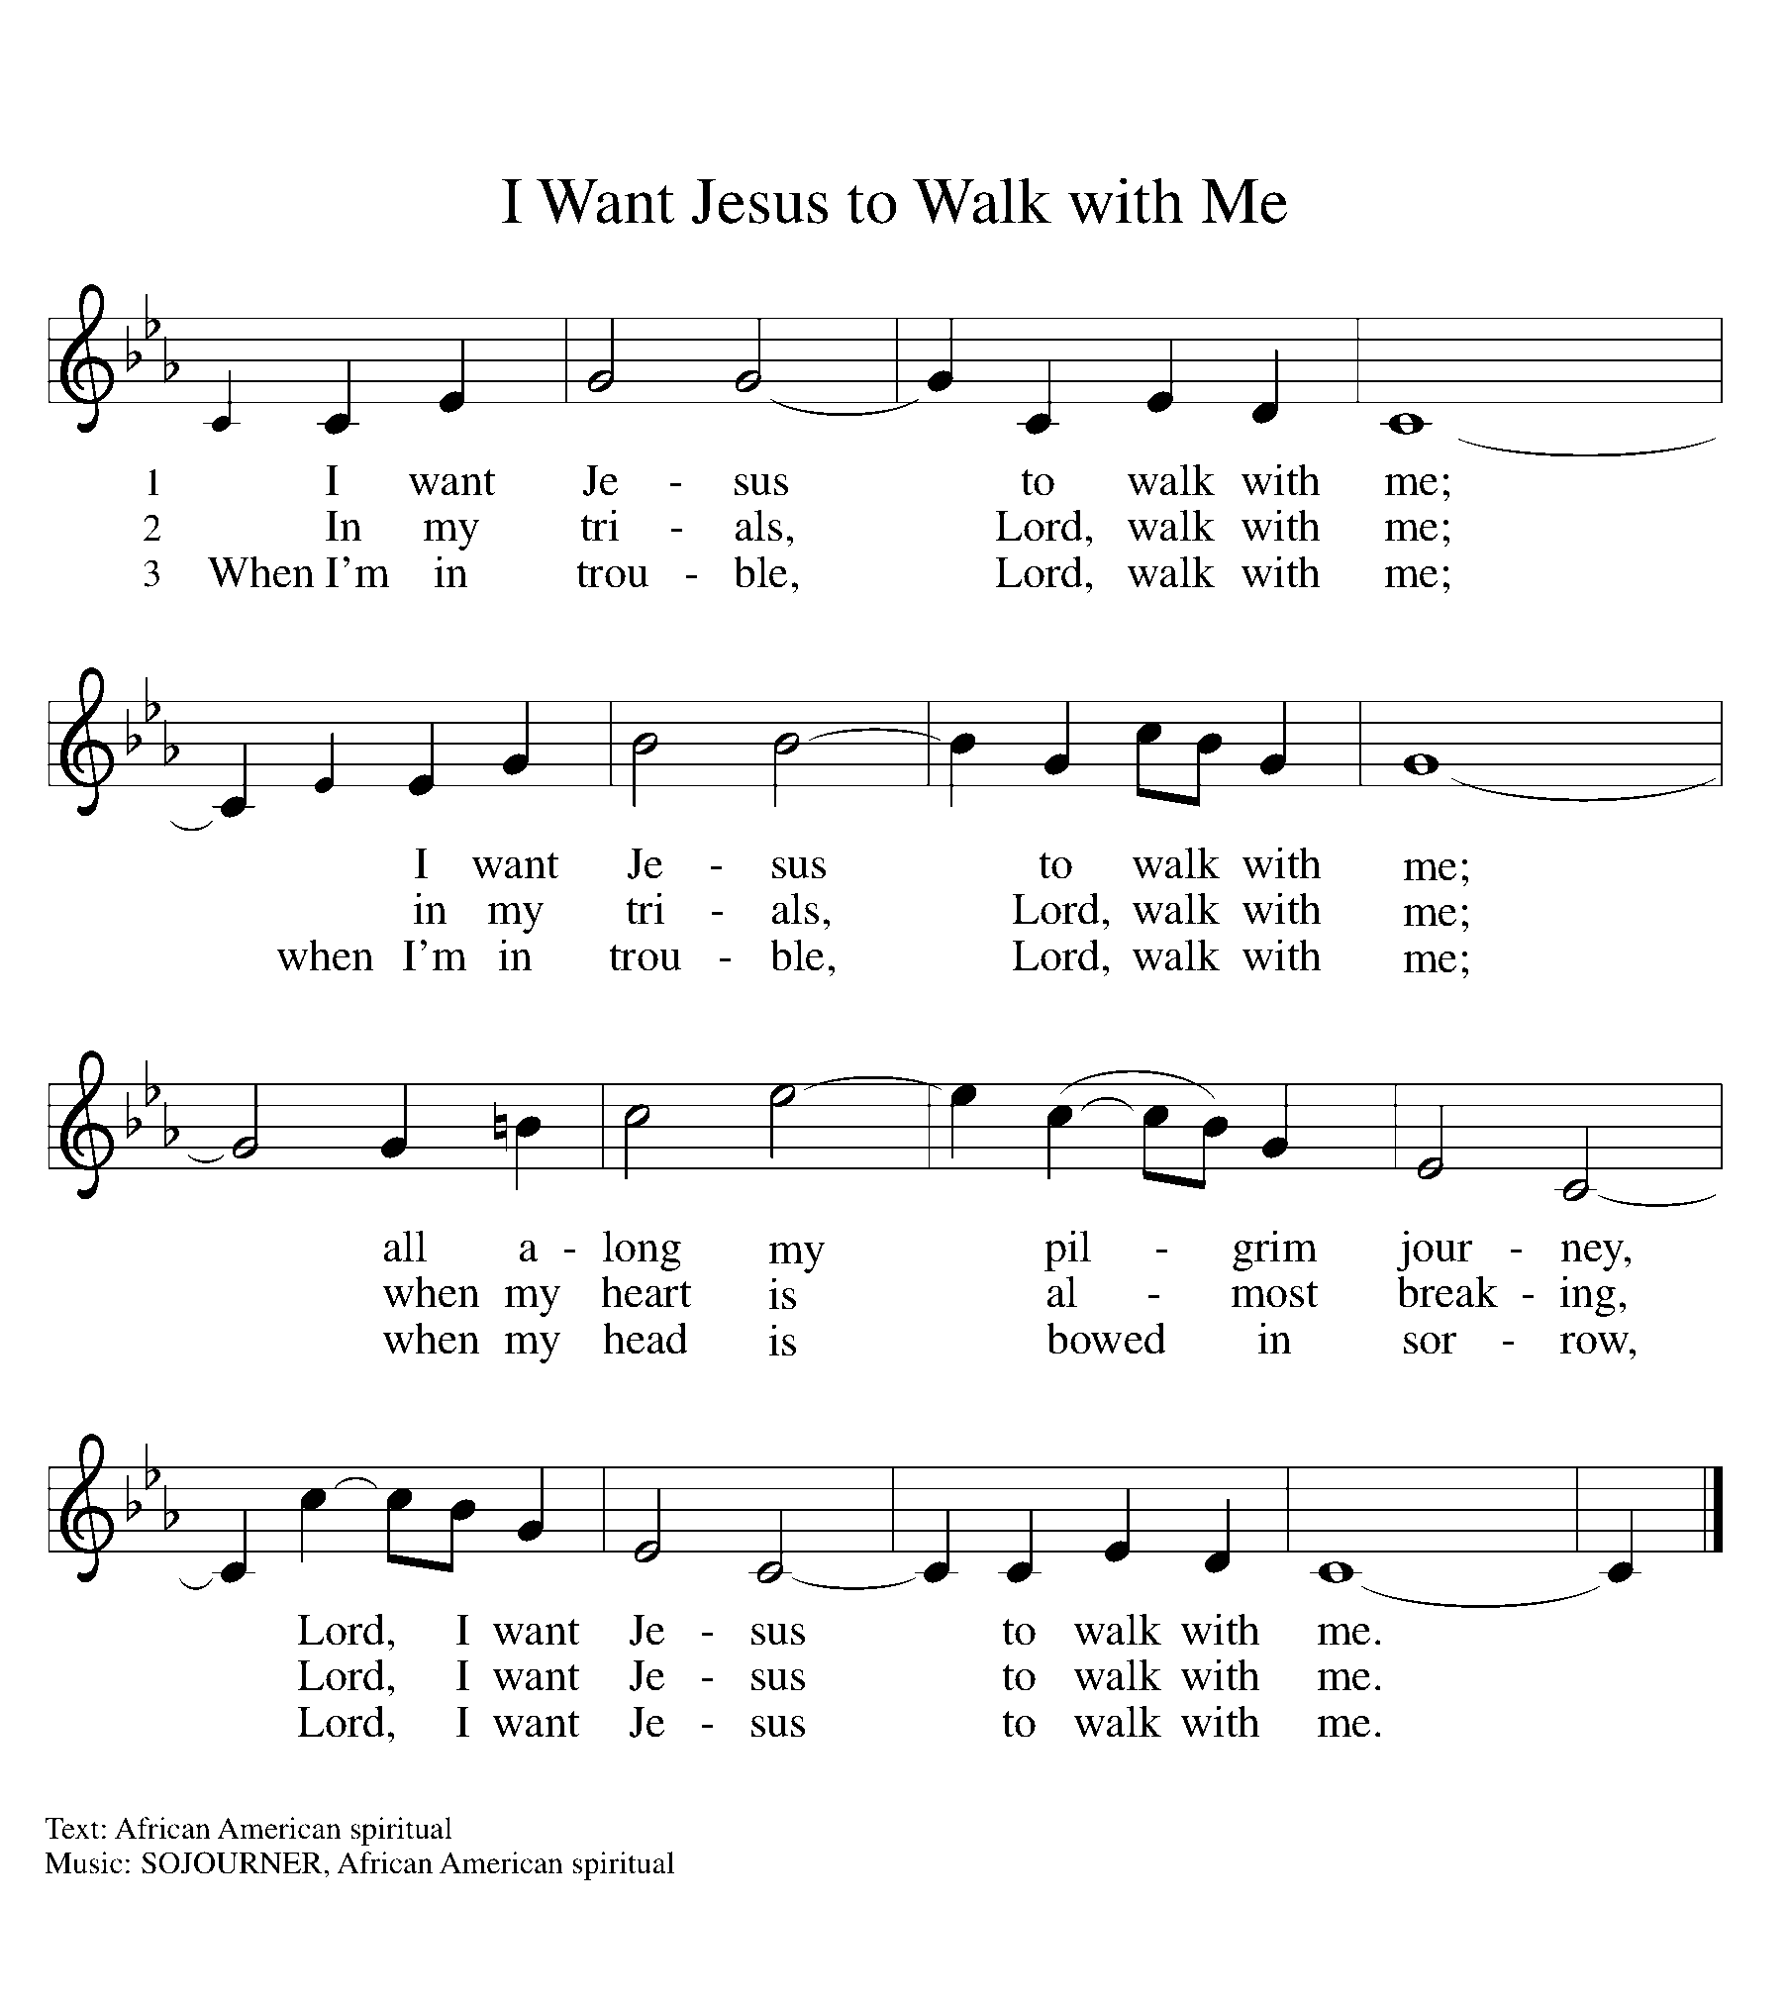

*DISMISSAL
Go in peace. Serve in love. Thanks be to God.

POSTLUDE Roger Halvorson

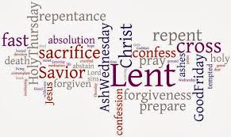

CHRIST LUTHERAN CHURCH STAFF

Pastor Rev. Nikki Fielder, pastor@christlutheranlb.com
Office Manager Kim Croes, officemanager@christlutheranlb.com
Preschool Director Lisa Clinton, info@clplb.com
Choir Director Kim Philips, kimsings@msn.com
Accompanist Roger Halvorson
A/V Technicians Brad Croes and Josh Baker
Missionary to Colombia Linda Gawthorne

Mission Statement
Living by Christ’s example, we welcome, serve, and love all through God’s grace.

Vision Statement
Embracing the truth that God’s love and grace is for all, Christ Lutheran Church is a vibrant and active community spreading the good news through acceptance, action, and benevolence.

Our Position
Christ is ALIVE!

Reconciling in Christ (RIC) Welcome Statement
Christ Lutheran Church is a congregation who joyfully welcomes everyone who enters our doors. We recognize that each of us is a unique creation made in the image of God. We celebrate and give thanks for the many diverse gifts that God has bestowed on us. We proclaim ourselves to be an open and affirming congregation to all of God's children, welcoming into our ministry persons of every race, culture, age, gender identity, gender expression, sexual orientation, ability, and economic status. We commit ourselves to the work of anti-racism and creating an anti-racist space. We believe that through our openness we all grow in our faith through Christ's teaching to love one another as God loves us.

