**Fourth Sunday of Advent**

**December 22, 2024**

**Christ Lutheran Church**

6500 E. Stearns Street

Long Beach, California 90815

Phone 562-598-2433

www.christlutheranlb.com

Preschool 562-594-6117

www.clplb.com

**Welcome to worship! We’re glad you’re here!**

To assist in your worship:

**bold** print means we respond together

**\*** meansrise in body or spirit,

+ you may make the sign of the cross should you so desire.

**It is our joy to worship with your whole family this morning!**

We encourage everyone of all ages and abilities to worship together.

We offer a “pray-ground” located in the back left of the Sanctuary for those with littles to have some room for movement and activity. The Narthex (gathering space at the entry) also has some resources for families, including activity bags filled with crayons, paper and storybooks. These supplies can be used in the Narthex or brought into the Sanctuary. For those that find themselves in the Narthex, there is a speaker with which you can still hear the service. Lastly, a changing table is located in the restroom off the Narthex. Please ask an usher if you need any assistance.

**TODAY’S worship THEME**

Cradle and cross are inextricably connected on the fourth Sunday of Advent. Between a lovely tribute to the little town of Bethlehem and Mary’s magnificent song of praise, the letter to the Hebrews reminds us in no uncertain terms that Christ’s advent is for “the offering of the body of Jesus Christ once for all.” It is the kind of tension in which the church always lives as when in holy communion—with high delight—“we proclaim the Lord’s death.”

Worship services for Christ Lutheran Church- Long Beach are live-streamed to Facebook

and later archived to YouTube. By entering the sanctuary and by your presence here,

you consent to be photographed, filmed, and/or otherwise recorded.

Please alert an usher if this is of concern to you.

Our liturgy is taken from:

Sundays and Seasons.com. Copyright 2024 Augsburg Fortress. All rights reserved.

Reprinted by permission under Augsburg Fortress Liturgies Annual License #20338.

Reprinted by permission under CCLI license # 230154. All rights reserved.

Reprinted by permission under © 2024 One License #A-706154. All rights reserved.

*© Church Anew. Used with Permission.*

**PRELUDE** Roger Halvorson

**WELCOME AND ANNOUNCEMENTS**

**GATHERING**

*The Holy Spirit calls us together as the people of God.*

**ADVENT CANDLE LIGHTING**

Today, we light the candle of love. Loralei Cabrera & Rachyl Theriault

**SONG**  “He Came Down” ELW #253

He came down that we may have hope;

He came down that we may have hope;

He came down that we may have hope,

Hallelujah forevermore.

…peace

…joy

…love

God of grace:

Renew our hearts in you, and help us look again to the day of restoration.

**Fill us with your love and prepare us to welcome you.**

Let us pray,

Stir up our hearts in love, O God. Give us voices to sing your praise as you make beginnings out of our endings. Deepen the imagination of our hearts, that we may live in justice, restoration, and peace. Through Jesus Christ, our love and salvation. Amen.

**\*GATHERING SONG**  *O Come, O Come Emmanuel ELW #257*

*(verses 1 & 2)*

**\*CONFESSION AND FORGIVENESS**

Blessed be the holy Trinity, ☩ one God, alive in the world, reviving creation, arriving soon. **Amen.**

Let us confess our sin in the presence of God and of one another.

*Silence is kept for reflection.*

God of mercy, **we confess that we have sinned. We trust earthly powers and human authority alone. We grow fearful. We cling to false comforts.**

God of might, **we confess that we have sinned. We have turned away from our neighbors. We have trusted false promises.**

God in our midst, **we confess that we have sinned. We plead: come to us.**

**Bring your mercy to birth in us.**

A righteous branch springs forth: it is Christ the Lord, our Savior, in whom we have forgiveness, life, and mercy. By the power of the Holy Spirit, receive the grace and forgiveness of God through ☩ Christ Jesus, whose day draws near. **Amen.**

**\*GREETING**

The grace of our Lord Jesus Christ, the love of God,and the communion of the Holy Spirit be with you all. **And also with you.**

**\*PRAYER OF THE DAY**

Let us pray. *A brief silence****.* Stir up your power, Lord Christ, and come. With your abundant grace and might, free us from the sin that binds us, that we may receive you in joy and serve you always, for you live and reign with the Father and the Holy Spirit, one God, now and forever. Amen.**

**WORD**

*God speaks to us in scripture reading, preaching, and song.*

*___________________________________________________________________________________________________________________________________________________________*

**CHILDREN’S CHAT**

*After this time, children will be invited to Sunday school. They will return during the passing of the peace.*

**FIRST READING** Micah 5:2-5a Pew Bible Old Testament Pg.966

**SECOND READING**  Hebrews 10:5-10Pew Bible New Testament Pg.240

Word of God, Word of Life**. Thanks be to God.**

**\*GOSPEL ACCLAMATION** *Prepare the Royal Highway ELW #264*

*(verse 1 only)*

**\*GOSPEL** Luke 1:39-55 Pew Bible New Testament Pg. 58

The Gospel comes from Luke, the 1st chapter. **Glory to you, O Lord.**

The reading concludes: The Gospel of the Lord. **Praise to you, O Christ.**

**SERMON** Pastor Nikki Fielder

**\*SERMON HYMN**  *Emmanuel W&P #36*

Emmanuel, Emmanuel,

His name is called Emmanuel;

God with us, revealed in us;

His name is called Emmanuel.

(Repeat)

**\*APOSTLES’ CREED**

**I believe in God, the Father almighty, creator of heaven and earth.**

**I believe in Jesus Christ, God’s only Son, our Lord, who was conceived by the Holy Spirit, born of the virgin Mary, suffered under Pontius Pilate, was crucified, died, and was buried; he descended to the dead. On the third day he rose again; he ascended into heaven, he is seated at the right hand of the Father, and he will come to judge the living and the dead.**

**I believe in the Holy Spirit, the holy catholic church, the communion of saints, the forgiveness of sins, the resurrection of the body, and the life everlasting. Amen.**

**PRAYERS OF THE CHURCH**

As we prepare for Emmanuel, God-with-us, let us pray for all people and places that long for God’s presence.

*A brief silence.*

Lord, in your mercy, **receive our prayer**.

Savior of the nations, come, and receive these prayers and the pleas of our hearts, in the name of Jesus Christ. **Amen.**

**\*SHARING OF PEACE**

The peace of Christ be with you always. **And also with you.**

**OFFERTORY***Mary, Did You Know?*Chancel Choir

**\*OFFERTORY RESPONSE** *Let the Vineyards be Fruitful ELW #184*

**\*OFFERTORY PRAYER**

Let us pray together, God of hope, **you fill the hungry with good things. Give us hopeful hearts and open hands to receive your love and share our abundance, that all may be fed. In the name of the one who sustains all life, Jesus Christ, our love. Amen.**

**MEAL**

*God feeds us with the presence of Jesus.*

**\*THE GREAT THANKSGIVING**

The Lord be with you. **And also with you.**

Lift up your hearts. **We lift them to the Lord,**

Let us give thanks to the Lord our God. **It is right to give our thanks and praise.**

It is indeed right, our duty and our joy…

…we praise your name and join their unending hymn:

**\*HOLY, HOLY, HOLY**  H*oly, Holy, Holy ELW pg.190*

**\*THANKSGIVING AT THE TABLE**

Holy God, the one who was and is and is to come…

**…** that we may all know your restoration and love in this world and the next, now and forever. **Amen.**

**\*LORD’S PRAYER**

**Our Father in heaven, hallowed be your name, your kingdom come, your will be done, on earth as in heaven. Give us today our daily bread. Forgive us our sins**

**as we forgive those who sin against us. Save us from the time of trial and deliver us from evil. For the kingdom, the power, and the glory are yours, now and forever.** **Amen.**

**DISTRIBUTION OF HOLY COMMUNION**

We believe that this is Jesus' table. All are welcome and invited to commune.  We serve communion by “intinction”; receive the bread and dip it in the chalice of red wine. Currently we are offering individual communion cups as an alternative to intinction if you so desire. Both wine and grape juice (white) are offered in the tray. Gluten free wafers are available; let your server know. Should you choose not to commune, you are invited to come forward to receive a blessing. Please cross your arms across your chest to let us know to give you that blessing.

**HEALING PRAYER**

*This morning we offer healing prayer. If you would like our healing minister to pray with and for you, please go to the right transept after taking communion.*

**INVITATION TO COMMUNION**

God feeds us with tender mercy. Come to the table.





**lamb of god** *Lamb of God* *ELW pg.191*





**COMMUNION SONG** *The Angel Gabriel from Heaven Came ELW #265*

**\*POST COMMUNION BLESSING**

The body and blood of our Lord Jesus Christ strengthen you and keep you in his grace. **Amen.**

**\*PRAYER AFTER COMMUNION**

Let us pray, Generous God, **we thank you for the gift of life, for the bread of salvation. We thank you for coming among us, for leading us into peace. We thank you for showering us with mercy, for sending us into the world. Come, Lord Jesus, and go with us as we feed the hungry in your name. Amen.**

**SENDING**

*God blesses us and sends us in mission to the world.*

**\*BLESSING**

May the God of hope guide you, May the way of peace sustain you, May the warmth of joy gather you, May the love of God hold you, In the name of the one who creates, redeems, and sustains us. **Amen.**

**\*SENDING HYMN** *O Come, O Come, Emmanuel ELW #257*

*(verses 6 & 7)*

**Verse 6**

O, come, O Dayspring, come and cheer;

O Sun of justice, now draw near.

Disperse the gloomy clouds of night,

and death’s dark shadow put to flight.

**Refrain**

Rejoice! Rejoice! Emmanuel shall come to you O Israel.

**Verse 7**

O come, O King of nations, come,

O Cornerstone that binds in one;

refresh the hearts that long for you;

restore the broken, make us new.

**Refrain**

Rejoice! Rejoice! Emmanuel shall come to you O Israel.

**\*DISMISSAL**

Go in peace, live in hope. **Thanks be to God.**

**POSTLUDE** Roger Halvorson

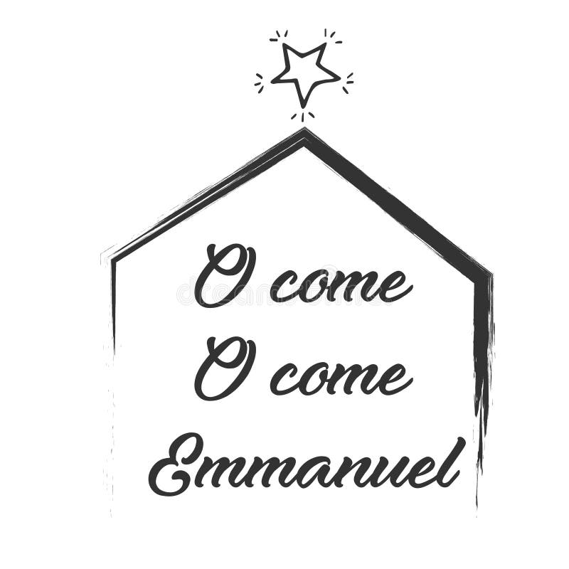



**CHRIST LUTHERAN CHURCH STAFF**

**Pastor**  Rev. Nikki Fielder, pastor@christlutheranlb.com

**Office Manager** Kim Croes, [officemanager@christlutheranlb.com](mailto:officemanager@christlutheranlb.com)

**Preschool Director** Lisa Clinton, info@clplb.com

**Choir Director** Kim Philips, kimsings@msn.com

**Accompanist** Roger Halvorson

**A/V Technicians** Brad Croes and Josh Baker

**Missionary to Colombia** Linda Gawthorne

**Mission Statement**

Living by Christ’s example, we welcome, serve, and love all through God’s grace.

**Vision Statement**

Embracing the truth that God’s love and grace is for all, Christ Lutheran Church is a vibrant and active community spreading the good news through acceptance, action, and benevolence.

**Our Position**

Christ is ALIVE!

**Reconciling in Christ (RIC) Welcome Statement**

Christ Lutheran Church is a congregation who joyfully welcomes everyone who enters our doors. We recognize that each of us is a unique creation made in the image of God. We celebrate and give thanks for the many diverse gifts that God has bestowed on us. We proclaim ourselves to be an open and affirming congregation to all of God's children, welcoming into our ministry persons of every race, culture, age, gender identity, gender expression, sexual orientation, ability, and economic status. We commit ourselves to the work of anti-racism and creating an anti-racist space. We believe that through our openness we all grow in our faith through Christ's teaching to love one another as God loves us.

**LIKE** us on **Facebook** at [www.facebook.com/christlutheranlb](http://www.facebook.com/christlutheranlb)

Write a review of Christ Lutheran Church on **YELP**