Third Sunday in Lent
March 12, 2023
9:30am

Christ Lutheran Church
6500 E. Stearns Street
Long Beach, California 90815
Phone 562-598-2433
www.christlutheranlb.com

Preschool 562-594-6117
www.clclb.com

Welcome to worship! We’re glad you’re here!

To assist in your worship:

bold print means we respond together
* means stand as you are able,
+ you may make the sign of the cross should you so desire.

TODAY’S worship THEME

In today’s gospel the Samaritan woman asks Jesus for water, an image of our thirst for God. Jesus offers living water, a sign of God’s grace flowing from the waters of baptism. The early church used this gospel and those of the next two Sundays to deepen baptismal reflection during the final days of preparation before baptism at Easter. As we journey to the resurrection feast, Christ comes among us in word, bath, and meal—offering us the life-giving water of God’s mercy and forgiveness.

Our liturgy is taken from:
Sundays and Seasons.com. Copyright 2023 Augsburg Fortress. All rights reserved.
Reprinted by permission under Augsburg Fortress Liturgies Annual License #20338.
Reprinted by permission under CCLI license # 230154. All rights reserved
Reprinted by permission under © 2023 One License #A-706154. All rights reserved
GATHERING
The Holy Spirit calls us together as the people of God.

PRELUDE Roger Halvorson

WELCOME AND ANNOUNCEMENTS

*CONfession & forgiveness (Please stand)
All may make the sign of the cross, the sign that is marked at baptism, as the presiding minister begins.

Blessed be the holy Trinity, ☩ one God, who journeys with us these forty days, and sustains us with the gift of grace. Amen.
Let us acknowledge before God and one another our need for repentance and God’s mercy. Silence is kept for reflection.
Holy God, we confess to you our faults and failings. Too often we neglect and do not trust your holy word; we take for ourselves instead of giving to others; we spoil rather than steward your creation; we cause hurt though you call us to heal; we choose fear over compassion. Forgive us, renew us, and lead us, as we seek to follow in your way of life. Amen.
Hear the good news:
God so loved the world that God gave the only Son, so that all may receive life.
This promise is for you! God embraces you with divine mercy, ☩ forgives you in Christ’s name, and revives you in the Spirit’s power. Amen.

*GATHERING SONG Shout to the Lord # 821
*GREETING
The grace of our Lord Jesus Christ, the love of God, and the communion of the Holy Spirit be with you all. And also with you.

*PRAYER OF THE DAY
Let us pray. A brief silence Merciful God, the fountain of living water, you quench our thirst and wash away our sin. Give us this water always. Bring us to drink from the well that flows with the beauty of your truth through Jesus Christ, our Savior and Lord, who lives and reigns with you and the Holy Spirit, one God, now and forever. Amen.

WORD
God speaks to us in scripture reading, preaching, and song.______________________

CHILDREN’S MESSAGE
Children will be invited to Sunday school following this time.

SCRIPTURE READING Romans 5:1-11 Pew Bible New Testament Pg.162
Word of God, Word of Life. Thanks be to God.

RESPONSIVE PSALM Psalm 95 Pew Bible Old Testament Pg. 608

¹O come, let us sing to the LORD; let us make a joyful noise to the rock of our salvation!
²Let us come into his presence with thanksgiving; let us make a joyful noise to him with songs of praise!
³For the LORD is a great God, and a great King above all gods.
⁴In his hand are the depths of the earth; the heights of the mountains are his also.
⁵The sea is his, for he made it, and the dry land, which his hands have formed.
⁶O come, let us worship and bow down, let us kneel before the LORD, our Maker!
⁷For he is our God, and we are the people of his pasture, and the sheep of his hand.
O that today you would listen to his voice!
⁸Do not harden your hearts, as at Meribah, as on the day at Massah in the wilderness,
⁹when your ancestors tested me, and put me to the proof, though they had seen my work.
¹⁰For forty years I loathed that generation and said, "They are a people whose hearts go astray, and they do not regard my ways."
¹¹Therefore in my anger I swore, "They shall not enter my rest."

*GOSPEL ACCLAMATION
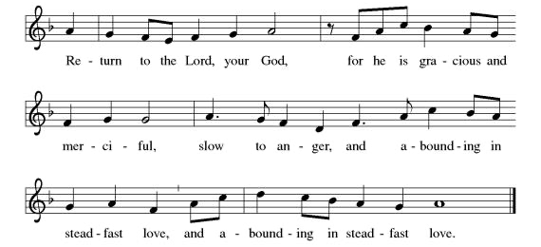

*GOSPEL John 4:5-42 Pew Bible New Testament Pg. 97

The Holy Gospel according to John the 4th chapter. Glory to you, O Lord.
The reading concludes: The Gospel of the Lord. Praise to you, O Christ.

SERMON

*SERMON SONG I Heard the Voice of Jesus Say #611
*NICENE CREED
We believe in one God, the Father, the Almighty, maker of heaven and earth, of all that is, seen and unseen.

We believe in one Lord, Jesus Christ, the only Son of God, eternally begotten of the Father, God from God, Light from Light, true God from true God, begotten, not made, of one Being with the Father; through him all things were made. For us and for our salvation he came down from heaven, was incarnate of the Holy Spirit and the virgin Mary and became truly human. For our sake he was crucified under Pontius Pilate; he suffered death and was buried. On the third day he rose again in accordance with the scriptures; he ascended into heaven and is seated at the right hand of the Father. He will come again in glory to judge the living and the dead, And his kingdom will have no end.
We believe in the Holy Spirit, the Lord, the giver of life, who proceeds from the Father and the Son, who with the Father and the Son is worshiped and glorified,
who has spoken through the prophets. We believe in one holy catholic and apostolic church. We acknowledge one baptism for the forgiveness of sins. We look for the resurrection of the dead, and the life of the world to come. Amen.

PRAYERS OF THE CHURCH

Sustained by God’s abundant mercy, let us pray for the church, the world, and all of creation.
Merciful God, receive our prayer.

We lift our prayers to you, O God, trusting in your steadfast love and your promise to renew your whole creation; through Jesus Christ our Savior.
Amen.

*SHARING OF PEACE

The peace of the Lord be with you always. And also with you.

OFFERTORY Here I Am, Lord Chancel Choir

*OFFERTORY RESPONSE Create in Me a Clean Heart

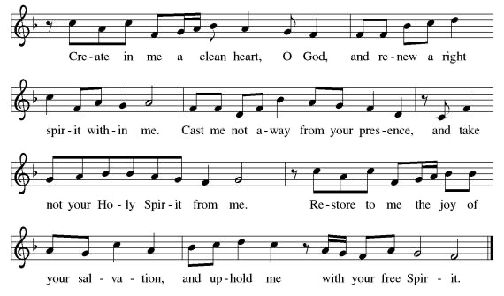

*OFFERTORY PRAYER

Let us pray together, God of good gifts, receive these and all our offerings as we present them in faithful service for the sake of the gospel. Prepare our hearts to receive you in this meal as you pour out your very presence through Jesus Christ, the wellspring of eternal life. Amen.

MEAL
God feeds us with the presence of Jesus.

*THE GREAT THANKSGIVING

The Lord be with you. And also with you.
Lift up your hearts. We lift them to the Lord,
Let us give thanks to the Lord our God. It is right to give our thanks and praise.
It is indeed right, our duty and our joy…
And so, with all the choirs of angels…and join their unending hymn;

*HOLY, HOLY, HOLY

*THANKSGIVING AT THE TABLE

Blessed are you, O God of the universe…

With this bread and cup we remember our Lord’s passover from death to life as we proclaim the mystery of faith:
Christ has died. Christ is risen. Christ will come again.

…Grace our table with your presence.
Come, Holy Spirit.

…Send us forth, burning with justice, peace, and love.
Come, Holy Spirit.

…we praise you, O God, blessed and holy Trinity, now and forever.
Amen.
*LORD’S PRAYER

Our Father in heaven, hallowed be your name, your kingdom come, your will be done, on earth as in heaven. Give us today our daily bread. Forgive us our sins
as we forgive those who sin against us. Save us from the time of trial and deliver us from evil. For the kingdom, the power, and the glory are yours, now and forever. Amen.

DISTRIBUTION OF HOLY COMMUNION
We believe that this is Jesus' table. All are welcome and invited to commune. We serve communion by “intinction”; receive the bread and dip it in the chalice of red wine. Currently we are offering individual communion cups as an alternative to intinction if you so desire. Both wine and grape juice (white) are offered in the tray. Gluten free bread is available; let your server know. Should you choose not to commune, please come forward to receive a blessing. Please cross your arms across your chest.

lamb of god

COMMUNION SONG Here is Bread #483
*PRAYER AFTER COMMUNION

Let us pray, Embodied God, at your table, we have tasted the goodness of Jesus. With the eyes of our hearts open to your promise, empower us to hear the needs of our neighbors and touch the world with your love. Amen.

SENDING
God blesses us and sends us in mission to the world.

*BLESSING
The Lord bless you and keep you. The Lord’s face shine on you with grace and mercy. The Lord looks upon you with favor and ☩ give you peace. Amen.

*SENDING HYMN Guide Me Ever, Great Redeemer #618

*Dismissal

Go in peace. Serve in love. Thanks be to God.

POSTLUDE Roger Halvorson

CHRIST LUTHERAN CHURCH STAFF

Interim Pastor Rev. Laurie Arroyo, lauriethere@msn.com
Office Manager Kim Croes, officemanager@christlutheranlb.com
Preschool Director Lisa Clinton, info@clplb.com
Interim Choir Director Kim Philips, kimsings@msn.com
Accompanist Roger Halvorson
Percussionist Nathan Latiolait
Missionary to Colombia Linda Gawthorne

It is our joy to worship with your whole family this morning!

CHILDCARE

We encourage everyone of all ages and abilities to worship together. If you do need to take a "time out", please do so in the narthex (gathering space at the entry), and return to worship when you are ready. A changing table is located in the restroom off the narthex. Activity bags, filled with crayons, paper and storybooks, are available in the narthex. Please ask an usher if you need any assistance.

OUR MISSION STATEMENT

Christ Is Alive!

OUR VISION STATEMENT

Christ Lutheran Church is a community of believers committed to praising our Savior Jesus Christ. With his love, we reach out to those in need and welcome all with open hearts. Our worship dynamically combines, word, song and prayer to share God’s incredible message. Having faith in this, we go forth knowing that with God and the power of the Holy Spirit, anything is possible.

LIKE us on Facebook at www.facebook.com/christlutheranlb

Write a review of Christ Lutheran Church on YELP!

