**Twenty Second Sunday of Pentecost**

**October 20, 2024**

**9:30am**



**Christ Lutheran Church**

6500 E. Stearns Street

Long Beach, California 90815

Phone 562-598-2433

www.christlutheranlb.com

Preschool 562-594-6117

www.clplb.com

**Welcome to worship! We’re glad you’re here!**

To assist in your worship:

**bold** print means we respond together

**\*** meansrise in body or spirit,

+ you may make the sign of the cross should you so desire.

**It is our joy to worship with your whole family this morning!**

We encourage everyone of all ages and abilities to worship together.

We offer a “pray-ground” located in the back left of the Sanctuary for those with littles to have some room for movement and activity. The Narthex (gathering space at the entry) also has some resources for families, including activity bags filled with crayons, paper and storybooks. These supplies can be used in the Narthex or brought into the Sanctuary. For those that find themselves in the Narthex, there is a speaker with which you can still hear the service. Lastly, a changing table is located in the restroom off the Narthex. Please ask an usher if you need any assistance.

**TODAY’S worship THEME**

Today’s gospel starts with disciples obsessing over who will be closest to Jesus, leading to Jesus teaching his followers about God’s take on importance and power. Here Jesus makes it explicit that the reversal of values in God’s community is a direct challenge to the values of the dominant culture, where wielding power over others is what makes you great. When we pray “your kingdom come” we are praying for an end to tyranny and oppression. We pray this gathered around the cross, a sign of great shame transformed to be the sign of great honor and service.

Worship services for Christ Lutheran Church- Long Beach are live-streamed to Facebook

and later archived to YouTube. By entering the sanctuary and by your presence here,

you consent to be photographed, filmed, and/or otherwise recorded.

Please alert an usher if this is of concern to you.

Our liturgy is taken from:

Sundays and Seasons.com. Copyright 2024 Augsburg Fortress. All rights reserved.

Reprinted by permission under Augsburg Fortress Liturgies Annual License #20338.

Reprinted by permission under CCLI license # 230154. All rights reserved.

Reprinted by permission under © 2024 One License #A-706154. All rights reserved.

**PRELUDE** Roger Halvorson

**WELCOME AND ANNOUNCEMENTS**

**SPECIAL MESSAGE** Pastor Marta Moscoso

**GATHERING**

*The Holy Spirit calls us together as the people of God.*

**\*GATHERING SONG**  *Savior, like a Shepherd Lead Us ELW #789*

*(verses 1, 3, & 4)*

**\*CONFESSION AND FORGIVENESS**

*All may make the sign of the cross, the sign that is marked at baptism, as the presiding minister begins.*

Blessed be the holy Trinity, ☩ one God, who forgives all our sin, whose mercy endures forever. **Amen.**

Let us confess our sin and come to God for healing.

*Silence is kept for reflection.*

Gracious God**, have mercy on us. We confess that we have honored you with our lips, but have harmed our neighbors with our tongues. The cravings at war within us cause conflicts and disputes. In our desire to be first we make distinctions among ourselves. We place the needs of the poor and the suffering last. In your great mercy, forgive us our sins. Draw near to us with grace in time of need, and turn us to follow in the way of Jesus Christ, our Savior and Lord.** **Amen.**

God promises to forgive our iniquity and to remember our sin no more. By grace you have been saved. In the name of ☩ Jesus Christ, the source of eternal healing,

your sins are forgiven**. Amen.**

**\*GREETING**

The grace of our Lord Jesus Christ, the love of God,and the communion of the Holy Spirit be with you all. **And also with you.**

**\*KYRIE** *ELW pg.184*



**Verse 4**

For your Spirit to guide; that you center our lives in the water and the Word;

that you nourish our souls with your body and blood,

let us pray to the Lord, let us pray to the Lord

 (Refrain)

**Verse 2**

That we may live out your impassioned response to the hungry and the poor;

that we may live out truth and justice and grace,

let us pray to the Lord, let us pray to the Lord

 (Refrain)

**\*PRAYER OF THE DAY**

Let us pray. *A brief silence****.* Sovereign God, you turn your greatness into goodness for all the peoples on earth. Shape us into willing servants of your kingdom, and make us desire always and only your will, through Jesus Christ, our Savior and Lord. Amen.**

**WORD**

*God speaks to us in scripture reading, preaching, and song.*

*___________________________________________________________________________________________________________________________________________________________*

**CHILDREN’S CHAT**

*After this time, children will be invited to Sunday school. They will return during the passing of the peace.*

**PSALM** Psalm 91:9-16Pew Bible Old Testament Pg.606

9Because you have made the LORD your refuge, the Most High your dwelling place,  
**10no evil shall befall you, no scourge come near your tent.** 11For he will command his angels concerning you to guard you in all your ways.  
 **12On their hands they will bear you up, so that you will not dash your foot against a stone.** 13You will tread on the lion and the adder, the young lion and the serpent you will trample under foot.  
 **14Those who love me, I will deliver; I will protect those who know my name.** 15When they call to me, I will answer them; I will be with them in trouble, I will rescue them and honor them.  
 **16With long life I will satisfy them, and show them my salvation.**

**SCRIPTURE READING** Hebrews 5:1-10 Pew Bible New Testament Pg.236

Word of God, Word of Life. **Thanks be to God.**

**\*GOSPEL ACCLAMATION** *Make Me A Servant W&P #96*

Make me a servant humble and meek

Lord let me lift up those who are weak

And may the prayer of my heart always be

Make me a servant make me a servant

Make me a servant today

**\*GOSPEL** Mark 10:35-45 Pew Bible New Testament Pg. 47

The Gospel comes from Mark, the 10th chapter. **Glory to you, O Lord.**

The reading concludes: The Gospel of the Lord. **Praise to you, O Christ.**

**SERMON** Pastor Nikki Fielder

**\*SERMON HYMN** *Will You Let Me Be Your Servant ELW #659*

*(verses 1, 3, & 5)*

**\*APOSTLES’ CREED**

**I believe in God, the Father almighty, creator of heaven and earth.**

**I believe in Jesus Christ, God’s only Son, our Lord, who was conceived by the Holy Spirit, born of the virgin Mary, suffered under Pontius Pilate, was crucified, died, and was buried; he descended to the dead. On the third day he rose again; he ascended into heaven, he is seated at the right hand of the Father, and he will come to judge the living and the dead.**

**I believe in the Holy Spirit, the holy catholic church, the communion of saints, the forgiveness of sins, the resurrection of the body, and the life everlasting. Amen.**

**PRAYERS OF THE CHURCH**

Challenged by God’s Word in Christ, let us pray for the church, the world, and the whole creation.

*A brief silence.*

God of grace, **hear our prayer.**

Into your hands, O God, we commend all for whom we pray, trusting in the saving grace you freely give, both now and forever. **Amen.**

**\*SHARING OF PEACE**

The peace of Christ be with you always. **And also with you.**

**OFFERTORY***Lean on Me* Chancel Choir

**\*OFFERTORY RESPONSE** *Refiner’s Fire*

Purify my heart, let me be as gold and precious silver.

Purify my heart, let me be as gold, pure gold.

Chorus:

Refiner’s fire: My heart’s one desire is to be holy, set apart for You, Lord.

I choose to be holy, set apart for You, my Master: Ready to do Your will.

**OFFERTORY PRAYER**

Let us pray together, **Blessed are you, O God, source of every gift of your creation. By these gifts and with our lives, help us to serve one another and all in need, through Jesus Christ, our Savior and Lord**. **Amen.**

**MEAL**

*God feeds us with the presence of Jesus.*

**\*THE GREAT THANKSGIVING**

The Lord be with you. **And also with you.**

Lift up your hearts. **We lift them to the Lord,**

Let us give thanks to the Lord our God. **It is right to give our thanks and praise.**

It is indeed right, our duty and our joy…

…and with angels and archangels, cherubim and seraphim, we praise your name and join their unending hymn:

**\*HOLY, HOLY, HOLY** *Holy, Holy, Holy ELW pg.173*

**\*THANKSGIVING AT THE TABLE**

…Pour out upon us the Spirit of your love, O Lord, and unite the wills of all who share this heavenly food, the body and blood of Jesus Christ, our Lord; to whom, with you and the Holy Spirit, be all honor and glory, now and forever. **Amen.**

**\*LORD’S PRAYER**

**Our Father in heaven, hallowed be your name, your kingdom come, your will be done, on earth as in heaven. Give us today our daily bread. Forgive us our sins**

**as we forgive those who sin against us. Save us from the time of trial and deliver us from evil. For the kingdom, the power, and the glory are yours, now and forever.** **Amen.**

**DISTRIBUTION OF HOLY COMMUNION**

We believe that this is Jesus' table. All are welcome and invited to commune.  We serve communion by “intinction”; receive the bread and dip it in the chalice of red wine. Currently we are offering individual communion cups as an alternative to intinction if you so desire. Both wine and grape juice (white) are offered in the tray. Gluten free wafers are available; let your server know. Should you choose not to commune, you are invited to come forward to receive a blessing. Please cross your arms across your chest to let us know to give you that blessing.

**INVITATION TO COMMUNION**

Jesus welcomes you to this table. Come, here is your God.





**lamb of god** *Lamb of God ELW pg.174*

**COMMUNION SONG** *Jesu, Jesu, Fill Us with Your Love ELW #708*

**\*POST COMMUNION BLESSING**

The body and blood of our Lord Jesus Christ strengthen you and keep you in his grace. **Amen.**

**\*PRAYER AFTER COMMUNION**

Let us pray, **Holy God, you have welcomed us to this meal and fed us with dignity at your table. Send us now to welcome others and to be at peace with one another, through Jesus Christ our Lord. Amen.**

**SENDING**

*God blesses us and sends us in mission to the world.*

**\*BLESSING**

God all mighty, God most merciful ☩ bless you, keep you, and give you peace.

**Amen.**

**\*SENDING HYMN** *The Lord Now Sends Us Forth ELW #538*

**\*Dismissal**

Go in peace. Follow Jesus. **Thanks be to God.**

**POSTLUDE** Roger Halvorson



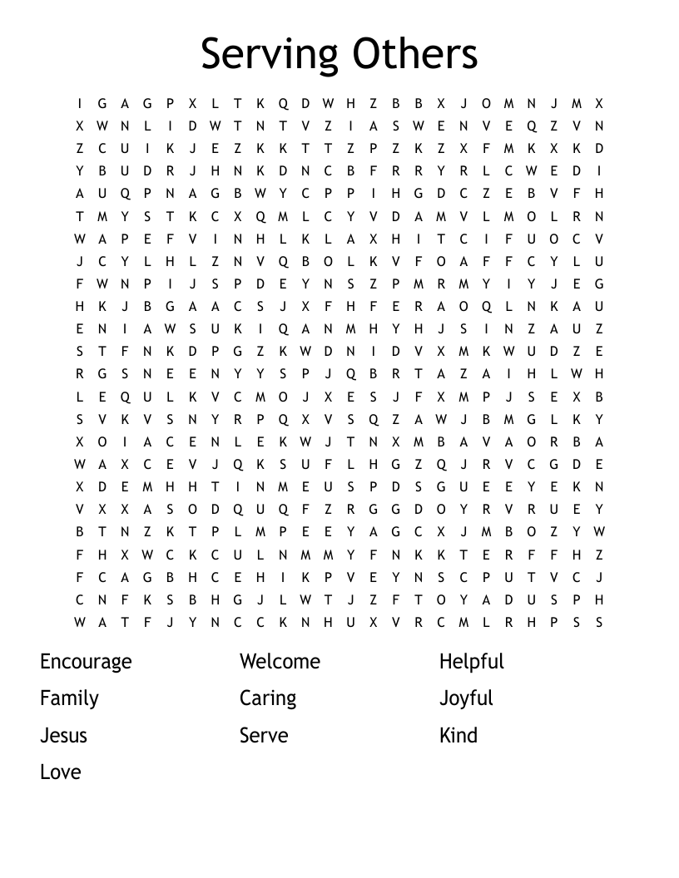

**CHRIST LUTHERAN CHURCH STAFF**

**Pastor**  Rev. Nikki Fielder, pastor@christlutheranlb.com

**Office Manager** Kim Croes, [officemanager@christlutheranlb.com](mailto:officemanager@christlutheranlb.com)

**Preschool Director** Lisa Clinton, info@clplb.com

**Choir Director** Kim Philips, kimsings@msn.com

**Accompanist** Roger Halvorson

**A/V Technicians** Brad Croes and Josh Baker

**Missionary to Colombia** Linda Gawthorne

**Mission Statement**

Living by Christ’s example, we welcome, serve, and love all through God’s grace.

**Vision Statement**

Embracing the truth that God’s love and grace is for all, Christ Lutheran Church is a vibrant and active community spreading the good news through acceptance, action, and benevolence.

**Our Position**

Christ is ALIVE!

**Reconciling in Christ (RIC) Welcome Statement**

Christ Lutheran Church is a congregation who joyfully welcomes everyone who enters our doors. We recognize that each of us is a unique creation made in the image of God. We celebrate and give thanks for the many diverse gifts that God has bestowed on us. We proclaim ourselves to be an open and affirming congregation to all of God's children, welcoming into our ministry persons of every race, culture, age, gender identity, gender expression, sexual orientation, ability, and economic status. We commit ourselves to the work of anti-racism and creating an anti-racist space. We believe that through our openness we all grow in our faith through Christ's teaching to love one another as God loves us.

**LIKE** us on **Facebook** at [www.facebook.com/christlutheranlb](http://www.facebook.com/christlutheranlb)

Write a review of Christ Lutheran Church on **YELP**