**Sixteenth Sunday of Pentecost**

**God’s work. Our hands.**

**September 8, 2024**

**9:30am**



**Christ Lutheran Church**

6500 E. Stearns Street

Long Beach, California 90815

Phone 562-598-2433

www.christlutheranlb.com

Preschool 562-594-6117

[www.clplb.com](http://www.clplb.com)

**Welcome to worship! We’re glad you’re here!**

To assist in your worship:

**bold** print means we respond together

**\*** meansrise in body or spirit,

+ you may make the sign of the cross should you so desire.

**It is our joy to worship with your whole family this morning!**

We encourage everyone of all ages and abilities to worship together.

We offer a “pray-ground” located in the back left of the Sanctuary for those with littles to have some room for movement and activity. The Narthex (gathering space at the entry) also has some resources for families, including activity bags filled with crayons, paper and storybooks. These supplies can be used in the Narthex or brought into the Sanctuary. For those that find themselves in the Narthex, there is a speaker with which you can still hear the service. Lastly, a changing table is located in the restroom off the Narthex. Please ask an usher if you need any assistance.

**TODAY’S worship THEME**

“God’s Work, Our Hands” began as an annual service day for the ELCA in 2013 on the 25th anniversary of its formation. “This day is an opportunity to celebrate who we are as the Evangelical Lutheran Church in America — one church, freed in Christ to serve and love our neighbor.

Service activities offer an opportunity for us to explore one of our most basic convictions as Lutherans: that all of life in Jesus Christ – every act of service, in every daily calling, in every corner of life — flows freely from a living, daring confidence in God’s grace.”

Worship services for Christ Lutheran Church- Long Beach are live-streamed to Facebook

and later archived to YouTube. By entering the sanctuary and by your presence here,

you consent to be photographed, filmed, and/or otherwise recorded.

Please alert an usher if this is of concern to you.

Our liturgy is taken from:

Sundays and Seasons.com. Copyright 2024 Augsburg Fortress. All rights reserved.

Reprinted by permission under Augsburg Fortress Liturgies Annual License #20338.

Reprinted by permission under CCLI license # 230154. All rights reserved.

Reprinted by permission under © 2024 One License #A-706154. All rights reserved.

**PRELUDE** Roger Halvorson

**WELCOME AND ANNOUNCEMENTS**

**GATHERING**

*The Holy Spirit calls us together as the people of God.*

**RECEIVING OF NEW MEMBERS**

**\*GATHERING SONG**  *He Who Began a Good Work in You W&P #56*

He who began a good work in you

He who began a good work in you

Will be faithful to complete it

He'll be faithful to complete it

He who started the work

Will be faithful to complete it in you

*(Repeat)*

**\*GREETING**

The grace of our Lord Jesus Christ, the love of God,and the communion of the Holy Spirit be with you all. **And also with you.**

**\*KYRIE** *ELW pg.184*



**Verse 4**

For your Spirit to guide; that you center our lives in the water and the Word;

that you nourish our souls with your body and blood,

let us pray to the Lord, let us pray to the Lord

(Refrain)

**Verse 2**

That we may live out your impassioned response to the hungry and the poor;

that we may live out truth and justice and grace,

let us pray to the Lord, let us pray to the Lord

 (Refrain)

**\*PRAYER OF THE DAY**

Let us pray. *A brief silence****.* Holy One, you stretch wide your tent that all may be welcomed in, and in Jesus you stretched out your hands in expansive love for a weary and wounded world. Help us to reach out with your own wounded hands of love, that through us your life may be known in the world, through Jesus Christ, our Savior and Lord. Amen.**

**\*SHARING OF PEACE**

The peace of Christ be with you always. **And also with you.**

**\*CELEBRATION OF VOCATION**

P: We are called to proclaim the good news:

C: **God is at work!**

P: This good news is not left in some history long ago or a place far

away:

C: **God is at work in the world still today!**

P: In us and through us, God is glorified in our work.

When we offer a helping hand, God is praised.

When we share of our abundance, God is known in the world.

C: **God is at work in us!**

P: In our service today and in our daily lives,

let us live out what God has called us to in baptism.

C: **God is at work through our hands!**

**SENDING**

*God blesses us and sends us in mission to the world.*

**\*BLESSING**

God all mighty, God most merciful ☩ bless you, keep you, and give you peace.

**Amen.**

**\*SENDING HYMN** *Let Us Talents and Tongues Employ ELW #674*

**\*Dismissal**

Go in peace. You are God’s hands at work in the world!

**Thanks be to God.**

**POSTLUDE** Roger Halvorson

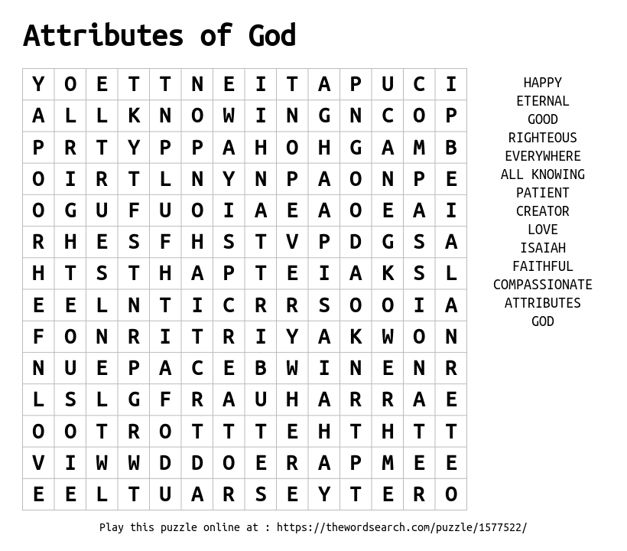

**CHRIST LUTHERAN CHURCH STAFF**

**Pastor**  Rev. Nikki Fielder, pastor@christlutheranlb.com

**Office Manager** Kim Croes, [officemanager@christlutheranlb.com](mailto:officemanager@christlutheranlb.com)

**Preschool Director** Lisa Clinton, info@clplb.com

**Choir Director** Kim Philips, kimsings@msn.com

**Accompanist** Roger Halvorson

**A/V Technicians** Brad Croes and Josh Baker

**Missionary to Colombia** Linda Gawthorne

**Mission Statement**

Living by Christ’s example, we welcome, serve, and love all through God’s grace.

**Vision Statement**

Embracing the truth that God’s love and grace is for all, Christ Lutheran Church is a vibrant and active community spreading the good news through acceptance, action, and benevolence.

**Our Position**

Christ is ALIVE!

**Reconciling in Christ (RIC) Welcome Statement**

Christ Lutheran Church is a congregation who joyfully welcomes everyone who enters our doors. We recognize that each of us is a unique creation made in the image of God. We celebrate and give thanks for the many diverse gifts that God has bestowed on us. We proclaim ourselves to be an open and affirming congregation to all of God's children, welcoming into our ministry persons of every race, culture, age, gender identity, gender expression, sexual orientation, ability, and economic status. We commit ourselves to the work of anti-racism and creating an anti-racist space. We believe that through our openness we all grow in our faith through Christ's teaching to love one another as God loves us.

**LIKE** us on **Facebook** at [www.facebook.com/christlutheranlb](http://www.facebook.com/christlutheranlb)

Write a review of Christ Lutheran Church on **YELP**