Christ Lutheran Church
Week at a Glance
September 1 – September 8

Today, September 1
9:30am Worship-In Person & Live Streamed
11:00am Worship & Music Meeting
11:00am His Grace Service (Sanctuary)
5:00pm OA (Founder’s Room)

Monday, September 2 Labor Day
Church Office and Preschool Closed

Tuesday, September 3
9:00am Cover G’s (Social Hall)
6:00pm His Grace Prayer Service (Sanctuary)

Wednesday, September 4
9:45am Bible Study (Zoom)
5:00pm Property Committee Meeting (CR)

Thursday, September 5
6:00pm OA (Founder’s Room)
7:00pm Choir Rehearsal (Sanctuary)

Friday, September 6
No Events Planned

Saturday, September 7
No Events Planned

Sunday, September 8 God’s Work. Our Hands. (GWOH)
9:30am Worship and Welcome of New Members
-In Person & Live Streamed
11:00am Activities for GWOH
11:00am His Grace Service (Sanctuary)
5:00pm OA (Founder’s Room)

Altar flowers this morning are given in thanksgiving and to the glory of God by Ruth Depuy in memory of her sister, Penny.

Please take a moment after worship to sign up to sponsor altar flowers for the coming months. Altar flowers can be sponsored in honor or memory of loved ones or in thanksgiving for special occasions. On your Sunday, be sure to take your arrangement home so you can enjoy it for the whole week. The 2024 flower chart is on the door of the Usher’s Room in the Narthex. Each arrangement sponsored is $45. Please make your check out to Christ Lutheran and place in the offering plate. Thank you so much.

Thank you to everyone who donated blood last week. We collected 30 units between regular pints and Power Red collections. That is 10 units more than last time.

We will be welcoming in our new members on September 8th. If you are interested in membership here and haven’t already let us know, please reach out to Pastor Nikki at the church office. Those people who join on the 8th of September will be eligible to attend and vote at the congregation meeting on the 15th.

Our next congregational meeting will be on Sunday, September 15th immediately following worship. Please come to the social hall for coffee and a light snack.

Church in Society’s giving focus for September is God’s Work.
Our Hands. (GWOH) Our focus will be our church home as there are so many things that need attention. There will be a list of tasks available after church next Sunday. The tasks are for all ability levels and we’re certain, you’ll find something you can handle.

Our next congregational meeting will be on Sunday, September 15th immediately following worship. Please come to the social hall for coffee and a light snack.

Name Tags are encouraged! This helps new and returning members alike to learn names and get to know one another. If you need one, please contact the church office.

The Healing Power of the Holy Spirit

We pray for:

Members at Home or in Care Centers: Laurie Ennen, Ione Marchael, Sydney Nichols, Bary & Janice Schlieder, and Frances Willms.

Those struggling with illness or other concerns: Don Darnauer, Judy Haenn, Daniel Howard, Sheryl Hunter, Andrea Joseph, Chris and Kathy Klute-Nelson, Karen Koch, Brianna Peralta, Kristine Trost, Rich Williams, Gary & Linda Zimmerman.

*Family & Friends: Barbara, Noah, Carolina, Bob Anderson, Lois Brown, Jeff Chan, Charlie and David Corm, Mary Croes, Denise Davis, Jessica, Tamra Fitzgerald, Zoey, Brechin Flournoy, Cindy Gray, Jerry & Joan Green, Susan, Kylie & Crystal Huber, Bryan Koenen, Aaron, Kim & Sienna Koepke, Barb Korsmo, Katrina Lahr, Sue Lance, Cameron, Tim & Mimi Philips, Kristina & Scott Randolph, Sharry Reed, Sandra Reyes, David & Debra Sarvela, Marlene Shafer, Vicki Thompson, Kathy Vonbuskirk, Jessica West, Marilyn Winebarger, Doris, Marc, and Adrianna Wurzel.

*Please use the blue prayer request form found in your pew pocket to add individuals or families to these lists. Names are included on the prayer list for 30 days unless specific requests are made through the office.

We also pray for the ongoing work of:

+ Linda Gawthorne among the Kogi people of Colombia

+ First responders who provide safety, security, and care

+ Those serving in our nation's military, especially: Samuel Brown, Ryan Dorris,
Morgan Llewellyn, Johnny Luna, Austin Marsh, Jim Reeder, Steven,
Brina and Michael Navarro.

+ Lutheran Social Services, Christian Outreach in Action, New Life Beginnings
+ We remember our unhoused neighbors, who find themselves without shelter
and a place to call home. We pray for their safety, health, and wellness. We
commit to treating them with compassion and working to combat systemic
issues that leave our neighbors in need.

This morning’s worship assistants:
Assisting Minister: Greg Koch
Lector: Chris Caldwell
Communion Assistants: Bryce Bonilla-Haenn, Shannon & Matthew Timney
Greeter: Rebecca and Matt Green
Coffee Cart: Ruth Depuy
Altar Guild: Annette Rodrigues
Ushers: Linda McGee, Mark Ennen, Claudia Fitzpatrick
Thank you all.
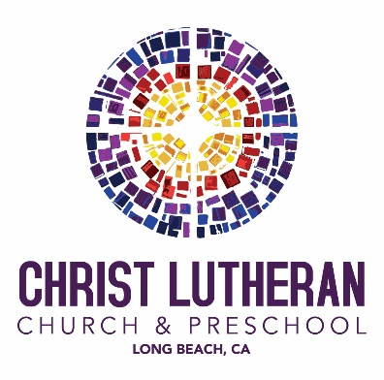

6500 E. Stearns Street, Long Beach, CA 90815
christlutheranlb.com
562.598.2433

Pastor Rev. Nicole Fielder, pastor@christlutheranlb.com
Office Manager Kim Croes, officemanager@christlutheranlb.com
Preschool Director Lisa Clinton, info@clplb.com Choir Director Kim Philips, kimsings@msn.com
Accompanist Roger Halvorson
A/V Technicians Brad Croes and Josh Baker
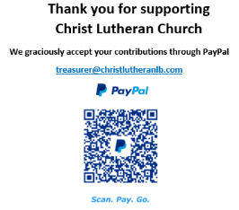
Missionary to Colombia Linda Gawthorne

