**August 25, 2024**

**9:30am**

**Christ Lutheran Church**

6500 E. Stearns Street

Long Beach, California 90815

Phone 562-598-2433

www.christlutheranlb.com

Preschool 562-594-6117

www.clplb.com

***August 25th- John 6:56-69***

***Pastor Luther Our Redeemer, Garden Grove***

***The Rev. Dr. Luther Symons was ordained on January 11, 1998. He was a Missionary and Professor in Cameroon and then Thailand until 2003. He has since served in Northwood, ND; Poway, CA and now, Garden Grove, CA.***

**Welcome to worship! We’re glad you’re here!**

To assist in your worship:

**bold** print means we respond together

**\*** meansrise in body or spirit,

+ you may make the sign of the cross should you so desire.

**It is our joy to worship with your whole family this morning!**

We encourage everyone of all ages and abilities to worship together.

We offer a “pray-ground” located in the back left of the Sanctuary for those with littles to have some room for movement and activity. The Narthex (gathering space at the entry) also has some resources for families, including activity bags filled with crayons, paper and storybooks. These supplies can be used in the Narthex or brought into the Sanctuary. For those that find themselves in the Narthex, there is a speaker with which you can still hear the service. Lastly, a changing table is located in the restroom off the Narthex. Please ask an usher if you need any assistance.

**TODAY’S worship THEME**

In today’s gospel many people take offense at Jesus’ invitation to eat his flesh and drink his blood; even many of Jesus’ disciples peel off. This is the backdrop in John’s gospel for Peter’s confession of faith. “To whom can we go?” asks Peter, in words we sometimes sing just before the gospel is read. “You have the words of eternal life.” In order to take such a stand, as Peter and Joshua did, Paul tells us to arm ourselves with the word of God. We pray in the Spirit that we might be bold ambassadors of the gospel.

Worship services for Christ Lutheran Church- Long Beach are live-streamed to Facebook

and later archived to YouTube. By entering the sanctuary and by your presence here,

you consent to be photographed, filmed, and/or otherwise recorded.

Please alert an usher if this is of concern to you.

Our liturgy is taken from:

Sundays and Seasons.com. Copyright 2024 Augsburg Fortress. All rights reserved.

Reprinted by permission under Augsburg Fortress Liturgies Annual License #20338.

Reprinted by permission under CCLI license # 230154. All rights reserved.

Reprinted by permission under © 2024 One License #A-706154. All rights reserved.

“The Gospel According to Bread” Eucharistic Prayer by Barn Geese Worship is licensed under CC BY-NC 4.0. [Adapted by Rev. Nikki Fielder].

**PRELUDE** Roger Halvorson

**WELCOME AND ANNOUNCEMENTS**

**GATHERING**

*The Holy Spirit calls us together as the people of God.*

**\*GATHERING SONG**  *How Can I Be Free From Sin? W&P #65*

**\*CONFESSION AND FORGIVENESS**

*All may make the sign of the cross, the sign that is marked at baptism, as the presiding minister begins.*

Blessed be the holy Trinity, ☩ one God, the God of manna, the God of miracles, the God of mercy. **Amen.**

Drawn to Christ and seeking God’s abundance, let us confess our sin.

*Silence is kept for reflection.*

God, our provider, **help us. It is hard to believe there is enough to share. We question your ways when they differ from the ways of the world in which we live.**

**We turn to our own understanding rather than trusting in you. We take offense at your teachings and your ways. Turn us again to you. Where else can we turn?**

**Share with us the words of eternal life and feed us for life in the world. Amen.**

Beloved people of God: in Jesus, the manna from heaven, you are fed and nourished. By Jesus, the worker of miracles, there is always more than enough. Through Jesus, ☩ the bread of life, you are shown God’s mercy: you are forgiven and loved into abundant life. **Amen.**

**\*GREETING**

The grace of our Lord Jesus Christ, the love of God,and the communion of the Holy Spirit be with you all. **And also with you.**

**\*KYRIE** *ELW pg.184*



**Verse 1**

For peace in the world, for the health of the church, for the unity of all;

for this holy house, for all who worship and praise,

let us pray to the Lord, let us pray to the Lord.

(Refrain)

**Verse 3**

For peace in our hearts, for peace in our homes, for friends and family;

for life and for love, for our work and our play,

let us pray to the Lord, let us pray to the Lord.

(Refrain)

**\*PRAYER OF THE DAY**

Let us pray. *A brief silence****.* Holy God, your word feeds your people with life that is eternal. Direct our choices and preserve us in your truth, that, renouncing what is false and evil, we may live in you, through your Son, Jesus Christ, our Savior and Lord. Amen.**

**WORD**

*God speaks to us in scripture reading, preaching, and song.*

*___________________________________________________________________________________________________________________________________________________________*

**CHILDREN’S CHAT**

**FIRST READING** Joshua 24:1-2a, 14-18Pew Bible Old Testament Pg.237

**SECOND READING** Ephesians 6:10-20 Pew Bible New Testament Pg.208

Word of God, Word of Life. **Thanks be to God.**

**\*GOSPEL ACCLAMATION** *Seek Ye First W&P #122*

**\*GOSPEL** John 6:56-69 Pew Bible New Testament Pg.102

The Gospel comes from John, the 6th chapter. **Glory to you, O Lord.**

The reading concludes: The Gospel of the Lord. **Praise to you, O Christ.**

**SERMON** Pastor Luther Symons

Our Redeemer, Garden Grove

**\*SERMON HYMN** *Break Now the Bread of Life ELW #515*

**\*APOSTLES’ CREED**

**I believe in God, the Father almighty, creator of heaven and earth.**

**I believe in Jesus Christ, God’s only Son, our Lord, who was conceived by the Holy Spirit, born of the virgin Mary, suffered under Pontius Pilate, was crucified, died, and was buried; he descended to the dead. On the third day he rose again; he ascended into heaven, he is seated at the right hand of the Father, and he will come to judge the living and the dead.**

**I believe in the Holy Spirit, the holy catholic church, the communion of saints, the forgiveness of sins, the resurrection of the body, and the life everlasting. Amen.**

**PRAYERS OF THE CHURCH**

Calling on the spirit of Wisdom to guide our hearts and our minds, let us pray for the church, the world, and all in need.

*A brief silence.*

Merciful God,

**receive our prayer.**

We lift up these prayers to you, gracious God. Receive them into your holy keeping. **Amen.**

**\*SHARING OF PEACE**

The peace of Christ be with you always. **And also with you.**

**OFFERTORY***Amazing Grace (My Chains are Gone)*  Kim Philips

**\*OFFERTORY RESPONSE** *Refiner’s Fire*

Purify my heart, let me be as gold and precious silver.

Purify my heart, let me be as gold, pure gold.

Chorus:

Refiner’s fire: My heart’s one desire is to be holy, set apart for You, Lord.

I choose to be holy, set apart for You, my Master: Ready to do Your will.

**\*OFFERTORY PRAYER**

Let us pray together**, Jesus, Bread of life, you have set this table with your very self, and called us to the feast of plenty. Gather what has been sown among us, and strengthen us in this meal. Make us to be what we receive here, your body for the life of the world. Amen.**

**MEAL**

*God feeds us with the presence of Jesus.*

**\*THE GREAT THANKSGIVING**

The Lord be with you. **And also with you.**

Lift up your hearts. **We lift them to the Lord,**

Let us give thanks to the Lord our God. **It is right to give our thanks and praise.**

It is indeed right, our duty and our joy…

…and with angels and archangels, cherubim and seraphim, we praise your name and join their unending hymn:

**\*HOLY, HOLY, HOLY** *Holy, Holy, Holy ELW pg.173*

**\*THANKSGIVING AT THE TABLE**

We thank you and praise you for you have satisfied the hunger of your people in every age…

…Pour out upon us the Spirit of your love, O Lord, And stir in us a hunger for justice and thirst for compassion. Open wide your hand and satisfy our deep desire— feed us with the Bread that is you. All honor and glory to you, almighty God, now and forever. **Amen.**

**\*LORD’S PRAYER**

**Our Father in heaven, hallowed be your name, your kingdom come, your will be done, on earth as in heaven. Give us today our daily bread. Forgive us our sins**

**as we forgive those who sin against us. Save us from the time of trial and deliver us from evil. For the kingdom, the power, and the glory are yours, now and forever.** **Amen.**

**DISTRIBUTION OF HOLY COMMUNION**

We believe that this is Jesus' table. All are welcome and invited to commune.  We serve communion by “intinction”; receive the bread and dip it in the chalice of red wine. Currently we are offering individual communion cups as an alternative to intinction if you so desire. Both wine and grape juice (white) are offered in the tray. Gluten free wafers are available; let your server know. Should you choose not to commune, you are invited to come forward to receive a blessing. Please cross your arms across your chest to let us know to give you that blessing.

**HEALING PRAYER**

*This morning we offer healing prayer. If you would like our healing minister to pray with and for you, please go to the right transept after taking communion.*

**INVITATION TO COMMUNION**

Christ has set the table with more than enough for all. Come!





**lamb of god** *Lamb of God ELW pg.174*

**COMMUNION SONG** *Eat This Bread, Drink This Cup ELW #492*

**\*POST COMMUNION BLESSING**

The body and blood of our Lord Jesus Christ strengthen you and keep you in his grace. **Amen.**

**\*PRAYER AFTER COMMUNION**

Let us pray**, Jesus, Bread of life, we have received from your table more than we could ever ask. As you have nourished us in this meal, now strengthen us to love the world with your own life. In your name we pray. Amen.**

**SENDING**

*God blesses us and sends us in mission to the world.*

**\*BLESSING**

The blessing of God, who provides for us, feeds us, and journeys with us, ☩ be upon you now and forever. **Amen.**

**\*SENDING HYMN** *Holy, Holy W&P #60 (verses 1, 3, & 5)*

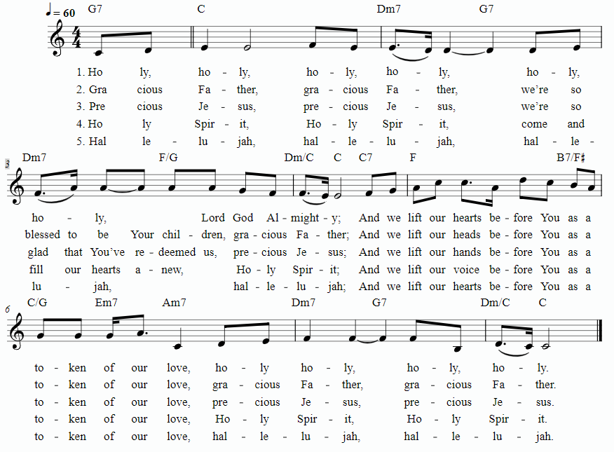

**\*Dismissal**

Go in peace. You are the body of Christ. **Thanks be to God.**

**POSTLUDE** Roger Halvorson

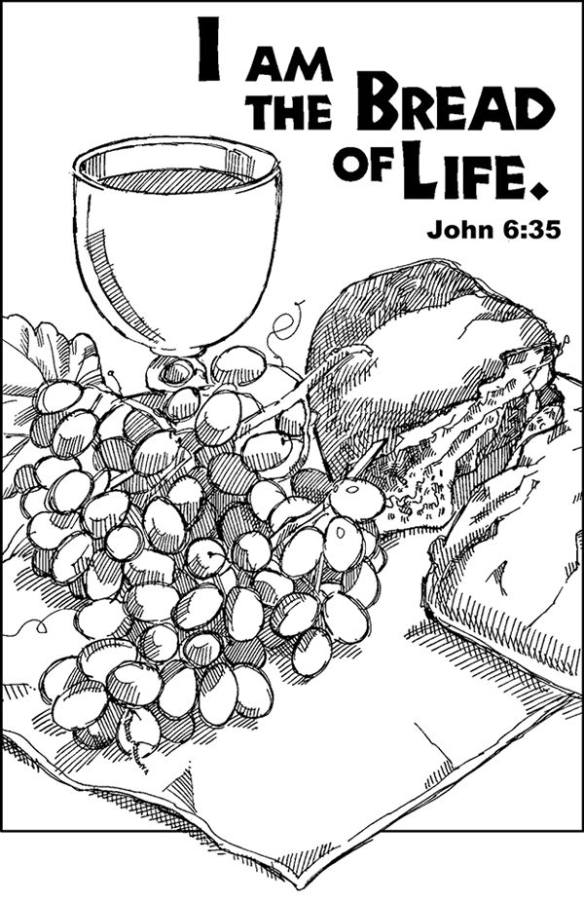

**CHRIST LUTHERAN CHURCH STAFF**

**Pastor**  Rev. Nikki Fielder, pastor@christlutheranlb.com

**Office Manager** Kim Croes, [officemanager@christlutheranlb.com](mailto:officemanager@christlutheranlb.com)

**Preschool Director** Lisa Clinton, info@clplb.com

**Choir Director** Kim Philips, kimsings@msn.com

**Accompanist** Roger Halvorson

**A/V Technicians** Brad Croes and Josh Baker

**Missionary to Colombia** Linda Gawthorne

**Mission Statement**

Living by Christ’s example, we welcome, serve, and love all through God’s grace.

**Vision Statement**

Embracing the truth that God’s love and grace is for all, Christ Lutheran Church is a vibrant and active community spreading the good news through acceptance, action, and benevolence.

**Our Position**

Christ is ALIVE!

**Reconciling in Christ (RIC) Welcome Statement**

Christ Lutheran Church is a congregation who joyfully welcomes everyone who enters our doors. We recognize that each of us is a unique creation made in the image of God. We celebrate and give thanks for the many diverse gifts that God has bestowed on us. We proclaim ourselves to be an open and affirming congregation to all of God's children, welcoming into our ministry persons of every race, culture, age, gender identity, gender expression, sexual orientation, ability, and economic status. We commit ourselves to the work of anti-racism and creating an anti-racist space. We believe that through our openness we all grow in our faith through Christ's teaching to love one another as God loves us.

**LIKE** us on **Facebook** at [www.facebook.com/christlutheranlb](http://www.facebook.com/christlutheranlb)

Write a review of Christ Lutheran Church on **YELP**