Sixth Sunday of Easter
May 5, 2024
9:30am

Christ Lutheran Church
6500 E. Stearns Street
Long Beach, California 90815
Phone 562-598-2433
www.christlutheranlb.com

Preschool 562-594-6117
www.clplb.com

Welcome to worship! We’re glad you’re here!

To assist in your worship:

bold print means we respond together
* means stand as you are able,
+ you may make the sign of the cross should you so desire.

TODAY’S worship THEME

This Sunday’s image of the life the risen Christ shares with us is the image of friendship. We are called to serve others as Jesus came to serve; but for John’s gospel, the image of servanthood is too hierarchical, too distant, to capture the essence of life with Christ. Friendship captures the love, the joy, the deep mutuality of the relationship into which Christ invites us. The Greeks believed that true friends are willing to die for each other. This is the mutual love of Christian community commanded by Christ and enabled by the Spirit.

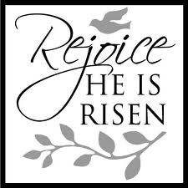

Our liturgy is taken from:
Sundays and Seasons.com. Copyright 2024 Augsburg Fortress. All rights reserved.
Reprinted by permission under Augsburg Fortress Liturgies Annual License #20338.
Reprinted by permission under CCLI license # 230154. All rights reserved.
Reprinted by permission under © 2024 One License #A-706154. All rights reserved.
PRELUDE Roger Halvorson

WELCOME AND ANNOUNCEMENTS

GATHERING
The Holy Spirit calls us together as the people of God.

*THANKSGIVING FOR BAPTISM

Blessed be the holy Trinity, ☩ one God, the wellspring of grace, our Easter and our joy.
Amen.

Look, here is water! Here is our water of life! Alleluia!

Immersed in the promises of baptism, let us give thanks for what God has done for us.

We give you thanks, O God, for in the beginning your voice thundered over the deep
and water became the essence of life. Adam and Eve beheld Eden’s verdant rivers.
The ark carried your creation through the flood into a new day. Miriam led the dancing as your people passed through the sea into freedom’s land. In a desert pool the Ethiopian official entered your boundless baptismal life.

At the river your beloved Son was baptized by John and anointed with the Holy Spirit.
By the baptism of Jesus’ death and resurrection you opened the floodgates of your reconciling love, freeing us to live as Easter people. We rejoice with glad hearts,
giving all honor and praise to you, through the risen Christ, our source of living water,
in the unity of the Holy Spirit, now and forever. Amen.

Look, here is water! Here is our water of life! Alleluia!

*GATHERING SONG All That We Have
(verses 1 & 2)

*GREETING
The grace of our Lord Jesus Christ, the love of God, and the communion of the Holy Spirit be with you all. And also with you.

*PRAYER OF THE DAY
Let us pray. A brief silence. O God, you have prepared for those who love you joys beyond understanding. Pour into our hearts such love for you that, loving you above all things, we may obtain your promises, which exceed all we can desire; through Jesus Christ, your Son and our Lord, who lives and reigns with you and the Holy Spirit, one God, now and forever. Amen.
WORD
God speaks to us in scripture reading, preaching, and song.
___________________________________________________________________________________________________________________________________________________________

CHILDREN’S CHAT After this time, children will be invited to Sunday school. They will return during the passing of the peace.

PSALM Psalm 98 Pew Bible Old Testament Pg.610

¹O sing to the LORD a new song, for he has done marvelous things. His right hand and his holy arm have gotten him victory.
²The LORD has made known his victory; he has revealed his vindication in the sight of the nations.
³He has remembered his steadfast love and faithfulness to the house of Israel.
All the ends of the earth have seen the victory of our God.
⁴Make a joyful noise to the LORD, all the earth; break forth into joyous song and sing praises.
⁵Sing praises to the LORD with the lyre, with the lyre and the sound of melody.
⁶With trumpets and the sound of the horn make a joyful noise before the King, the LORD.
⁷Let the sea roar, and all that fills it; the world and those who live in it.
⁸Let the floods clap their hands; let the hills sing together for joy
⁹at the presence of the LORD, for he is coming to judge the earth.
He will judge the world with righteousness, and the peoples with equity.

FIRST READING Acts 10:44-48 Pew Bible New Testament Pg.135
Word of God, Word of Life. Thanks be to God.

*GOSPEL ACCLAMATION Alleluia ELW pg.142

*GOSPEL John 15:9-17 Pew Bible New Testament Pg.113

The Holy Gospel according to John the 15th chapter. Glory to you, O Lord.
The reading concludes: The Gospel of the Lord. Praise to you, O Christ.

SERMON Pastor Nikki Fielder

*SERMON HYMN Jesu, Jesu, Fill Us with Your Love ELW #708

APOSTLES’ CREED

I believe in God, the Father almighty, creator of heaven and earth.

I believe in Jesus Christ, God’s only Son, our Lord, who was conceived by the Holy Spirit, born of the virgin Mary, suffered under Pontius Pilate, was crucified, died, and was buried; he descended to the dead. On the third day he rose again; he ascended into heaven, he is seated at the right hand of the Father, and he will come to judge the living and the dead.

I believe in the Holy Spirit, the holy catholic church, the communion of saints, the forgiveness of sins, the resurrection of the body, and the life everlasting. Amen.
PRAYERS OF THE CHURCH

Rejoicing that Jesus is risen, and love has triumphed over fear, let us pray for the church, the world, and all those in need of good news.

A brief silence.

God of grace,
hear our prayer.

Into your hands, most merciful God, we commend all for whom we pray, trusting in your abiding love; through Jesus Christ, our resurrected and living Lord. Amen.

*SHARING OF PEACE

The peace of Christ be with you always. And also with you.

OFFERTORY Brad Croes and Roger Halvorson

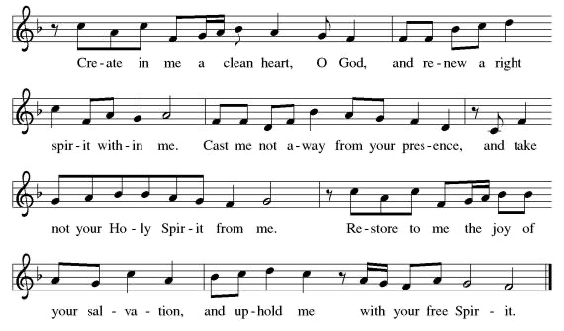
*OFFERTORY RESPONSE Create in Me a Clean Heart ELW #186
*OFFERTORY PRAYER

Let us pray together, Risen One, you call us to believe and bear fruit. May the gifts that we offer here be signs of your abiding love. Form us to be your witnesses in the world, through Jesus Christ, our true vine. Amen.
MEAL
God feeds us with the presence of Jesus.

*THE GREAT THANKSGIVING

The Lord be with you. And also with you.
Lift up your hearts. We lift them to the Lord.
Let us give thanks to the Lord our God. It is right to give our thanks and praise.
It is indeed right, our duty and our joy…
…and with angels and archangels, cherubim and seraphim, we praise your name and join their unending hymn:
*HOLY, HOLY, HOLY Holy, Holy, Holy ELW pg.153

*THANKSGIVING AT THE TABLE

…with this bread and cup, we remember our Lord’s passover from death to life as we proclaim the mystery of faith: Christ has died. Christ is risen. Christ will come again.

…Grace our table with your presence. Come, Holy Spirit.
…Send us forth, burning with justice, peace, and love. Come, Holy Spirit.
…blessed and holy Trinity, now and forever. Amen.

*LORD’S PRAYER

Our Father in heaven, hallowed be your name, your kingdom come, your will be done, on earth as in heaven. Give us today our daily bread. Forgive us our sins
as we forgive those who sin against us. Save us from the time of trial and deliver us from evil. For the kingdom, the power, and the glory are yours, now and forever. Amen.

DISTRIBUTION OF HOLY COMMUNION
We believe that this is Jesus' table. All are welcome and invited to commune. We serve communion by “intinction”; receive the bread and dip it in the chalice of red wine. Currently we are offering individual communion cups as an alternative to intinction if you so desire. Both wine and grape juice (white) are offered in the tray. Gluten free bread is available; let your server know. Should you choose not to commune, please come forward to receive a blessing. Please cross your arms across your chest.

INVITATION TO COMMUNION

The risen Christ is made known to us in the breaking of the bread. Come and eat at God’s table.

lamb of god Lamb of God ELW pg.154

COMMUNION SONG Jesus Loves Me! ELW #595

*POST COMMUNION BLESSING
The body and blood of our Lord Jesus Christ strengthen you and keep you in his grace. Amen.

*PRAYER AFTER COMMUNION

Let us pray, Shepherding God, you have prepared a table before us and nourished us with your love. Send us forth from this banquet to proclaim your goodness and share the abundant mercy of Jesus, our redeemer and friend. Amen.

SENDING
God blesses us and sends us in mission to the world.

*BLESSING

Alleluia! Christ is risen! Christ is risen indeed! Alleluia!
The God of resurrection power, the Christ of unending joy, and the Spirit of Easter hope
☩ bless you now and always. Amen.

*SENDING HYMN Great is the Lord
Great is the Lord
He is holy and just
by His power we trust in His love

Great is the Lord
He is faithful and true
by His mercy He proves He is Love

Great is the Lord, and worthy of glory.
Great is the Lord, and worthy of praise.
Great is the Lord, now lift up your voice, now lift up your voice:
Great is the Lord!
Great is the Lord!
(repeat)

*Dismissal
Alleluia! Go in peace. Rejoice and be glad.
Thanks be to God. Alleluia!

POSTLUDE Roger Halvorson
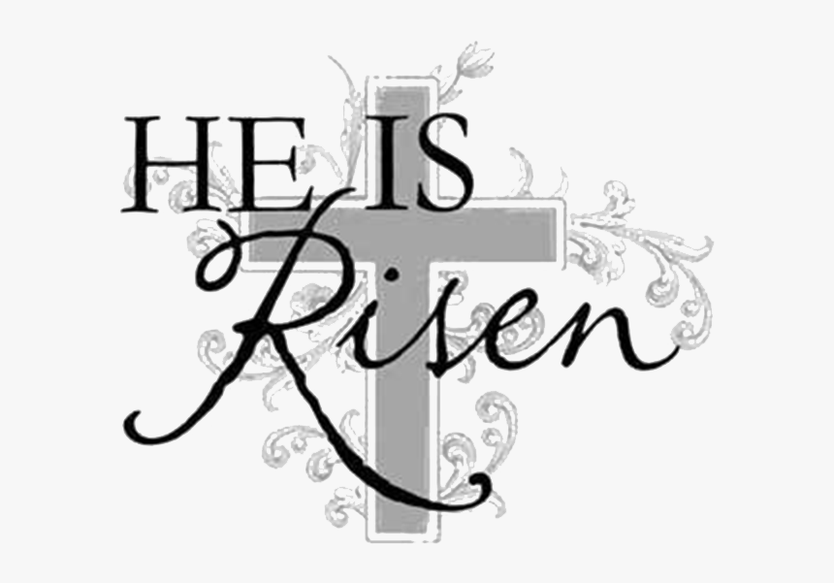

CHRIST LUTHERAN CHURCH STAFF

Pastor Rev. Nikki Fielder, pastor@christlutheranlb.com
Office Manager Kim Croes, officemanager@christlutheranlb.com
Preschool Director Lisa Clinton, info@clplb.com
Choir Director Kim Philips, kimsings@msn.com
Accompanist Roger Halvorson
A/V Technicians Brad Croes and Josh Baker
Missionary to Colombia Linda Gawthorne

It is our joy to worship with your whole family this morning!

We encourage everyone of all ages and abilities to worship together. If you do need to take a "time out", please do so in the narthex (gathering space at the entry), and return to worship when you are ready. A changing table is located in the restroom off the narthex. Activity bags, filled with crayons, paper and storybooks, are available in the narthex. Please ask an usher if you need any assistance.

Mission Statement
Living by Christ’s example, we welcome, serve, and love all through God’s grace.

Vision Statement
Embracing the truth that God’s love and grace is for all, Christ Lutheran Church is a vibrant and active community spreading the good news through acceptance, action, and benevolence.

Our Position
Christ is ALIVE!

LIKE us on Facebook at www.facebook.com/christlutheranlb

Write a review of Christ Lutheran Church on YELP

