Holy Trinity Sunday
May 26, 2024
9:30am

Christ Lutheran Church
6500 E. Stearns Street
Long Beach, California 90815
Phone 562-598-2433
www.christlutheranlb.com

Preschool 562-594-6117
www.clplb.com
Welcome to worship! We’re glad you’re here!

To assist in your worship:

bold print means we respond together
* means stand as you are able,
+ you may make the sign of the cross should you so desire.

TODAY’S worship THEME
When we say God is the triune God, we are saying something about who God is beyond, before, and after the universe: that there is community within God. Our experience of this is reflected in Paul’s words today. When we pray to God as Jesus prayed to his Abba (an everyday, intimate parental address), the Spirit prays within us, creating between us and God the same relationship Jesus has with the one who sent him.

Our liturgy is taken from:
Sundays and Seasons.com. Copyright 2024 Augsburg Fortress. All rights reserved.
Reprinted by permission under Augsburg Fortress Liturgies Annual License #20338.
Reprinted by permission under CCLI license # 230154. All rights reserved.
Reprinted by permission under © 2024 One License #A-706154. All rights reserved.

PRELUDE Kim Philips & Lisa Cottrell

WELCOME AND ANNOUNCEMENTS

GATHERING
The Holy Spirit calls us together as the people of God.

*CONFESSION AND FORGIVENESS

All may make the sign of the cross, the sign that is marked at baptism, as the presiding minister begins.
Blessed be the holy Trinity, ☩ one God, the God of manna, the God of miracles, the God of mercy. Amen.

Drawn to Christ and seeking God’s abundance, let us confess our sin.

Silence is kept for reflection.

God, our provider, help us. It is hard to believe there is enough to share. We question your ways when they differ from the ways of the world in which we live.
We turn to our own understanding rather than trusting in you. We take offense at your teachings and your ways. Turn us again to you. Where else can we turn?
Share with us the words of eternal life and feed us for life in the world. Amen.

Beloved people of God: in Jesus, the manna from heaven, you are fed and nourished. By Jesus, the worker of miracles, there is always more than enough. Through Jesus, ☩ the bread of life, you are shown God’s mercy: you are forgiven and loved into abundant life. Amen.

*GATHERING SONG Come, Let Us Worship and Bow Down
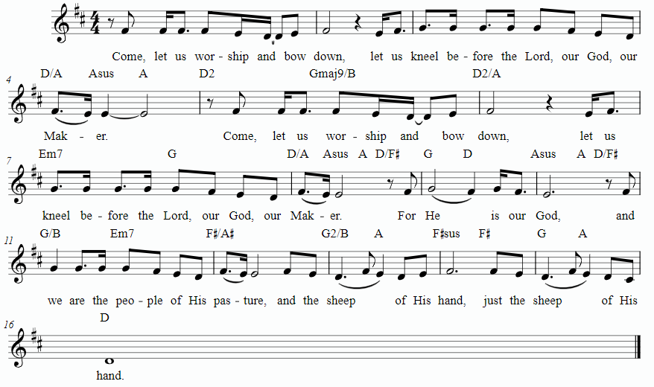

*GREETING
The grace of our Lord Jesus Christ, the love of God, and the communion of the Holy Spirit be with you all. And also with you.

*PRAYER OF THE DAY
Let us pray. A brief silence. Almighty Creator and ever-living God: we worship your glory, eternal Three-in-One, and we praise your power, majestic One-in-Three. Keep us steadfast in this faith, defend us in all adversity, and bring us at last into your presence, where you live in endless joy and love, Father, Son, and Holy Spirit, one God, now and forever. Amen.

WORD
God speaks to us in scripture reading, preaching, and song.
___________________________________________________________________________________________________________________________________________________________

CHILDREN’S CHAT After this time, children will be invited to Sunday school. They will return during the passing of the peace.

FIRST READING Isaiah 6:1-8 Pew Bible Old Testament Pg.704

SECOND READING Romans 8:12-17 Pew Bible New Testament Pg.164

Word of God, Word of Life. Thanks be to God.

*GOSPEL ACCLAMATION Seek Ye First

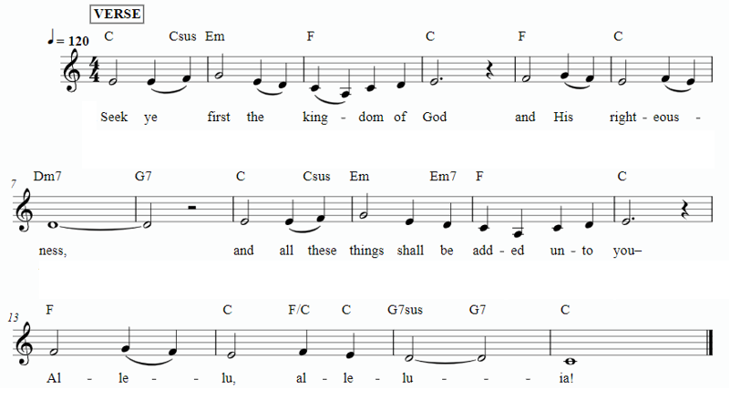

*GOSPEL John 3:1-17 Pew Bible New Testament Pg.96

The Gospel comes from John, the 3rd chapter. Glory to you, O Lord.
The reading concludes: The Gospel of the Lord. Praise to you, O Christ.

SERMON Pastor Nikki Fielder

*SERMON HYMN Father, I Adore You

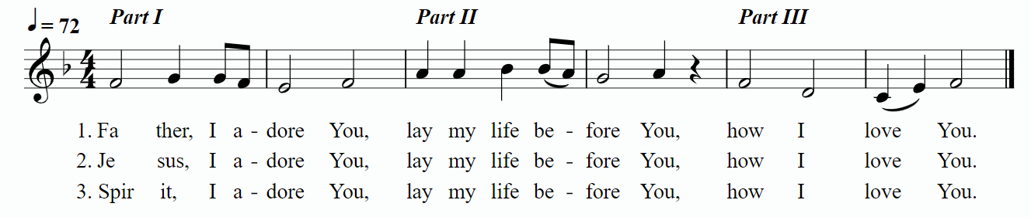

*APOSTLES’ CREED

I believe in God, the Father almighty, creator of heaven and earth.

I believe in Jesus Christ, God’s only Son, our Lord, who was conceived by the Holy Spirit, born of the virgin Mary, suffered under Pontius Pilate, was crucified, died, and was buried; he descended to the dead. On the third day he rose again; he ascended into heaven, he is seated at the right hand of the Father, and he will come to judge the living and the dead.

I believe in the Holy Spirit, the holy catholic church, the communion of saints, the forgiveness of sins, the resurrection of the body, and the life everlasting. Amen.

PRAYERS OF THE CHURCH

We come before the triune God to pray for our communities, ourselves, and our world.
A brief silence.
Merciful God,
receive our prayer.

Receive our prayers, O God, and come quickly to our aid, through the power of the Spirit and the love of Jesus Christ. Amen.

*SHARING OF PEACE

The peace of Christ be with you always. And also with you.

OFFERTORY Kim Philips and Lisa Cottrell

*OFFERTORY RESPONSE Praise God From Whom All Blessings Flow
(Doxology)

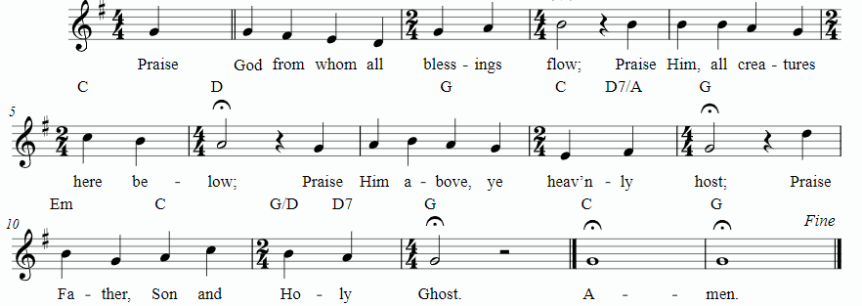

*OFFERTORY PRAYER

Let us pray together, Jesus, Bread of life, you have set this table with your very self, and called us to the feast of plenty. Gather what has been sown among us, and strengthen us in this meal. Make us to be what we receive here, your body for the life of the world. Amen.
MEAL
God feeds us with the presence of Jesus.

*THE GREAT THANKSGIVING

The Lord be with you. And also with you.
Lift up your hearts. We lift them to the Lord,
Let us give thanks to the Lord our God. It is right to give our thanks and praise.
It is indeed right, our duty and our joy…
…and with angels and archangels, cherubim and seraphim, we praise your name and join their unending hymn:
*HOLY, HOLY, HOLY Holy, Holy, Holy
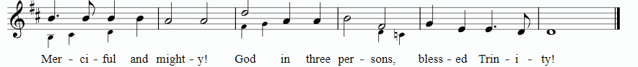
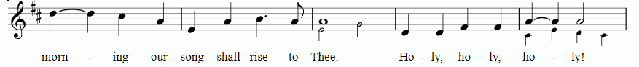

*THANKSGIVING AT THE TABLE

…with this bread and cup, we remember our Lord’s passover from death to life as we proclaim the mystery of faith: Christ has died. Christ is risen. Christ will come again.

…Grace our table with your presence. Come, Holy Spirit.
…Send us forth, burning with justice, peace, and love. Come, Holy Spirit.
…blessed and holy Trinity, now and forever. Amen.

*LORD’S PRAYER

Our Father in heaven, hallowed be your name, your kingdom come, your will be done, on earth as in heaven. Give us today our daily bread. Forgive us our sins
as we forgive those who sin against us. Save us from the time of trial and deliver us from evil. For the kingdom, the power, and the glory are yours, now and forever. Amen.

DISTRIBUTION OF HOLY COMMUNION
We believe that this is Jesus' table. All are welcome and invited to commune. We serve communion by “intinction”; receive the bread and dip it in the chalice of red wine. Currently we are offering individual communion cups as an alternative to intinction if you so desire. Both wine and grape juice (white) are offered in the tray. Gluten free bread is available; let your server know. Should you choose not to commune, please come forward to receive a blessing. Please cross your arms across your chest.
HEALING PRAYER
This morning we offer healing prayer. If you would like our healing minister to pray with and for you, please go to the right transept after taking communion.

INVITATION TO COMMUNION
Christ has set the table with more than enough for all. Come!

lamb of god Lamb of God ELW pg.154

COMMUNION SONG Everlasting God
Verse
Strength will rise as we wait upon the Lord
We will wait upon the Lord
We will wait upon the Lord
(Repeat)

Pre-Chorus
Our God You reign forever
Our Hope our strong Deliv'rer

Chorus
You are the everlasting God
The everlasting God
You do not faint
You won't grow weary
You're the defender of the weak
You comfort those in need
You lift us up on wings like eagles
(Repeat from the Beginning)
*POST COMMUNION BLESSING
The body and blood of our Lord Jesus Christ strengthen you and keep you in his grace. Amen.

*PRAYER AFTER COMMUNION

Let us pray, Jesus, Bread of life, we have received from your table more than we could ever ask. As you have nourished us in this meal, now strengthen us to love the world with your own life. In your name we pray. Amen.
SENDING
God blesses us and sends us in mission to the world.

*BLESSING

The blessing of God, who provides for us, feeds us, and journeys with us, ☩ be upon you now and forever. Amen.

*SENDING HYMN Indescribable
Verse 1
From the highest of heights to the depths of the sea
Creation's revealing Your majesty
From the colors of Fall to the fragrance of Spring
Ev'ry creature unique in the song that it sings
All exclaiming

Chorus
Indescribable uncontainable
You placed the stars in the sky
And You know them by name
You are amazing God
All powerful untamable
Awestruck we fall to our knees
As we humbly proclaim
You are amazing God

Verse 2
Who has told ev'ry lightning bolt where it should go
Or seen heavenly storehouses laden with snow
Who imagined the sun and gives source to its light
Yet conceals it to bring us the coolness of night
None can fathom

Chorus

You see the depths of my heart
And You love me the same
You are amazing God

You see the depths of our hearts
And You love us the same
You are amazing God
You are amazing God
*Dismissal
Go in peace. You are the body of Christ.
Thanks be to God.

POSTLUDE Kim Philips and Lisa Cottrell

CHRIST LUTHERAN CHURCH STAFF

Pastor Rev. Nikki Fielder, pastor@christlutheranlb.com
Office Manager Kim Croes, officemanager@christlutheranlb.com
Preschool Director Lisa Clinton, info@clplb.com
Choir Director Kim Philips, kimsings@msn.com
Accompanist Roger Halvorson
A/V Technicians Brad Croes and Josh Baker
Missionary to Colombia Linda Gawthorne

It is our joy to worship with your whole family this morning!

We encourage everyone of all ages and abilities to worship together. If you do need to take a "time out", please do so in the narthex (gathering space at the entry), and return to worship when you are ready. A changing table is located in the restroom off the narthex. Activity bags, filled with crayons, paper and storybooks, are available in the narthex. Please ask an usher if you need any assistance.

Mission Statement
Living by Christ’s example, we welcome, serve, and love all through God’s grace.

Vision Statement
Embracing the truth that God’s love and grace is for all, Christ Lutheran Church is a vibrant and active community spreading the good news through acceptance, action, and benevolence.

Our Position
Christ is ALIVE!

LIKE us on Facebook at www.facebook.com/christlutheranlb

Write a review of Christ Lutheran Church on YELP

