Nativity of Our Lord I
December 24, 2023
5:30pm
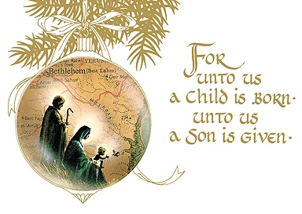

Christ Lutheran Church
6500 E. Stearns Street
Long Beach, California 90815
Phone 562-598-2433
www.christlutheranlb.com

Preschool 562-594-6117
www.clclb.com
Welcome to worship! We’re glad you’re here!

To assist in your worship:

bold print means we respond together
* means stand as you are able,
+ you may make the sign of the cross should you so desire.

TODAY’S worship THEME
In winter’s deepest night, we welcome the light of the Christ child. Isaiah declares that the light of the long-promised king will illumine the world and bring endless peace and justice. Paul reminds us that the grace of God through Jesus Christ brings salvation to all people. The angels declare that Jesus’ birth is good and joyful news for everyone, including lowly shepherds. Filled with the light that shines in our lives, we go forth to share the light of Christ with the whole world.

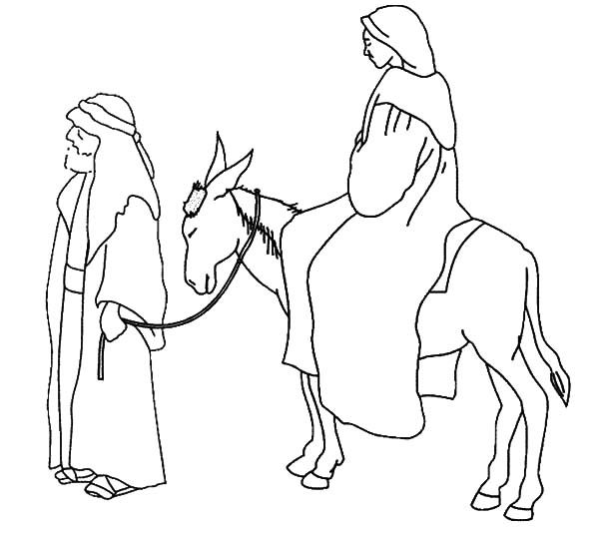

Our liturgy is taken from:
Sundays and Seasons.com. Copyright 2023 Augsburg Fortress. All rights reserved.
Reprinted by permission under Augsburg Fortress Liturgies Annual License #20338.
Reprinted by permission under CCLI license # 230154. All rights reserved
Reprinted by permission under © 2023 One License #A-706154. All rights reserved
PRELUDE Roger Halvorson

WELCOME AND ANNOUNCEMENTS

GATHERING

The Holy Spirit calls us together as the people of God._______________________

CONFESSION AND FORGIVENESS
All may make the sign of the cross, the sign that is marked at baptism, as the presiding minister begins.
Blessed be the holy Trinity, ☩ one God, the Word made flesh, our life and our salvation.
Amen.

Trusting the goodness and lovingkindness of God our Savior, let us confess our sin.

Silence is kept for reflection.

God of life, you promise good news of great joy for all people, and call us to be messengers of your peace. We confess that too often we hoard our joy, our resources, and our security. We nurture conflict and build barriers. We neglect the needs of our neighbors and ignore the groaning of creation. Have mercy on us.
Where we are self-centered, open our hearts. Where we are reluctant, give us courage. Where we are cynical, restore our trust. Renew us with your grace
and give us again the hope of eternal life in you. Amen.

Hear the good news: We are children of God and heirs of God’s promises through the outpouring of the Holy Spirit. In ☩ Jesus we are forgiven and redeemed. Sing with joy, for all the ends of the earth shall know the salvation of God. Amen.

*GATHERING SONG Joy to the World ELW 267
*GREETING
The grace of our Lord Jesus Christ, the love of God, and the communion of the Holy Spirit be with you all. And also with you.
*CANTICLE OF PRAISE Good Christian Friends, Rejoice! # 288

*pRAYER OF THE DAY
Let us pray together. A brief silence. Almighty God, you made this holy night shine with the brightness of the true Light. Grant that here on earth we may walk in the light of Jesus’ presence and in the last day wake to the brightness of his glory; through your Son, Jesus Christ our Lord, who lives and reigns with you and the Holy Spirit, one God, now and forever. Amen.
WORD
God speaks to us in scripture reading, preaching, and song.______________________

CHILDREN’S MESSAGE After this time, children will be invited to Sunday school. They will return during the passing of the peace.

*GOSPEL ACCLAMATION Go Tell It on the Mountain # 290

*GOSPEL Luke 2:1-20 Pew Bible New Testament Pg. 59

The Holy Gospel according to Luke the 1st chapter. Glory to you, O Lord.
The reading concludes: The Gospel of the Lord. Praise to you, O Christ.

SERMON Pastor Laurie Arroyo

*SERMON SONG Once in Royal David’s City #269

*Nicene CREED
We believe in one God, the Father, the Almighty, maker of heaven and earth, of all that is, seen and unseen.
We believe in one Lord, Jesus Christ, the only Son of God, eternally begotten of the Father, God from God, Light from Light, true God from true God, begotten, not made, of one Being with the Father; through him all things were made. For us and for our salvation he came down from heaven, was incarnate of the Holy Spirit and the virgin Mary and became truly human. For our sake he was crucified under Pontius Pilate; he suffered death and was buried. On the third day he rose again in accordance with the scriptures; he ascended into heaven and is seated at the right hand of the Father. He will come again in glory to judge the living and the dead, and his kingdom will have no end.
We believe in the Holy Spirit, the Lord, the giver of life, who proceeds from the Father and the Son, who with the Father and the Son is worshiped and glorified, who has spoken through the prophets.
We believe in one holy catholic and apostolic church. We acknowledge one baptism for the forgiveness of sins. We look for the resurrection of the dead, and the life of the world to come. Amen.

PRAYERS OF THE CHURCH

Trusting in God’s good news of great joy for all people, we offer our prayers for ourselves, our neighbors, and the world God loves.
A brief silence.
Hear us, O God, Your mercy is Great.

Abide with us, O God of mercy, and receive our prayers according to your abundant grace. Amen.

*SHARING OF PEACE

The peace of the Lord be with you always. And also with you.
OFFERTORY

*OFFERTORY RESPONSE What Child Is This # 296

*OFFERTORY PRAYER
Let us pray together: God of abundance, receive and bless these gifts we have offered. Join our hearts with the song of the angels, and gather us at your table of celebration. Strengthen us to share with all the world the abundance of your grace upon grace, poured out in Jesus Christ, the Word made flesh. Amen.
MEAL___________________________________________
God feeds us with the presence of Jesus.

*THE GREAT THANKSGIVING

The Lord be with you. And also with you.
Lift up your hearts. We lift them to the Lord,
Let us give thanks to the Lord our God. It is right to give our thanks and praise.
It is indeed right, our duty and our joy…
We praise your name and join their unending hymn:

*SONG OF THANKSGIVING Love Has Come # 292

*THANKSGIVING AT THE TABLE

… shining with the light of your Son, as we proclaim the mystery of faith,
Christ has died. Christ has risen. Christ will come again.
*LORD’S PRAYER
Our Father in heaven, hallowed be your name, your kingdom come, your will be done, on earth as in heaven. Give us today our daily bread. Forgive us our sins
as we forgive those who sin against us. Save us from the time of trial and deliver us from evil. For the kingdom, the power, and the glory are yours, now and forever. Amen.

DISTRIBUTION OF HOLY COMMUNION
We believe that this is Jesus' table. All are welcome and invited to commune. We serve communion by “intinction”; receive the bread and dip it in the chalice of red wine. Currently we are offering individual communion cups as an alternative to intinction if you so desire. Both wine and grape juice (white) are offered in the tray. Gluten free bread is available; let your server know. Should you choose not to commune, please come forward to receive a blessing. Please cross your arms across your chest.

INVITATION TO COMMUNION

Glory to God in the highest! Come to the table of peace. Amen.

Lamb of god
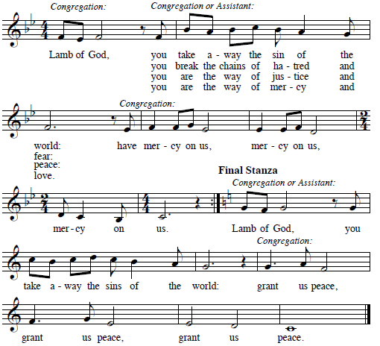

COMMUNION SONG Away in a Manger #277
O Little Town of Bethlehem #279

*PRAYER AFTER COMMUNION
Let us pray together. God our redeemer, you have fed us at this table with gifts of grace, truth, and life. As you have gathered us in joy, send us forth as messengers of your peace. Make us shine with the good news of your glory, born to us in Jesus Christ, our Savior and Lord. Amen.
SENDING__________________________________________
God blesses us and sends us in mission to the world.

*BLESSING

God bless you and keep you, ☩ Jesus grant you grace and truth, and the Spirit send peace upon your hearts, now and forever. Amen.
*SENDING SONG Silent Night, Holy Night #281 (All verses, may repeat)

*DISMISSAL
Christ the Savior is born! Go in peace. Proclaim the good news. Thanks be to God.

POSTLUDE Roger Halvorson

CHRIST LUTHERAN CHURCH STAFF

Interim Pastor Rev. Laurie Arroyo, lauriethere@msn.com
Office Manager Kim Croes, officemanager@christlutheranlb.com
Preschool Director Lisa Clinton, info@clplb.com
Interim Choir Director Kim Philips, kimsings@msn.com
Accompanist Roger Halvorson
Percussionist Nathan Latiolait
Missionary to Colombia Linda Gawthorne

It is our joy to worship with your whole family this morning!

We encourage everyone of all ages and abilities to worship together. If you do need to take a "time out", please do so in the narthex (gathering space at the entry), and return to worship when you are ready. A changing table is located in the restroom off the narthex. Activity bags, filled with crayons, paper and storybooks, are available in the narthex. Please ask an usher if you need any assistance.

Mission Statement
Living by Christ’s example, we welcome, serve, and love all through God’s grace.

Vision Statement
Embracing the truth that God’s love and grace is for all, Christ Lutheran Church is a vibrant and active community spreading the good news through acceptance, action, and benevolence.

Our Position
Christ is ALIVE!

LIKE us on Facebook at www.facebook.com/christlutheranlb

Write a review of Christ Lutheran Church on YELP

