Fourth Sunday of Advent
December 24, 2023
9:30am

Christ Lutheran Church
6500 E. Stearns Street
Long Beach, California 90815
Phone 562-598-2433
www.christlutheranlb.com

Preschool 562-594-6117
www.clclb.com
Welcome to worship! We’re glad you’re here!

To assist in your worship:

bold print means we respond together
* means stand as you are able,
+ you may make the sign of the cross should you so desire.

TODAY’S worship THEME
God keeps the promise made to David to give him an everlasting throne. The angel tells Mary that God will give David’s throne to her son Jesus. She is perplexed by Gabriel’s greeting and by the news of her coming pregnancy, but she is able still to say, “Count me in.” We who know that Jesus is called king only as he is executed still find it a mystery hard to fathom, but with Mary today we hear the news of what God is up to and say, “Count us in.”

Our liturgy is taken from:
Sundays and Seasons.com. Copyright 2023 Augsburg Fortress. All rights reserved.
Reprinted by permission under Augsburg Fortress Liturgies Annual License #20338.
Reprinted by permission under CCLI license # 230154. All rights reserved
Reprinted by permission under © 2023 One License #A-706154. All rights reserved
PRELUDE Roger Halvorson

WELCOME AND ANNOUNCEMENTS

LIGHTING THE ADVENT WREATH

Praise to you, O God, who lives with us, sharing our flesh and bones. As Mary waited and Joseph dreamed, so we wait and dream for you. Bless us and let your face shine upon us, more radiant than these candles, and more dear than all else we seek. Restore us when we fail to refuse the evil and choose the good, and banish all our fears. We pray in the name of Emmanuel, your promised child and our Savior. Amen.

ADVENT CANDLE SONG O Come, O Come, Emmanuel verse 4

O come, O Branch of Jesse, free your own from Satan's tyranny;
from depths of hell your people save, and give them vict'ry o'er the grave.

Refrain
Rejoice! Rejoice! Emmanuel
shall come to you, O Israel.

GATHERING

The Holy Spirit calls us together as the people of God._______________________

All may make the sign of the cross, the sign marked at baptism, as the presiding minister begins.
Blessed be the holy Trinity, ☩ one God, who opens the heavens and draws near to us with salvation. Amen.
God is patient and merciful, desiring all to come to repentance. Trusting this promise of grace, let us confess our sin.

Silence is kept for reflection.

Everlasting God, you love justice, and you hate wrongdoing. We confess the fear, greed, and self-centeredness that make us reluctant to work against oppression.
We are complicit in systems of exploitation. We choose comfort over courage.
We are careless with creation’s bounty. Look upon us with mercy. Turn our hearts again to you. Make us glad to do your will and to walk in your ways for the sake of our waiting world. Amen.

Hear these words of assurance: God clothes you with garments of salvation
and covers you with robes of righteousness. In the tender compassion of ☩ Jesus Christ, your sins are forgiven. God’s covenant is eternal, and God’s blessing rests upon us all. Amen.

*GATHERING SONG Hark! A Thrilling Voice Is Sounding #246
*GREETING
The grace of our Lord Jesus Christ, the love of God, and the communion of the Holy Spirit be with you all. And also with you.

*CANTICLE OF PRAISE Canticle of the Turning

*pRAYER OF THE DAY
Let us pray together. A brief silence. Stir up your power, Lord Christ, and come. With your abundant grace and might, free us from the sin that would obstruct your mercy, that willingly we may bear your redeeming love to all the world, for you live and reign with the Father and the Holy Spirit, one God, now and forever. Amen.
WORD
God speaks to us in scripture reading, preaching, and song.______________________

CHILDREN’S MESSAGE After this time, children will be invited to Sunday school. They will return during the passing of the peace.

SCRIPTURE READING Romans 16:25-27 Pew Bible New Testament Pg. 172

Word of God, Word of Life. Thanks be to God

RESPONSIVE PSALM Psalm 89:1-4,19-26 Pew Bible Old Testament Pg. 634

¹I will sing of your steadfast love, O LORD, forever; with my mouth I will proclaim your faithfulness to all generations.
²I declare that your steadfast love is established forever; your faithfulness is as firm as the heavens.
³You said, "I have made a covenant with my chosen one, I have sworn to my servant David:
⁴'I will establish your descendants forever, and build your throne for all generations.'"
Selah
¹⁹Then you spoke in a vision to your faithful one, and said: "I have set the crown on one who is mighty, I have exalted one chosen from the people.
²⁰I have found my servant David; with my holy oil I have anointed him;
²¹my hand shall always remain with him; my arm also shall strengthen him.
²²The enemy shall not outwit him, the wicked shall not humble him.
²³I will crush his foes before him and strike down those who hate him.
²⁴My faithfulness and steadfast love shall be with him; and in my name his horn shall be exalted.
²⁵I will set his hand on the sea and his right hand on the rivers.
²⁶He shall cry to me, 'You are my Father, my God, and the Rock of my salvation!'

*GOSPEL ACCLAMATION He Came Down ELW 253

*GOSPEL Luke 1:26-38 Pew Bible New Testament Pg. 58

The Holy Gospel according to Luke the 1st chapter. Glory to you, O Lord.
The reading concludes: The Gospel of the Lord. Praise to you, O Christ.

SERMON Pastor Laurie Arroyo

*SERMON SONG Lift Up Your Heads

Verse 1
Lift up your heads O you gates
Swing wide you everlasting doors
Lift up your heads O you gates
Swing wide you everlasting doors

Chorus
That the King of glory may come in
That the King of glory may come in
That the King of glory may come in
That the King of glory may come in

Verse 2
Up from the dead He ascends
Through every rank of heavenly power
Let heaven prepare the highest place
Throw wide the everlasting doors
Chorus

Verse 3
With trumpet blast and shouts of joy
All heaven greets the risen King
With angel choirs come line the way
Throw wide the gates and welcome Him
Chorus

*Nicene CREED
We believe in one God, the Father, the Almighty, maker of heaven and earth, of all that is, seen and unseen.
We believe in one Lord, Jesus Christ, the only Son of God, eternally begotten of the Father, God from God, Light from Light, true God from true God, begotten, not made, of one Being with the Father; through him all things were made. For us and for our salvation he came down from heaven, was incarnate of the Holy Spirit and the virgin Mary and became truly human. For our sake he was crucified under Pontius Pilate; he suffered death and was buried. On the third day he rose again in accordance with the scriptures; he ascended into heaven and is seated at the right hand of the Father. He will come again in glory to judge the living and the dead, and his kingdom will have no end.
We believe in the Holy Spirit, the Lord, the giver of life, who proceeds from the Father and the Son, who with the Father and the Son is worshiped and glorified, who has spoken through the prophets.
We believe in one holy catholic and apostolic church. We acknowledge one baptism for the forgiveness of sins. We look for the resurrection of the dead, and the life of the world to come. Amen.

PRAYERS OF THE CHURCH

With hope and expectation, we offer our prayers for the church, the world, and all who await God’s day of restoration.
A brief silence.
Merciful God, receive our prayer.

Listen to these and all our prayers, O God of hosts, and restore us with your great and everlasting mercy. Amen.

*SHARING OF PEACE

The peace of the Lord be with you always. And also with you.

OFFERTORY

*OFFERTORY RESPONSE Give Thanks

*OFFERTORY PRAYER
Let us pray together: God our provider, by your merciful hand abundance springs up from the earth. Receive and bless these gifts of your own bounty. Let them be a sign of your steadfast love and faithfulness for all people, through Jesus Christ our Savior. Amen.

MEAL___________________________________________

God feeds us with the presence of Jesus.

*THE GREAT THANKSGIVING

The Lord be with you. And also with you.
Lift up your hearts. We lift them to the Lord,
Let us give thanks to the Lord our God. It is right to give our thanks and praise.
It is indeed right, our duty and our joy…
We praise your name and join their unending hymn:

*SONG OF THANKSGIVING

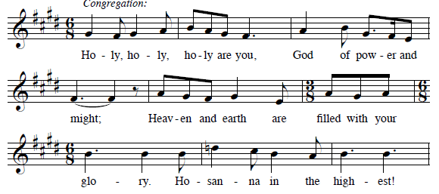

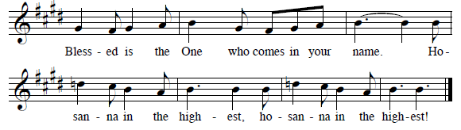

*THANKSGIVING AT THE TABLE

…with this bread and cup, we remember our Lord’s passover from death to life as we proclaim the mystery of faith: Christ has died. Christ is risen. Christ will come again.
…Word made flesh, Power of the Most high, now and forever. Amen.

*LORD’S PRAYER
Our Father in heaven, hallowed be your name, your kingdom come, your will be done, on earth as in heaven. Give us today our daily bread. Forgive us our sins
as we forgive those who sin against us. Save us from the time of trial and deliver us from evil. For the kingdom, the power, and the glory are yours, now and forever. Amen.

DISTRIBUTION OF HOLY COMMUNION
We believe that this is Jesus' table. All are welcome and invited to commune. We serve communion by “intinction”; receive the bread and dip it in the chalice of red wine. Currently we are offering individual communion cups as an alternative to intinction if you so desire. Both wine and grape juice (white) are offered in the tray. Gluten free bread is available; let your server know. Should you choose not to commune, please come forward to receive a blessing. Please cross your arms across your chest.

INVITATION TO COMMUNION
In this meal, righteousness and peace meet together. Come, take your place at the table. Amen.

lamb of god
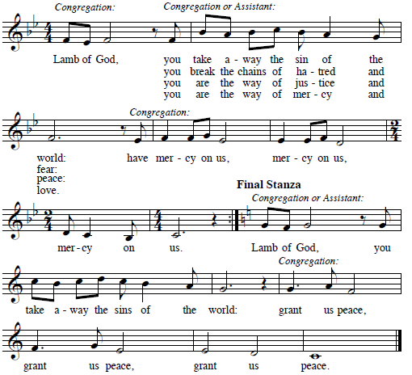

COMMUNION SONGS I Love You, Lord
I love You Lord
And I lift my voice
To worship You
O my soul rejoice
Take joy my King
In what You hear
May it be a sweet, sweet sound
In Your ear
Make Me A Servant
Make me a servant humble and meek
Lord let me lift up those who are weak
And may the prayer of my heart always be
Make me a servant make me a servant
Make me a servant today

*PRAYER AFTER COMMUNION
Let us pray together. Generous God, in this bread and cup you have revealed your glory, for all people to see together. Nourished by this meal, send us out to proclaim your good news of liberation and release, brought to birth in Jesus Christ our Savior. Amen.

SENDING__________________________________________
God blesses us and sends us in mission to the world.

*BLESSING

The God of peace bless you, the love of Christ sustain you in hope, and the anointing of the Spirit ☩ remain upon you now and forever. Amen.

*SENDING SONG Go Tell It on the Mountain #290

*DISMISSAL
Go in peace. Keep awake. Thanks be to God.

POSTLUDE Roger Halvorson

CHRIST LUTHERAN CHURCH STAFF

Interim Pastor Rev. Laurie Arroyo, lauriethere@msn.com
Office Manager Kim Croes, officemanager@christlutheranlb.com
Preschool Director Lisa Clinton, info@clplb.com
Interim Choir Director Kim Philips, kimsings@msn.com
Accompanist Roger Halvorson
Percussionist Nathan Latiolait
Missionary to Colombia Linda Gawthorne

It is our joy to worship with your whole family this morning!

We encourage everyone of all ages and abilities to worship together. If you do need to take a "time out", please do so in the narthex (gathering space at the entry), and return to worship when you are ready. A changing table is located in the restroom off the narthex. Activity bags, filled with crayons, paper and storybooks, are available in the narthex. Please ask an usher if you need any assistance.

Mission Statement
Living by Christ’s example, we welcome, serve, and love all through God’s grace.

Vision Statement
Embracing the truth that God’s love and grace is for all, Christ Lutheran Church is a vibrant and active community spreading the good news through acceptance, action, and benevolence.

Our Position
Christ is ALIVE!

LIKE us on Facebook at www.facebook.com/christlutheranlb

Write a review of Christ Lutheran Church on YELP

