Seventh Sunday After Pentecost
July 16, 2023
9:30am

Christ Lutheran Church
6500 E. Stearns Street
Long Beach, California 90815
Phone 562-598-2433
www.christlutheranlb.com

Preschool 562-594-6117
www.clclb.com

Welcome to worship! We’re glad you’re here!

To assist in your worship:

bold print means we respond together
* means stand as you are able,
+ you may make the sign of the cross should you so desire.

TODAY’S worship THEME

God’s word is like the rain that waters the earth and brings forth vegetation. It is also like the sower who scatters seed indiscriminately. Our lives are like seeds sown in the earth. Even from what appears to be little, dormant, or dead, God promises a harvest. At the Lord’s table we are fed with the bread of life, that we may bear fruit in the world.

Our liturgy is taken from:
Sundays and Seasons.com. Copyright 2023 Augsburg Fortress. All rights reserved.
Reprinted by permission under Augsburg Fortress Liturgies Annual License #20338.
Reprinted by permission under CCLI license # 230154. All rights reserved
Reprinted by permission under © 2023 One License #A-706154. All rights reserved
PRELUDE

WELCOME AND ANNOUNCEMENTS

GATHERING
The Holy Spirit calls us together as the people of God._______________________

*CONFESSION AND FORGIVENESS
All may make the sign of the cross, the sign marked at baptism, as the presiding minister begins.
Blessed be the holy Trinity, ☩ one God, who greets us in this and every season,
whose word never fails, whose promise is sure. Amen.

Let us confess our sin in the presence of God and of our neighbors.

Merciful God, we confess that we have sinned. We have hurt our community.
We have squandered your blessings. We have hoarded your bounty. In the name of Jesus, forgive us and grant us your mercy.

Silence is kept for reflection.

Righteous God, we confess that we have sinned. We have failed to be
honest. We have lacked courage to speak. We have spoken falsely. In the name of Jesus, forgive us and grant us your mercy.

Silence is kept for reflection.

God is a cup of cold water when we thirst. God offers boundless grace when we fail. Claim the gift of God’s mercy: you are freed and forgiven in the name of + Jesus Christ. Amen.

*GREETING
The grace of our Lord Jesus Christ, the love of God, and the communion of the Holy Spirit be with you all. And also with you.
*HYMN OF PRAISE Lord, I Lift Your Name On High #857
*pRAYER OF THE DAY
Let us pray together. A brief silence. Almighty God, we thank you for planting in us the seed of your word. By your Holy Spirit help us to receive it with joy, live according to it, and grow in faith and hope and love, through Jesus Christ, our Savior and Lord. Amen.

WORD
God speaks to us in scripture reading, preaching, and song.______________________

CHILDREN’S MESSAGE Pastor Deborah Andersen

SCRIPTURE READING Romans 8:1-11 Pew Bible New Testament Pg.164
Word of God, Word of Life. Thanks be to God.

RESPONSIVE PSALM Psalm 65:1-13 Pew Bible Old Testament Pg. 583

Praise is due to you, O God, in Zion; and to you shall vows be performed,
²O you who answer prayer! To you all flesh shall come.
³When deeds of iniquity overwhelm us, you forgive our transgressions.
⁴Happy are those whom you choose and bring near to live in your courts. We shall be satisfied with the goodness of your house, your holy temple.
⁵By awesome deeds you answer us with deliverance, O God of our salvation;
you are the hope of all the ends of the earth and of the farthest seas.
⁶By your strength you established the mountains; you are girded with might.
⁷You silence the roaring of the seas, the roaring of their waves, the tumult of the peoples.
⁸Those who live at earth's farthest bounds are awed by your signs; you make the gateways of the morning and the evening shout for joy.
⁹You visit the earth and water it, you greatly enrich it; the river of God is full of water;
you provide the people with grain, for so you have prepared it.
¹⁰You water its furrows abundantly, settling its ridges, softening it with showers,
and blessing its growth.
¹¹You crown the year with your bounty; your wagon tracks overflow with richness.
¹²The pastures of the wilderness overflow, the hills gird themselves with joy,
¹³the meadows clothe themselves with flocks, the valleys deck themselves with grain,
they shout and sing together for joy

*GOSPEL ACCLAMATION

Alleluia. The word is very near to you;
it is in your mouth and in your heart. Alleluia.

*GOSPEL Matthew 13:1-9, 18-23 Pew Bible New Testament Pg. 14

The Holy Gospel according to Matthew the 13th chapter. Glory to you, O Lord.
The reading concludes: The Gospel of the Lord. Praise to you, O Christ.

SERMON Rev. Deborah Andersen

*SERMON SONG Oh, Sing to the Lord #822

*APOSTLES’ CREED

I believe in God, the Father almighty, creator of heaven and earth.

I believe in Jesus Christ, God’s only Son, our Lord, who was conceived by the Holy Spirit, born of the virgin Mary, suffered under Pontius Pilate, was crucified, died, and was buried; he descended to the dead. On the third day he rose again; he ascended into heaven, he is seated at the right hand of the Father, and he will come to judge the living and the dead.

I believe in the Holy Spirit, the holy catholic church, the communion of saints, the forgiveness of sins, the resurrection of the body, and the life everlasting. Amen.

PRAYERS OF THE CHURCH

Confident that God receives our joys and concerns, let us offer our prayers for the church, those in need, and all of creation.
A brief silence.
Hear us, O God,
Your mercy is great.

Into your hands, O God, we commend all for whom we pray, in the name of the one who reconciled all creation to himself, Jesus Christ our Savior. Amen.

*SHARING OF PEACE

The peace of the Lord be with you always. And also with you.

OFFERTORY

*OFFERTORY PRAYER

Let us pray together. God of field and forest, sea and sky, You are the giver of all good things. Sustain us with these gifts of your creation, And multiply your graciousness in us, That the world may be fed with your love, through Jesus Christ, our Savior and Lord. Amen.

MEAL
God feeds us with the presence of Jesus.

*THE GREAT THANKSGIVING

The Lord be with you. And also with you.
Lift up your hearts. We lift them to the Lord,
Let us give thanks to the Lord our God. It is right to give our thanks and praise.
It is indeed right, our duty and our joy…
We praise your name and join their unending hymn:

*WORDS OF THANKSGIVING

Holy, holy, holy are You, God of power and might.
Heaven and earth are filled with your glory, Hosanna in the highest!
Blessed is the One who comes in your name, Hosanna in the highest!

*THANKSGIVING AT THE TABLE

With this bread and cup, we remember our Lord’s passover from death to life as we proclaim the mystery of faith: Christ has died. Christ is risen. Christ will come again.
We pray for the gift of your Spirit…in your church, without end. Amen.

*LORD’S PRAYER
Our Father in heaven, hallowed be your name, your kingdom come, your will be done, on earth as in heaven. Give us today our daily bread. Forgive us our sins
as we forgive those who sin against us. Save us from the time of trial and deliver us from evil. For the kingdom, the power, and the glory are yours, now and forever. Amen.

DISTRIBUTION OF HOLY COMMUNION
We believe that this is Jesus' table. All are welcome and invited to commune. We serve communion by “intinction”; receive the bread and dip it in the chalice of red wine. Currently we are offering individual communion cups as an alternative to intinction if you so desire. Both wine and grape juice (white) are offered in the tray. Gluten free bread is available; let your server know. Should you choose not to commune, please come forward to receive a blessing. Please cross your arms across your chest.

COMMUNION SONG Jesu, Jesu, Fill us with your Love #708

*PRAYER AFTER COMMUNION

Let us pray together. We thank you, generous God, for the refreshment we have received at your banquet table. Send us now to spread your generosity into all the world, through the one who is our dearest treasure, Jesus Christ, our Savior, and Lord. Amen.

SENDING
God blesses us and sends us in mission to the world.

*BLESSING

The God who faithfully calls across the cosmos and speaks in the smallest seed ☩ bless, keep, and sustain you, now and to the end of the age. Amen.

*SENDING HYMN Pass It On
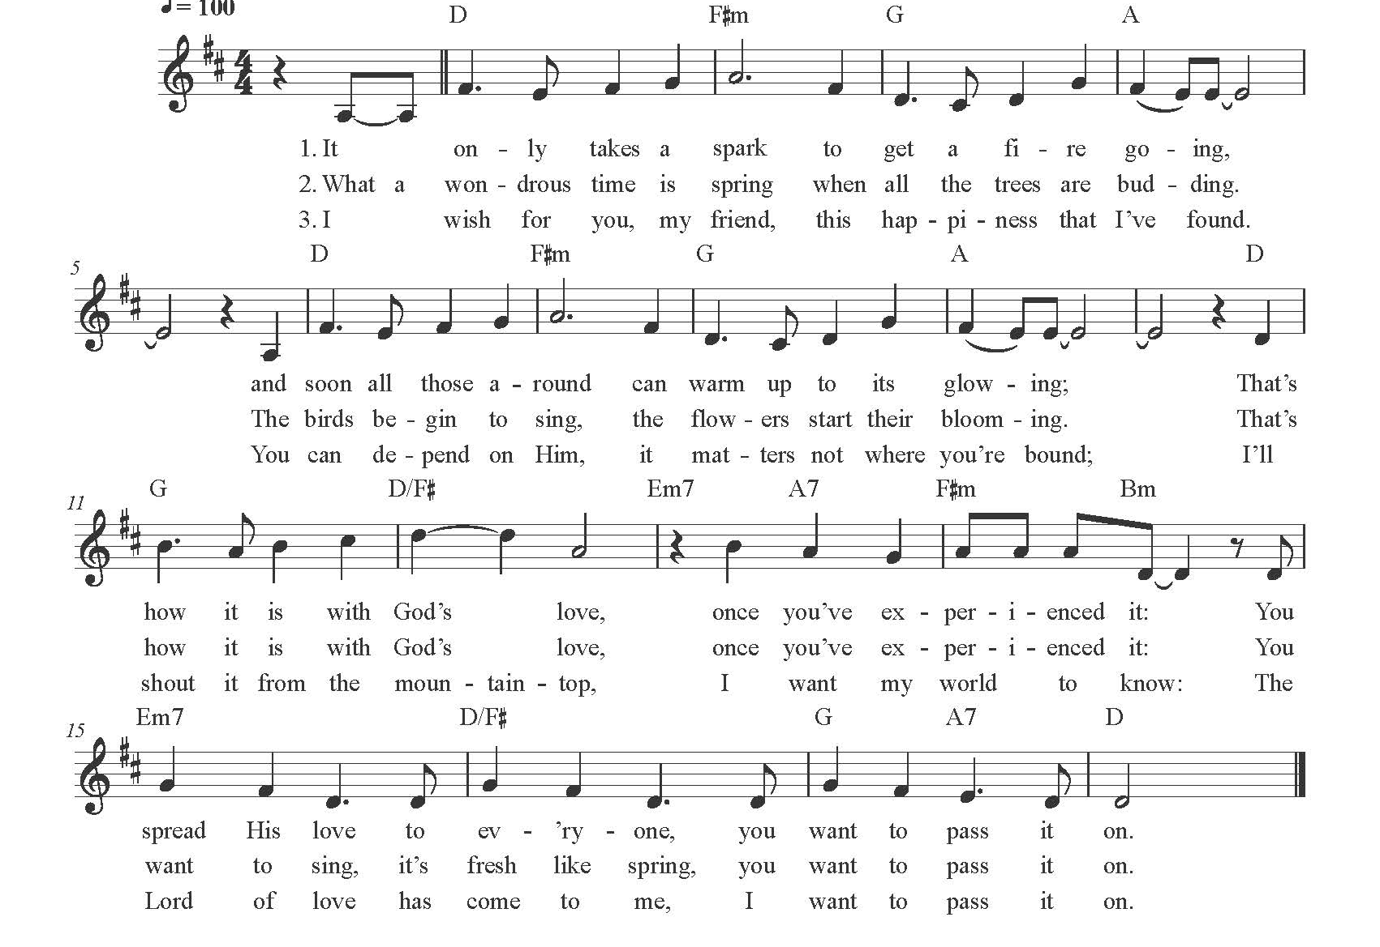
*Dismissal

Go in peace. Share the harvest. Thanks be to God.

POSTLUDE

CHRIST LUTHERAN CHURCH STAFF

Interim Pastor Rev. Laurie Arroyo, lauriethere@msn.com
Office Manager Kim Croes, officemanager@christlutheranlb.com
Preschool Director Lisa Clinton, info@clplb.com
Interim Choir Director Kim Philips, kimsings@msn.com
Accompanist Roger Halvorson
Percussionist Nathan Latiolait
Missionary to Colombia Linda Gawthorne

It is our joy to worship with your whole family this morning!

We encourage everyone of all ages and abilities to worship together. If you do need to take a "time out", please do so in the narthex (gathering space at the entry), and return to worship when you are ready. A changing table is located in the restroom off the narthex. Activity bags, filled with crayons, paper and storybooks, are available in the narthex. Please ask an usher if you need any assistance.

Mission Statement
Living by Christ’s example, we welcome, serve, and love all through God’s grace.

Vision Statement
Embracing the truth that God’s love and grace is for all, Christ Lutheran Church is a vibrant and active community spreading the good news through acceptance, action, and benevolence.

Our Position
Christ is ALIVE!

LIKE us on Facebook at www.facebook.com/christlutheranlb

Write a review of Christ Lutheran Church on YELP

