Ascension of our Lord
May 21, 2023
9:30am

Christ Lutheran Church
6500 E. Stearns Street
Long Beach, California 90815
Phone 562-598-2433
www.christlutheranlb.com

Preschool 562-594-6117
www.clclb.com

Welcome to worship! We’re glad you’re here!

To assist in your worship:

bold print means we respond together
* means stand as you are able,
+ you may make the sign of the cross should you so desire.

TODAY’S worship THEME
In today’s readings the risen Christ ascends into heaven and his followers are assured that the Spirit will empower them to be witnesses throughout the earth. The disciples were told to not gaze up into heaven to look for Jesus (Acts 1:11); we find his presence among us as we proclaim the word and share the Easter feast. We too, long for the Spirit to enliven our faith and invigorate our mission.

Our liturgy is taken from:
Sundays and Seasons.com. Copyright 2023 Augsburg Fortress. All rights reserved.
Reprinted by permission under Augsburg Fortress Liturgies Annual License #20338.
Reprinted by permission under CCLI license # 230154. All rights reserved
Reprinted by permission under © 2023 One License #A-706154. All rights reserved

PRELUDE Roger Halvorson

WELCOME AND ANNOUNCEMENTS

GATHERING
The Holy Spirit calls us together as the people of God._______________________

GATHERING SONG Lord, I Lift Your Name on High #857
GREETING
The grace of our Lord Jesus Christ, the love of God, and the communion of the Holy Spirit be with you all. And also with you.
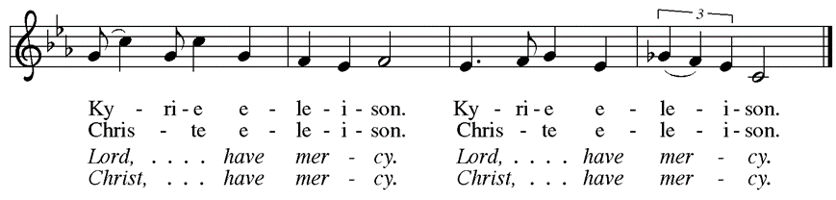
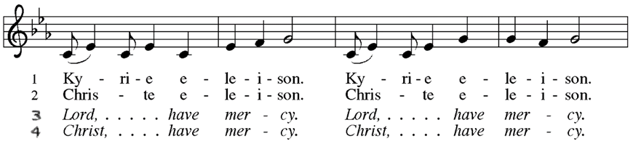
KYRIE

pRAYER OF THE DAY
Let us pray together. A brief silence. Almighty God, your only Son was taken into the heavens and in your presence intercedes for us. Receive us and our prayers for all the world, and in the end bring everything into your glory, through Jesus Christ, our Sovereign and Lord, who lives and reigns with you and the Holy Spirit, one God, now and forever. Amen.
WORD
God speaks to us in scripture reading, preaching, and song.______________________

At this time, children will be invited to Sunday school. They will return during the passing of the peace.

CHOIR ANTHEM How Great Is Our God Chancel Choir

SCRIPTURE READING Acts 1:1-11 Pew Bible New Testament Pg. 122
Word of God, Word of Life. Thanks be to God.

RESPONSIVE PSALM Psalm 47 Pew Bible Old Testament Pg. 572
Clap your hands, all you peoples; shout to God with loud songs of joy.
²For the LORD, the Most High, is awesome, a great king over all the earth.
³He subdued peoples under us, and nations under our feet.
⁴He chose our heritage for us, the pride of Jacob whom he loves.
Selah
⁵God has gone up with a shout, the LORD with the sound of a trumpet.
⁶Sing praises to God, sing praises; sing praises to our King, sing praises.
⁷For God is the king of all the earth; sing praises with a psalm.
⁸God is king over the nations; God sits on his holy throne.
⁹The princes of the peoples gather as the people of the God of Abraham. For the shields of the earth belong to God; he is highly exalted.

*GOSPEL ACCLAMATION

*GOSPEL Luke 24:44-53 Pew Bible New Testament Pg. 93

The Holy Gospel according to Luke the 24th chapter. Glory to you, O Lord.
The reading concludes: The Gospel of the Lord. Praise to you, O Christ.

HOMILY D’Jesus Trujillo
*SERMON SONG “How Can I Be Free From Sin?
How can I be free from sin? Lead me to the cross of Jesus.
from the guilt, the pow'r, the pain, lead me to the cross of Jesus.

There's no other way, no price that I could pay, Simply to the cross I cling.
This is all I need, this is all I plead, that His blood was shed for me.

How can I know peace within? Lead me to the cross of Jesus;
Sing a song of joy again, lead me to the cross of Jesus.

Flowing from above, all forgiving love, from the Maker's heart to me.
What a gift of grace, God's own righteousness, clothing me in purity.

How can I live day by day? Lead me to the cross of Jesus.
Following His narrow way, lead me to the cross of Jesus.
*NICENE CREED
We believe in one God, the Father, the Almighty, maker of heaven and earth, of all that is, seen and unseen.

We believe in one Lord, Jesus Christ, the only Son of God, eternally begotten of the Father, God from God, Light from Light, true God from true God, begotten, not made, of one Being with the Father; through him all things were made. For us and for our salvation he came down from heaven, was incarnate of the Holy Spirit and the virgin Mary and became truly human. For our sake he was crucified under Pontius Pilate; he suffered death and was buried. On the third day he rose again in accordance with the scriptures; he ascended into heaven and is seated at the right hand of the Father. He will come again in glory to judge the living and the dead, and his kingdom will have no end.

We believe in the Holy Spirit, the Lord, the giver of life, who proceeds from the Father and the Son, who with the Father and the Son is worshiped and glorified,
who has spoken through the prophets. We believe in one holy catholic and apostolic church. We acknowledge one baptism for the forgiveness of sins. We look for the resurrection of the dead, and the life of the world to come. Amen.

PRAYERS OF THE CHURCH

United in the hope and joy of the resurrection, let us pray for the church, the world, and all in need.

…Hear us O God,
Your mercy is great.

Rejoicing in the victory of Christ’s resurrection, we lift our prayers and praise to you, almighty and eternal God; through Jesus Christ, our risen Lord. Amen.

*SHARING OF PEACE

The peace of the Lord be with you always. And also with you.

OFFERTORY Roger Halvorson and Brad Croes

*OFFERTORY RESPONSE Take My Life, That I May Be #583

*OFFERTORY PRAYER

Let us pray together, Generous God, in this meal you offer your very self. We give thanks for these gifts of the earth. In the breaking of this bread reveal to us the Risen One. In the pouring of this wine pour us out in service to the world; through Christ our Lord. Amen.

*LORD’S PRAYER

Our Father in heaven, hallowed be your name, your kingdom come, your will be done, on earth as in heaven. Give us today our daily bread. Forgive us our sins
as we forgive those who sin against us. Save us from the time of trial and deliver us from evil. For the kingdom, the power, and the glory are yours, now and forever. Amen.

SENDING
God blesses us and sends us in mission to the world.

*BLESSING

The God of all, who raised ☩ Jesus from the dead, bless you by the power of the Holy Spirit to live in the new creation. Amen.
*SENDING HYMN Lead Me, Guide Me #768
*Dismissal

Go in peace. Serve the Risen One. Thanks be to God.

POSTLUDE Roger Halvorson

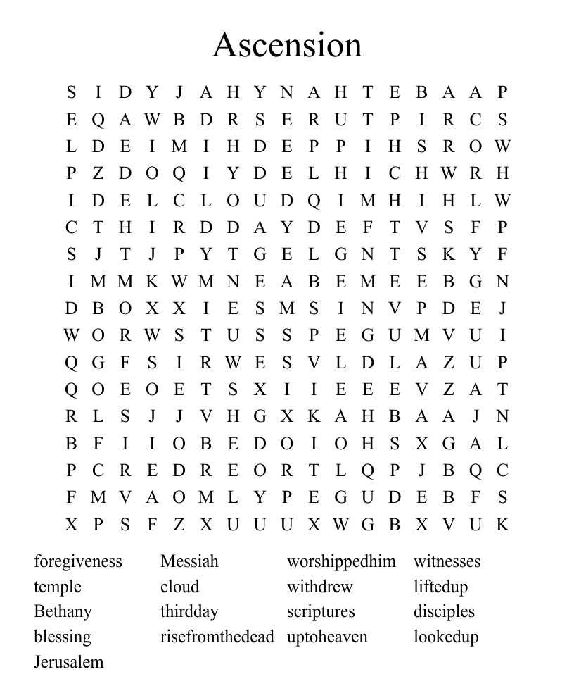
Find the differences. Matthew 20:1-16

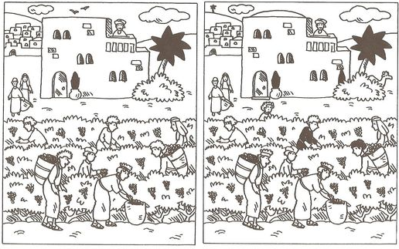

CHRIST LUTHERAN CHURCH STAFF

Interim Pastor Rev. Laurie Arroyo, lauriethere@msn.com
Office Manager Kim Croes, officemanager@christlutheranlb.com
Preschool Director Lisa Clinton, info@clplb.com
Interim Choir Director Kim Philips, kimsings@msn.com
Accompanist Roger Halvorson
Percussionist Nathan Latiolait
Missionary to Colombia Linda Gawthorne

It is our joy to worship with your whole family this morning!

CHILDCARE

We encourage everyone of all ages and abilities to worship together. If you do need to take a "time out", please do so in the narthex (gathering space at the entry), and return to worship when you are ready. A changing table is located in the restroom off the narthex. Activity bags, filled with crayons, paper and storybooks, are available in the narthex. Please ask an usher if you need any assistance.

OUR MISSION STATEMENT

Christ Is Alive!

OUR VISION STATEMENT

Christ Lutheran Church is a community of believers committed to praising our Savior Jesus Christ. With his love, we reach out to those in need and welcome all with open hearts. Our worship dynamically combines, word, song and prayer to share God’s incredible message. Having faith in this, we go forth knowing that with God and the power of the Holy Spirit, anything is possible.

LIKE us on Facebook at www.facebook.com/christlutheranlb

Write a review of Christ Lutheran Church on YELP

