**Sixth Sunday of Easter**

**May 14, 2023**

**9:30am**



**Christ Lutheran Church**

6500 E. Stearns Street

Long Beach, California 90815

Phone 562-598-2433

www.christlutheranlb.com

Preschool 562-594-6117

[www.clclb.com](http://www.clclb.com)

**Welcome to worship! We’re glad you’re here!**

To assist in your worship:

**bold** print means we respond together

**\*** meansstand as you are able,

+ you may make the sign of the cross should you so desire.

**TODAY’S worship THEME**

Jesus does not abandon his followers. Through the Holy Spirit, Jesus comes to abide with his disciples of every generation. As Pentecost draws near, we are reminded that the risen Christ dwells in us as the Spirit of truth. We receive this Spirit in baptism and pray that in our gathering around the Lord’s table the Spirit will transform us to be the body of the risen Christ in the world.



Our liturgy is taken from:

Sundays and Seasons.com. Copyright 2023 Augsburg Fortress. All rights reserved.

Reprinted by permission under Augsburg Fortress Liturgies Annual License #20338.

Reprinted by permission under CCLI license # 230154. All rights reserved

Reprinted by permission under © 2023 One License #A-706154. All rights reserved

**PRELUDE** Claudia Fitzpatrick & Maggie Fitzpatrick

**WELCOME AND ANNOUNCEMENTS**

**GATHERING**

*The Holy Spirit calls us together as the people of God._______________________*

**GATHERING SONG** *Good Soil*

Lord, let my heart be good soil,

Open to the seed of your word.

Lord, let my heart be good soil,

Where love can grow, and peace is understood.

When my heart is hard, break the stone away.

When my heart is cold, warm it with the day.

When my heart is lost, lead me on your way.

Lord, let my heart, Lord let my heart,

Lord, let my heart be good soil.

(Repeat)

**GREETING**

The grace of our Lord Jesus Christ, the love of God,and the communion of the Holy Spirit be with you all. **And also with you.**

**KYRIE**

**pRAYER OF THE DAY**

Let us pray together. *A brief silence***. Almighty and ever-living God, you hold together all things in heaven and on earth. In your great mercy receive the prayers of all your children, and give to all the world the Spirit of your truth and peace, through Jesus Christ, our Savior and Lord, who lives and reigns with you and the Holy Spirit, one God, now and forever. Amen.**

**WORD**

*God speaks to us in scripture reading, preaching, and song.______________________*

**CHILDREN’S MESSAGE** *After this time, children will be invited to Sunday school. They will return during the passing of the peace.*

**SCRIPTURE READING** Acts 17:22-31 PewBible New Testament Pg. 143

Word of God, Word of Life. **Thanks be to God.**

**RESPONSIVE PSALM** Psalm 66:8-20 PewBible Old Testament Pg. 584

 Bless our God, O peoples, let the sound of his praise be heard,  
**9who has kept us among the living, and has not let our feet slip.** 10For you, O God, have tested us; you have tried us as silver is tried.  
 **11You brought us into the net; you laid burdens on our backs;** 12you let people ride over our heads; we went through fire and through water; yet you have brought us out to a spacious place.  
**13I will come into your house with burnt offerings; I will pay you my vows,** 14those that my lips uttered and my mouth promised when I was in trouble.  
 **15I will offer to you burnt offerings of fatlings, with the smoke of the sacrifice of rams; I will make an offering of bulls and goats.**Selah  
 16Come and hear, all you who fear God, and I will tell what he has done for me.  
**17I cried aloud to him, and he was extolled with my tongue.** 18If I had cherished iniquity in my heart, the LORD would not have listened.  
**19But truly God has listened; he has given heed to the words of my prayer.** 20Blessed be God, because he has not rejected my prayer or removed his steadfast love from me.

\***GOSPEL ACCLAMATION**

**\*GOSPEL**  [John 14:15-21](https://members.sundaysandseasons.com/Home/TextsAndResources/2023-5-14/2410) Pew Bible New Testament Pg. 113

The Holy Gospel according to John the 14th chapter. **Glory to you, O Lord.**

The reading concludes: The Gospel of the Lord. **Praise to you, O Christ.**

**SERMON** Pastor Laurie Arroyo

**\*SERMON SONG** *Bind Us Together*

Refrain: Bind us together, Lord, bind us together with cords that cannot be broken.  
              Bind us together, Lord, bind us together, Lord, bind us together in love.

There is only one God, there is only one King,  
There is only one Body, that is why we sing: (Refrain)

Though there are many branches, there is only one vine,  
We are one in Christ Jesus, that is why we sing: (Refrain)

One with Christ in his death that, as one, we might rise.  
So we are but one people, that is why we sing: (Refrain)

There is only one table, Christ alone is our host.  
He invites us together, that is why we sing: (Refrain)

**\*NICENE CREED**

**We believe in one God, the Father, the Almighty, maker of heaven and earth, of all that is, seen and unseen.**

**We believe in one Lord, Jesus Christ, the only Son of God, eternally begotten of the Father, God from God, Light from Light, true God from true God, begotten, not made, of one Being with the Father; through him all things were made. For us and for our salvation he came down from heaven, was incarnate of the Holy Spirit and the virgin Mary and became truly human. For our sake he was crucified under Pontius Pilate; he suffered death and was buried. On the third day he rose again in accordance with the scriptures; he ascended into heaven and is seated at the right hand of the Father. He will come again in glory to judge the living and the dead, and his kingdom will have no end.**

**We believe in the Holy Spirit, the Lord, the giver of life, who proceeds from the Father and the Son, who with the Father and the Son is worshiped and glorified,**

**who has spoken through the prophets. We believe in one holy catholic and apostolic church. We acknowledge one baptism for the forgiveness of sins. We look for the resurrection of the dead, and the life of the world to come. Amen.**

**PRAYERS OF THE CHURCH**

United in the hope and joy of the resurrection, let us pray for the church, the world, and all in need.

…Hear us O God,

**Your mercy is great.**

Rejoicing in the victory of Christ’s resurrection, we lift our prayers and praise to you, almighty and eternal God; through Jesus Christ, our risen Lord. **Amen.**

**\*SHARING OF PEACE**

The peace of the Lord be with you always. **And also with you.**

**OFFERTORY**

**\*OFFERTORY RESPONSE** *Take My Life, That I May Be* #583

**\*OFFERTORY PRAYER**

Let us pray together**, Generous God, in this meal you offer your very self. We give thanks for these gifts of the earth. In the breaking of this bread reveal to us the Risen One. In the pouring of this wine pour us out in service to the world; through Christ our Lord. Amen.**

**MEAL**

*God feeds us with the presence of Jesus.*

**\*THE GREAT THANKSGIVING**

The Lord be with you. **And also with you.**

Lift up your hearts. **We lift them to the Lord,**

Let us give thanks to the Lord our God. **It is right to give our thanks and praise.**

It is indeed right, our duty and our joy…

we praise your name and join their unending hymn:

**\*SONG OF THANKSGIVING**

**

**\*THANKSGIVING AT THE TABLE**

Holy God, holy and mighty, holy and immortal: you we praise and glorify, you we worship and adore…

…With this bread and cup we remember our Lord’s passover from death to life as we proclaim the mystery of faith: **Christ has died. Christ is risen. Christ will come again.**

…with the whole world made perfect through your wisdom, all our sins and sorrows will be no more. **Amen. Come, Lord Jesus.**

…Nurture in us the fruits of the Spirit, that we may be a living tree, sharing your bounty with all the world. **Amen. Come, Holy Spirit.**

…through whom all glory and honor is yours, O God, O Living One, with the Holy Spirit, in your holy church, now and forever. **Amen.**

**\*LORD’S PRAYER**

**Our Father in heaven, hallowed be your name, your kingdom come, your will be done, on earth as in heaven. Give us today our daily bread. Forgive us our sins**

**as we forgive those who sin against us. Save us from the time of trial and deliver us from evil. For the kingdom, the power, and the glory are yours, now and forever.** **Amen.**

**DISTRIBUTION OF HOLY COMMUNION**

We believe that this is Jesus' table. All are welcome and invited to commune.  We serve communion by “intinction”; receive the bread and dip it in the chalice of red wine. Currently we are offering individual communion cups as an alternative to intinction if you so desire. Both wine and grape juice (white) are offered in the tray. Gluten free bread is available; let your server know. Should you choose not to commune, please come forward to receive a blessing. Please cross your arms across your chest.





**lamb of god**

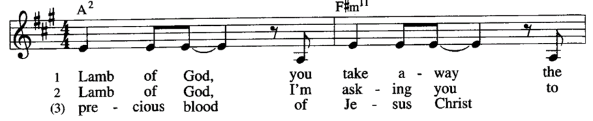

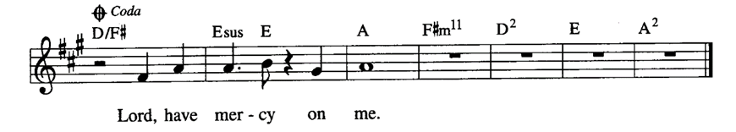

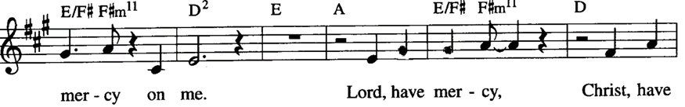

**COMMUNION SONG** Claudia Fitzpatrick & Maggie Fitzpatrick

**\*PRAYER AFTER COMMUNION**

Let us pray together.  **Gracious God, in you we live and move and have our being. With your word and this meal of grace, you have nourished our life together. Strengthen us to show your love and serve the world in Jesus’ name. Amen.**

**SENDING**

*God blesses us and sends us in mission to the world.*

**\*BLESSING**

The God of all, who raised ☩ Jesus from the dead, bless you by the power of the Holy Spirit to live in the new creation. **Amen.**

**\*SENDING HYMN** *On Our Way Rejoicing #537*

**\*Dismissal**

Go in peace. Serve the Risen One. **Thanks be to God.**

**POSTLUDE** Claudia Fitzpatrick & Maggie Fitzpatrick

**CHRIST LUTHERAN CHURCH STAFF**

**Interim Pastor**  Rev. Laurie Arroyo, lauriethere@msn.com

**Office Manager** Kim Croes, [officemanager@christlutheranlb.com](mailto:officemanager@christlutheranlb.com)

**Preschool Director** Lisa Clinton, info@clplb.com

**Interim Choir Director** Kim Philips, kimsings@msn.com

**Accompanist** Roger Halvorson

**Percussionist** Nathan Latiolait

**Missionary to Colombia** Linda Gawthorne

**It is our joy to worship with your whole family this morning!**

**CHILDCARE**

We encourage everyone of all ages and abilities to worship together. If you do need to take a "time out", please do so in the narthex (gathering space at the entry), and return to worship when you are ready. A changing table is located in the restroom off the narthex. Activity bags, filled with crayons, paper and storybooks, are available in the narthex. Please ask an usher if you need any assistance.

**OUR MISSION STATEMENT**

*Christ Is Alive!*

**OUR VISION STATEMENT**

*Christ Lutheran Church is a community of believers committed to praising our Savior Jesus Christ. With his love, we reach out to those in need and welcome all with open hearts. Our worship dynamically combines, word, song and prayer to share God’s incredible message. Having faith in this, we go forth knowing that with God and the power of the Holy Spirit, anything is possible.*

**LIKE** us on **Facebook** at [www.facebook.com/christlutheranlb](http://www.facebook.com/christlutheranlb)

Write a review of Christ Lutheran Church on **YELP**