Resurrection of Our Lord
April 9, 2023
9:30am

Christ Lutheran Church
6500 E. Stearns Street
Long Beach, California 90815
Phone 562-598-2433
www.christlutheranlb.com

Preschool 562-594-6117
www.clclb.com

Welcome to worship! We’re glad you’re here!

To assist in your worship:

bold print means we respond together
* means stand as you are able,
+ you may make the sign of the cross should you so desire.

TODAY’S worship THEME

This is the day the Lord has made! Christ is risen, and through him all creation is made new! Indeed, “God shows no partiality” (Acts 10:34): Christ’s resurrection truly brings life to everyone. We sing hymns of praise, gather around sacred words, and proclaim God’s faithfulness, power, and love in the feast of holy communion. With the women at the tomb, we are astonished, elated, and grateful. We depart with joy to proclaim the good news of God’s endless love.

Our liturgy is taken from:
Sundays and Seasons.com. Copyright 2023 Augsburg Fortress. All rights reserved.
Reprinted by permission under Augsburg Fortress Liturgies Annual License #20338.
Reprinted by permission under CCLI license # 230154. All rights reserved
Reprinted by permission under © 2023 One License #A-706154. All rights reserved

PRELUDE Sunflower Trio

CALL TO WORSHIP Thine Is the Glory #376

WELCOME AND ANNOUNCEMENTS

GATHERING
The Holy Spirit calls us together as the people of God.

CHILDREN’S MESSAGE Releasing of the Alleluias
*GATHERING SONG Agnus Dei Chancel Choir
HOLY BAPTISM
God, who is rich in mercy and love, gives us a new birth into a living hope through the sacrament of baptism. By water and the Word God delivers us from sin and death and raises us to new life in Jesus Christ. We are united with all the baptized in the one body of Christ, anointed with the gift of the Holy Spirit, and joined in God's mission for the life of the world….
People of God, do you promise to support Annie & Donald and pray for them in their new life in Christ?
Response: We do.
*I ask you to profess your faith in Christ Jesus, reject sin, and confess the faith of the church. Do you renounce the devil and all the forces that defy God, the powers of this world that rebel against God, and the ways of sin that draw you from God?
Response: I renounce them.
Do you believe in God the Father?
I believe in God, the Father almighty, creator of heaven and earth.
Do you believe in Jesus Christ, the Son of God?
I believe in Jesus Christ, God’s only Son, our Lord, who was conceived by the Holy Spirit, born of the virgin Mary, suffered under Pontius Pilate, was crucified, died, and was buried; he descended to the dead. On the third day he rose again; he ascended into heaven, he is seated at the right hand of the Father, and he will come to judge the living and the dead.

Do you believe in God the Holy Spirit?
I believe in the Holy Spirit, the holy catholic church, the communion of saints, the forgiveness of sins, the resurrection of the body, and the life everlasting.

*THANKSGIVING AT THE FONT
The Lord be with you. And also with you.
Let us give thanks to the Lord our God. It is right to give our thanks and praise.
We give you thanks, O God, …
…To you be given honor and praise through Jesus Christ our Lord, in the unity of the Holy Spirit, now and forever. Amen.
BAPTISM
You belong to Christ, in whom you have been baptized. Alleluia!
WELCOME
Let us welcome the newly baptized Annie & Donald.
We welcome you into the body of Christ and into the mission we share: join us in giving thanks and praise to God and bearing God's creative and redeeming word to all the world.
Those who have gathered at the font may return to their places.

EASTER HYMN Jesus Christ Is Risen Today #365
vs 1,3,5
*GREETING
The grace of our Lord Jesus Christ, the love of God, and the communion of the Holy Spirit be with you all. And also with you.
*PRAYER OF THE DAY
Let us pray. A brief silence. God of mercy, we no longer look for Jesus among the dead, for he is alive and has become the Lord of life! Increase in our minds and hearts the risen life we share with Christ, and help us to grow as your people toward the fullness of eternal life with you, through Jesus Christ, our Savior and Lord, who lives and reigns with you and the Holy Spirit, one God, now and forever. Amen.
WORD
God speaks to us in scripture reading, preaching, and song.______________________

SCRIPTURE READING Acts 10:34-43 Pew Bible New Testament Pg.134

Word of God, Word of Life. Thanks be to God.

RESPONSIVE PSALM Psalm 118:1-2, 14-24 Pew Bible Old Testament Pg. 623

O give thanks to the LORD, for he is good; his steadfast love endures forever!
²Let Israel say, "His steadfast love endures forever."
¹⁴The LORD is my strength and my might; he has become my salvation.
¹⁵There are glad songs of victory in the tents of the righteous: "The right hand of the LORD does valiantly;
¹⁶the right hand of the LORD is exalted; the right hand of the LORD does valiantly."
¹⁷I shall not die, but I shall live, and recount the deeds of the LORD.
¹⁸The LORD has punished me severely, but he did not give me over to death.
¹⁹Open to me the gates of righteousness, that I may enter through them
and give thanks to the LORD.
²⁰This is the gate of the LORD; the righteous shall enter through it.
²¹I thank you that you have answered me and have become my salvation.
²²The stone that the builders rejected has become the chief cornerstone.
²³This is the LORD's doing; it is marvelous in our eyes.
²⁴This is the day that the LORD has made; let us rejoice and be glad in it.

*GOSPEL ACCLAMATION

*GOSPEL John 20:1-18 Pew Bible New Testament Pg. 119

The Holy Gospel according to John the 20th chapter. Glory to you, O Lord.
The reading concludes: The Gospel of the Lord. Praise to you, O Christ.

SERMON Pastor Laurie Arroyo
CHOIR ANTHEM Risen Indeed Chancel Choir

PRAYERS OF THE CHURCH

United in the hope and joy of the resurrection, let us pray for the church, the world, and all in need.

Risen Lord, in your mercy,
hear our prayer

Rejoicing in the victory of Christ’s resurrection, we lift our prayers and praise to you, almighty and eternal God; through Jesus Christ, our risen Lord. Amen.

*SHARING OF PEACE

The peace of the Lord be with you always. And also with you.

OFFERTORY Ode to Joy Brass Quintet

*OFFERTORY RESPONSE Crown Him With Many Crowns #855
vs. 1,3,4

*OFFERTORY PRAYER

Let us pray together, Generous God, in this meal you offer your very self. We give thanks for these gifts of the earth. In the breaking of this bread reveal to us the Risen One. In the pouring of this wine pour us out in service to the world; through Christ our Lord. Amen.
MEAL
God feeds us with the presence of Jesus.

*THE GREAT THANKSGIVING

The Lord be with you. And also with you.
Lift up your hearts. We lift them to the Lord,
Let us give thanks to the Lord our God. It is right to give our thanks and praise.
It is indeed right, our duty and our joy…
With angels and archangels, cherubim and seraphim, we praise your name and join their unending hymn:…and join their unending hymn;
*HOLY, HOLY, HOLY

*THANKSGIVING AT THE TABLE

Holy God, holy and mighty, holy and immortal: you we praise and glorify, you we worship and adore…

…With this bread and cup we remember our Lord’s passover from death to life as we proclaim the mystery of faith: Christ has died. Christ is risen. Christ will come again.
…with the whole world made perfect through your wisdom, all our sins and sorrows will be no more. Amen. Come, Lord Jesus.
…Nurture in us the fruits of the Spirit, that we may be a living tree, sharing your bounty with all the world. Amen. Come, Holy Spirit.
…through whom all glory and honor is yours, O God, O Living One, with the Holy Spirit, in your holy church, now and forever. Amen.

*LORD’S PRAYER

Our Father in heaven, hallowed be your name, your kingdom come, your will be done, on earth as in heaven. Give us today our daily bread. Forgive us our sins
as we forgive those who sin against us. Save us from the time of trial and deliver us from evil. For the kingdom, the power, and the glory are yours, now and forever. Amen.

DISTRIBUTION OF HOLY COMMUNION
We believe that this is Jesus' table. All are welcome and invited to commune. We serve communion by “intinction”; receive the bread and dip it in the chalice of red wine. Currently we are offering individual communion cups as an alternative to intinction if you so desire. Both wine and grape juice (white) are offered in the tray. Gluten free bread is available; let your server know. Should you choose not to commune, please come forward to receive a blessing. Please cross your arms across your chest.

lamb of god

COMMUNION MUSIC Sunflower Trio
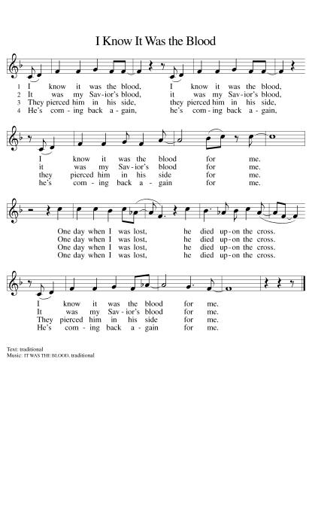
COMMUNION SONGS I Know it Was the Blood #474
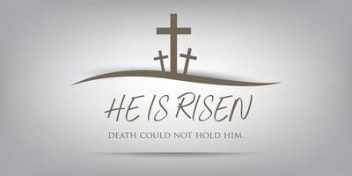

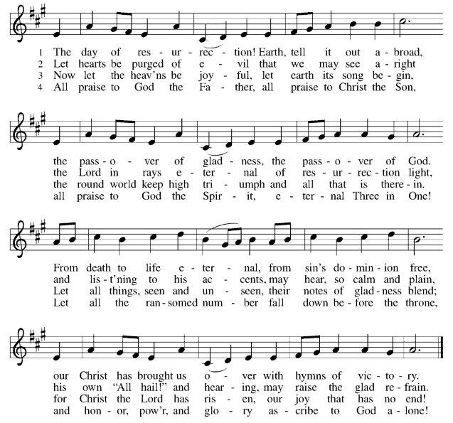
The Day of Resurrection

*PRAYER AFTER COMMUNION

Let us pray, Gracious God, in you we live and move and have our being. With your word and this meal of grace, you have nourished our life together. Strengthen us to show your love and serve the world in Jesus’ name. Amen.
SENDING
God blesses us and sends us in mission to the world.

*BLESSING

The God of all, who raised ☩ Jesus from the dead, bless you by the power of the Holy Spirit to live in the new creation. Amen.
*SENDING HYMN Now All the Vault of Heaven Resounds #367
*Dismissal

Go in peace. Serve the Risen One. Thanks be to God.

POSTLUDE Sunflower Trio

We want to thank the musicians involved in making this worship service so very special.

The Sunflower Trio Claudia Fitzpatrick-Cello,
Brooke Parker -Violin,
Cathy Parker- Violin

The Brass Quintet Trumpet – Eddy Martinez, Tom Philips
French Horn – Valeria Gonzalez
Trombone – Evan Wicks
Tuba - Daniel Orellana

Everyone is invited to come to the inner courtyard
for a reception celebrating the baptisms and
this beautiful Easter morning.
There is an egg hunt and bounce house on the
play yard for all children.

Our Sunday worship service is at 9:30am.
Children’s Sunday school is held during worship, and they return to the sanctuary during the Passing of the Peace.
All are welcome always.

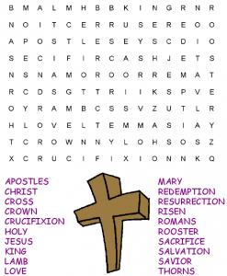

CHRIST LUTHERAN CHURCH STAFF

Interim Pastor Rev. Laurie Arroyo, lauriethere@msn.com
Office Manager Kim Croes, officemanager@christlutheranlb.com
Preschool Director Lisa Clinton, info@clplb.com
Interim Choir Director Kim Philips, kimsings@msn.com
Accompanist Roger Halvorson
Percussionist Nathan Latiolait
Missionary to Colombia Linda Gawthorne

It is our joy to worship with your whole family this morning!

CHILDCARE

We encourage everyone of all ages and abilities to worship together. If you do need to take a "time out", please do so in the narthex (gathering space at the entry), and return to worship when you are ready. A changing table is located in the restroom off the narthex. Activity bags, filled with crayons, paper and storybooks, are available in the narthex. Please ask an usher if you need any assistance.

OUR MISSION STATEMENT

Christ Is Alive!

OUR VISION STATEMENT

Christ Lutheran Church is a community of believers committed to praising our Savior Jesus Christ. With his love, we reach out to those in need and welcome all with open hearts. Our worship dynamically combines, word, song and prayer to share God’s incredible message. Having faith in this, we go forth knowing that with God and the power of the Holy Spirit, anything is possible.

LIKE us on Facebook at www.facebook.com/christlutheranlb

Write a review of Christ Lutheran Church on YELP!

