**Maundy Thursday**

**April 6, 2023**

**7:00 pm**



**Christ Lutheran Church**

6500 E. Stearns Street

Long Beach, California 90815

Phone 562-598-2433

Preschool 562-594-6117

www.christlutheranlb.com

**Welcome to worship! We’re glad you’re here!**

To assist in your worship:

**bold** print means we respond together

**\*** meansstand as you are able,

+ you may make the sign of the cross should you so desire.

**TOnight’S worship THEME**

This evening our Lenten observance comes to an end, and we gather with Christians around the world to celebrate the Three Days of Jesus’ death and resurrection. Tonight we remember Christ’s last meal with his disciples, but the central focus is his commandment that we live out the promise embodied in this meal. As Jesus washed his disciples’ feet, so we are called to give and receive love in humble service to one another. Formed into a new body in Christ through this holy meal, we are transformed by the mercy we have received and carry it into the world. Departing worship in solemn silence, we anticipate the coming days.



Our liturgy is taken from:

Sundays and Seasons.com. Copyright 2023 Augsburg Fortress. All rights reserved.

Reprinted by permission under Augsburg Fortress Liturgies Annual License #20338.

Reprinted by permission under CCLI license # 230154. All rights reserved

Reprinted by permission under © 2023 One License #A-706154. All rights reserved

**GATHERING**

*The Holy Spirit calls us together as the people of God.*

**PRELUDE** Roger Halvorson

**WELCOME AND ANNOUNCEMENTS**

**\*GATHERING HYMN** *Where Charity and Love Prevail* #359

**CONFESSION AND FORGIVENESS**

Friends in Christ, in this Lenten season we have heard our Lord’s call to struggle against sin, death, and the devil—all that keeps us from loving God and each other. This is the struggle to which we were called at baptism. We have shared this discipline of Lent with new brothers and sisters in Christ who will be baptized at the Easter Sunday Service.

Within the community of the church, God never wearies of forgiving sin and giving the peace of reconciliation. On this night let us confess our sin against God and our neighbor, and enter the celebration of the great Three Days reconciled with God and with one another.

*All kneel or sit and keep silence for reflection and self-examination.*

Most merciful God,

**we confess that we are captive to sin and cannot free ourselves. We have sinned against you in thought, word, and deed, by what we have done and by what we have left undone. We have not loved you with our whole heart; we have not loved our neighbors as ourselves. For the sake of your Son, Jesus Christ, have mercy on us. Forgive us, renew us, and lead us, so that we may delight in your will and walk in your ways, to the glory of your holy name.**

**Amen.**

God, who is rich in mercy, loved us even when we were dead in sin, and made us alive together with Christ. By grace you have been saved. In the name of **☩** Jesus Christ, your sins are forgiven. Almighty God strengthen you with power through the Holy Spirit, that Christ may live in your hearts through faith. **Amen.**

*The assembly is seated. People may come forward for the laying on of hands.*

In obedience to the command of our Lord Jesus Christ, I forgive you all your sins.

*The person may respond***Amen.**

**\*GREETING**

The grace of our Lord Jesus Christ, the love of God and the communion of the Holy Spirit be with you all. **And also with you.**

**\*PRAYER OF THE DAY**

Let us pray together. **Eternal God, in the sharing of a meal your Son established a new covenant for all people, and in the washing of feet he showed us the dignity of service. Grant that by the power of your Holy Spirit these signs of our life in faith may speak again to our hearts, feed our spirits, and refresh our bodies, through Jesus Christ, our Savior and Lord, who lives and reigns with you and the Holy Spirit, one God, now and forever. Amen.**

**WORD**

*God speaks to us in scripture reading, preaching, and song.*

**FIRST READING** 1 Corinthians 11:23-26PewBible New Testament Pg. 181

Word of God, Word of Life. **Thanks be to God**

**RESPONSIVE PSALM** Psalm 116:1-2, 12-19 Pew Bible Old testament Pg. 625

I love the LORD, because he has heard my voice and my supplications.  
**2Because he inclined his ear to me, therefore I will call on him as long as I live.**  
**12What shall I return to the LORD for all his bounty to me?** 13I will lift up the cup of salvation and call on the name of the LORD**,** **14I will pay my vows to the LORD in the presence of all his people.** 15Precious in the sight of the LORD is the death of his faithful ones.  
 **16O LORD, I am your servant; I am your servant, the child of your serving girl. You have loosed my bonds.** 17I will offer to you a thanksgiving sacrifice and call on the name of the LORD.  
**18I will pay my vows to the LORD in the presence of all his people,** 19in the courts of the house of the LORD, in your midst, O Jerusalem. Praise the LORD!

**\*GOSPEL ACLAMATION**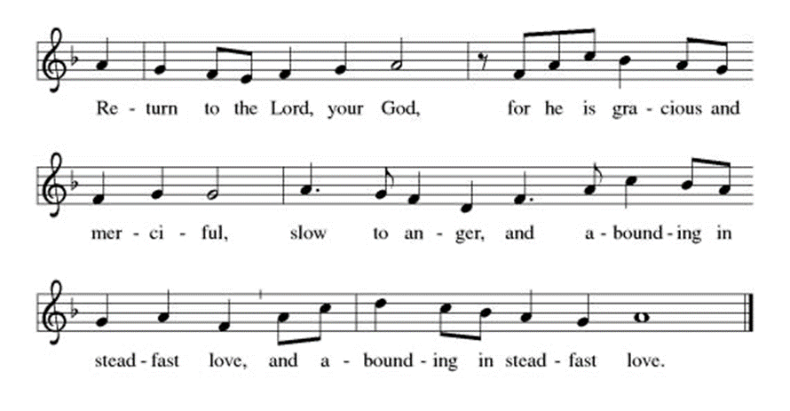

**\*GOSPEL** John 13:1-17, 31b-35Pew Bible NewTestament Pg. 111

The Holy Gospel according to John the 13th chapter. **Glory to you, O Lord.**

The Gospel of the Lord. **Praise to You O, Christ.**

**SERMON**

**\*SERMON HYMN** *Be Thou My Vision* #793

**PRAYERS OF THE CHURCH**

Sustained by God’s abundant mercy, let us pray for the church, the world, and all of creation.

Merciful God, **receive our prayer.**

We lift our prayers to you, O God, trusting in your steadfast love and your promise to renew your whole creation; through Jesus Christ our Savior. **Amen.**

**\*SHARING OF PEACE**

The peace of the Lord be with you always. **And also with you.**

**OFFERTORY**

**\*OFFERTORY RESPONSE** Create a Clean Heart in Me

**\*OFFERTORY PRAYER**

Let us pray together**, God of good gifts, receive these and all our offerings as we present them in faithful service for the sake of your gospel. Prepare our hearts to receive you in this meal as you pour out your very presence through Christ Jesus, the wellspring of eternal life. Amen.**

**MEAL**

*God feeds us with the presence of Jesus Christ.*

**GREAT THANKSGIVING**

The Lord be with you. **And also with you.**

Lift up your hearts. **We lift them to the Lord.**

Let us give thanks to the Lord our God. **It is right to give our thanks and praise**

It is indeed right, our duty and our joy…

…we praise your name and join their unending hymn:

**\*HOLY, HOLY, HOLY**

**\*THANKSGIVING AT THE TABLE**

Blessed are you, O God of the universe. Your mercy is everlasting, and your faithfulness endures from age to age…

…as we proclaim the mystery of faith: **Christ has died. Christ is risen. Christ will come again.**

O God of resurrection and new life: Pour out your Holy Spirit on us and on these gifts of bread and wine. Bless this feast. Grace our table with your presence. **Come, Holy Spirit.**

Reveal yourself to us in the breaking of the bread. Raise us up as the body of Christ for the world. Breathe new life into us. Send us forth, burning with justice, peace, and love. **Come, Holy Spirit.**

With your holy ones of all times and places, with the earth and all its creatures, with sun and moon and stars, we praise you, O God, blessed and holy Trinity,

now and forever. **Amen.**

**\*LORD’S PRAYER**

**Our Father in heaven, hallowed be your name, your kingdom come, your will be done, on earth as in heaven. Give us today our daily bread. Forgive us our sins as we forgive those who sin against us. Save us from the time of trial and deliver us from evil. For the kingdom, the power, and the glory are yours, now and forever.** **Amen.**

**DISTRIBUTION OF HOLY COMMUNION**

*We believe that this is Jesus' table. All are welcome and invited to commune.  We serve communion by “intinction”; receive the bread and dip it in the chalice of red wine. Currently we are offering individual communion cups as an alternative to intinction if you so desire. Both wine and grape juice (white) are offered in the tray. Gluten free bread is available; let your server know. Should you choose not to commune, please come forward to receive a blessing. Please cross your arms across your chest.*

**lamb of god**

**HEALING PRAYER**

*Tonight we offer healing prayer. If you would like our healing minister to pray with and for you, please go to the right transept after taking communion.*

**SONGS** *Let All Mortal Flesh Keep Silence* #490

*Jesu, Jesu, Fill Us with Your Love* #708

**\*POST-COMMUNION PRAYER**

Let us pray together.  **Lord Jesus, in a wonderful sacrament you strengthen us with the saving power of your suffering, death, and resurrection. May this sacrament of your body and blood so work in us that the fruits of your redemption will show forth in the way we live, for you live and reign with the Father and the Holy Spirit, one God, now and forever.**

**Amen.**

**STRIPPING OF THE ALTAR**

*Were You There* Lonnie Timney-Cello

*The congregation may kneel or be seated as linens, paraments, ornaments, and candles are removed from the altar and chancel. As this is done, the cello plays.*

*There is no benediction. Please leave the church in silence. The service resumes tomorrow evening at 7:00pm*

**CHRIST LUTHERAN CHURCH STAFF**

**Interim Pastor**  Rev. Laurie Arroyo, lauriethere@msn.com

**Office Manager** Kim Croes, [officemanager@christlutheranlb.com](mailto:officemanager@christlutheranlb.com)

**Preschool Director** Lisa Clinton, info@clplb.com

**Interim Choir Director** Kim Philips, kimsings@msn.com

**Accompanist** Roger Halvorson

**Percussionist** Nathan Latiolait

**Missionary to Colombia** Linda Gawthorne

**It is our joy to worship with your whole family this morning!**

**CHILDCARE**

We encourage everyone of all ages and abilities to worship together. If you do need to take a "time out", please do so in the narthex (gathering space at the entry), and return to worship when you are ready. A changing table is located in the restroom off the narthex. Activity bags, filled with crayons, paper and storybooks, are available in the narthex. Please ask an usher if you need any assistance.

**OUR MISSION STATEMENT**

*Christ Is Alive!*

**OUR VISION STATEMENT**

*Christ Lutheran Church is a community of believers committed to praising our Savior Jesus Christ. With his love, we reach out to those in need and welcome all with open hearts. Our worship dynamically combines, word, song and prayer to share God’s incredible message. Having faith in this, we go forth knowing that with God and the power of the Holy Spirit, anything is possible.*

**LIKE** us on **Facebook** at [www.facebook.com/christlutheranlb](http://www.facebook.com/christlutheranlb)

Write a review of Christ Lutheran Church on **YELP!**