**Third Sunday of Easter**

**April 23, 2023**

**9:30am**

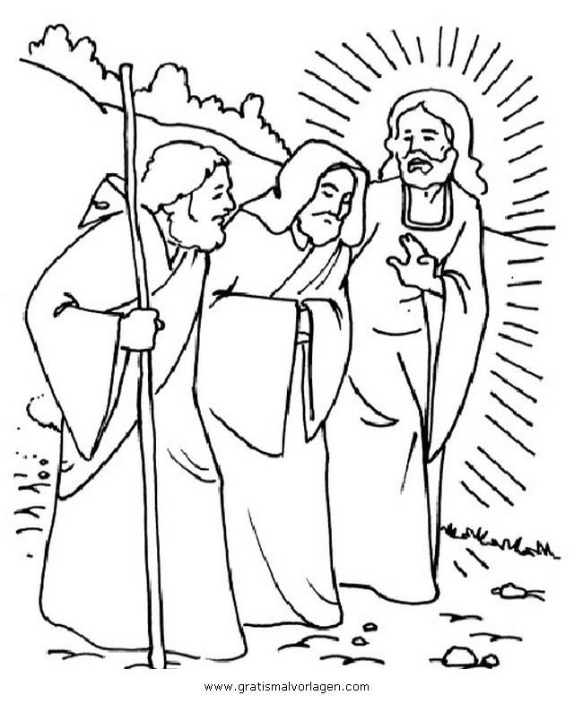

**Christ Lutheran Church**

6500 E. Stearns Street

Long Beach, California 90815

Phone 562-598-2433

www.christlutheranlb.com

Preschool 562-594-6117

[www.clclb.com](http://www.clclb.com)

**Welcome to worship! We’re glad you’re here!**

To assist in your worship:

**bold** print means we respond together

**\*** meansstand as you are able,

+ you may make the sign of the cross should you so desire.

**TODAY’S worship THEME**

Today’s gospel begins with two disciples walking to Emmaus, overcome with sadness, loss, and disappointment. They had hoped Jesus, who was crucified, would be the one to redeem Israel! Yet the risen Christ walks with them and then opens their eyes in the breaking of the bread. Each Sunday our hearts burn within us as the scriptures are proclaimed and Christ appears to us as bread is broken and wine is poured. The story of Emmaus becomes the pattern of our worship each Lord’s day.

Our liturgy is taken from:

Sundays and Seasons.com. Copyright 2023 Augsburg Fortress. All rights reserved.

Reprinted by permission under Augsburg Fortress Liturgies Annual License #20338.

Reprinted by permission under CCLI license # 230154. All rights reserved

Reprinted by permission under © 2023 One License #A-706154. All rights reserved

**PRELUDE** Roger Halvorson

**WELCOME AND ANNOUNCEMENTS**

**GATHERING**

*The Holy Spirit calls us together as the people of God._______________________*

**GATHERING SONG** *Change My Heart, O God* #801

**GREETING**

The grace of our Lord Jesus Christ, the love of God,and the communion of the Holy Spirit be with you all. **And also with you.**

**KYRIE**

**pRAYER OF THE DAY**

Let us pray together. *A brief silence***. O God, your Son makes himself known to all his disciples in the breaking of bread. Open the eyes of our faith, that we may see him in his redeeming work, who lives and reigns with you and the Holy Spirit, one God, now and forever. Amen**

**WORD**

*God speaks to us in scripture reading, preaching, and song.______________________*

**MUSIC MAKERS** Preschool Children

Directed by Claudia Fitzpatrick

**CHILDREN’S MESSAGE** *After this time, children will be invited to Sunday school. They will return during the passing of the peace.*

**SCRIPTURE READING** Acts 2:14a, 36-41 PewBible New Testament Pg.123

Word of God, Word of Life. **Thanks be to God.**

**RESPONSIVE PSALM** Psalm 116:1-4,12-19 PewBible Old Testament Pg. 625

1I love the LORD, because he has heard my voice and my supplications.  
**2Because he inclined his ear to me, therefore I will call on him as long as I live.**  
 3The snares of death encompassed me; the pangs of Sheol laid hold on me; I suffered distress and anguish.  
 **4Then I called on the name of the LORD: "O LORD, I pray, save my life!"**  
 12What shall I return to the LORD for all his bounty to me?  
 **13I will lift up the cup of salvation and call on the name of the LORD,** 14I will pay my vows to the LORD in the presence of all his people.  
 **15Precious in the sight of the LORD is the death of his faithful ones.** 16O LORD, I am your servant; I am your servant, the child of your serving girl. You have loosed my bonds.  
 **17I will offer to you a thanksgiving sacrifice and call on the name of the LORD.** 18I will pay my vows to the LORD in the presence of all his people,  
**19in the courts of the house of the LORD, in your midst, O Jerusalem. Praise the LORD!**

**\*GOSPEL ACCLAMATION**

### **\*GOSPEL** Luke 24:13-35 Pew Bible New Testament Pg. 92

The Holy Gospel according to Luke the 24th chapter. **Glory to you, O Lord.**

The reading concludes: The Gospel of the Lord. **Praise to you, O Christ.**

**SERMON** Pastor Laurie Arroyo

**\*SERMON SONG** *Let Us Talents and Tongues Employ* #674

**\*NICENE CREED**

**We believe in one God, the Father, the Almighty, maker of heaven and earth, of all that is, seen and unseen.**

**We believe in one Lord, Jesus Christ, the only Son of God, eternally begotten of the Father, God from God, Light from Light, true God from true God, begotten, not made, of one Being with the Father; through him all things were made. For us and for our salvation he came down from heaven, was incarnate of the Holy Spirit and the virgin Mary and became truly human. For our sake he was crucified under Pontius Pilate; he suffered death and was buried. On the third day he rose again in accordance with the scriptures; he ascended into heaven and is seated at the right hand of the Father. He will come again in glory to judge the living and the dead, and his kingdom will have no end.**

**We believe in the Holy Spirit, the Lord, the giver of life, who proceeds from the Father and the Son, who with the Father and the Son is worshiped and glorified,**

**who has spoken through the prophets. We believe in one holy catholic and apostolic church. We acknowledge one baptism for the forgiveness of sins. We look for the resurrection of the dead, and the life of the world to come. Amen.**

**PRAYERS OF THE CHURCH**

United in the hope and joy of the resurrection, let us pray for the church, the world, and all in need.

…Hear us O God,

**Your mercy is great.**

Rejoicing in the victory of Christ’s resurrection, we lift our prayers and praise to you, almighty and eternal God; through Jesus Christ, our risen Lord. **Amen.**

**\*SHARING OF PEACE**

The peace of the Lord be with you always. **And also with you.**

**OFFERTORY** Roger Halvorson

**\*OFFERTORY RESPONSE** *Take My Life, That I May Be* #583

**\*OFFERTORY PRAYER**

Let us pray together**, Generous God, in this meal you offer your very self. We give thanks for these gifts of the earth. In the breaking of this bread reveal to us the Risen One. In the pouring of this wine pour us out in service to the world; through Christ our Lord. Amen.**

**MEAL**

*God feeds us with the presence of Jesus.*

**\*THE GREAT THANKSGIVING**

The Lord be with you. **And also with you.**

Lift up your hearts. **We lift them to the Lord,**

Let us give thanks to the Lord our God. **It is right to give our thanks and praise.**

It is indeed right, our duty and our joy…

we praise your name and join their unending hymn:

**\*SONG OF THANKSGIVING**

**

**\*THANKSGIVING AT THE TABLE**

Holy God, holy and mighty, holy and immortal: you we praise and glorify, you we worship and adore…

…With this bread and cup we remember our Lord’s passover from death to life as we proclaim the mystery of faith: **Christ has died. Christ is risen. Christ will come again.**

…with the whole world made perfect through your wisdom, all our sins and sorrows will be no more. **Amen. Come, Lord Jesus.**

…Nurture in us the fruits of the Spirit, that we may be a living tree, sharing your bounty with all the world. **Amen. Come, Holy Spirit.**

…through whom all glory and honor is yours, O God, O Living One, with the Holy Spirit, in your holy church, now and forever. **Amen.**

**\*LORD’S PRAYER**

**Our Father in heaven, hallowed be your name, your kingdom come, your will be done, on earth as in heaven. Give us today our daily bread. Forgive us our sins**

**as we forgive those who sin against us. Save us from the time of trial and deliver us from evil. For the kingdom, the power, and the glory are yours, now and forever.** **Amen.**

**DISTRIBUTION OF HOLY COMMUNION**

We believe that this is Jesus' table. All are welcome and invited to commune.  We serve communion by “intinction”; receive the bread and dip it in the chalice of red wine. Currently we are offering individual communion cups as an alternative to intinction if you so desire. Both wine and grape juice (white) are offered in the tray. Gluten free bread is available; let your server know. Should you choose not to commune, please come forward to receive a blessing. Please cross your arms across your chest.





**lamb of god**

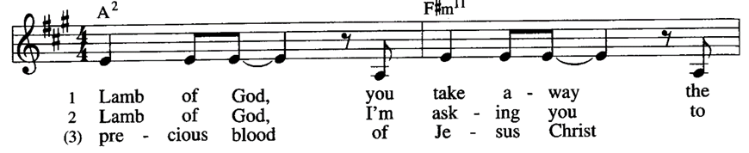

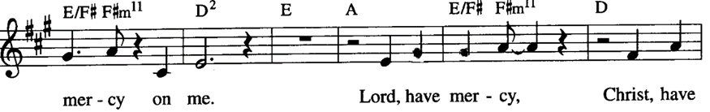

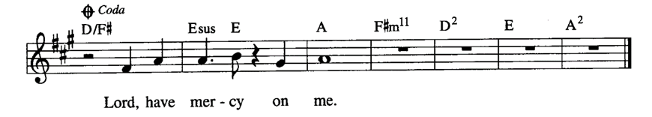

**COMMUNION SONG** *Jesu, Jesu, Fill Us with Your Love* #708

**\*PRAYER AFTER COMMUNION**

Let us pray together.  **Gracious God, in you we live and move and have our being. With your word and this meal of grace, you have nourished our life together. Strengthen us to show your love and serve the world in Jesus’ name. Amen.**

**SENDING**

*God blesses us and sends us in mission to the world.*

**\*BLESSING**

The God of all, who raised ☩ Jesus from the dead, bless you by the power of the Holy Spirit to live in the new creation. **Amen.**

**\*SENDING HYMN** *We Are Marching in the Light #866*

**\*Dismissal**

Go in peace. Serve the Risen One. **Thanks be to God.**

**POSTLUDE** Roger Halvorson

**CHRIST LUTHERAN CHURCH STAFF**

**Interim Pastor**  Rev. Laurie Arroyo, lauriethere@msn.com

**Office Manager** Kim Croes, [officemanager@christlutheranlb.com](mailto:officemanager@christlutheranlb.com)

**Preschool Director** Lisa Clinton, info@clplb.com

**Interim Choir Director** Kim Philips, kimsings@msn.com

**Accompanist** Roger Halvorson

**Percussionist** Nathan Latiolait

**Missionary to Colombia** Linda Gawthorne

**It is our joy to worship with your whole family this morning!**

**CHILDCARE**

We encourage everyone of all ages and abilities to worship together. If you do need to take a "time out", please do so in the narthex (gathering space at the entry), and return to worship when you are ready. A changing table is located in the restroom off the narthex. Activity bags, filled with crayons, paper and storybooks, are available in the narthex. Please ask an usher if you need any assistance.

**OUR MISSION STATEMENT**

*Christ Is Alive!*

**OUR VISION STATEMENT**

*Christ Lutheran Church is a community of believers committed to praising our Savior Jesus Christ. With his love, we reach out to those in need and welcome all with open hearts. Our worship dynamically combines, word, song and prayer to share God’s incredible message. Having faith in this, we go forth knowing that with God and the power of the Holy Spirit, anything is possible.*

**LIKE** us on **Facebook** at [www.facebook.com/christlutheranlb](http://www.facebook.com/christlutheranlb)

Write a review of Christ Lutheran Church on **YELP!**