Christ Lutheran Church
Week at a Glance
January 1 -January 8

Today New Year’s Day
9:30am Worship -In Person & Live Streamed

Monday, January 2
Preschool Closed

Tuesday, January 3
Preschool Opens
9:00am Cover G’s
6:30pm Stephen’s Ministry

Wednesday, January 4
9:45am Bible Study (Zoom format)
6:00pm Guide Dogs of American Puppy Training

Thursday, January 5
7:00pm Choir Rehearsal

Friday, January 6
No Events Scheduled

Saturday, January 7
No Events Scheduled

Sunday, January 8
9:30am Worship-In Person & Live Streamed

The Flower Chart for 2023 is now available on the door to the Usher’s Room, off of the Narthex. All are invited to sign up to sponsor altar flowers in honor of birthdays, anniversaries or other special events, or in memory of a loved one. Please make checks for $50 payable to Christ Lutheran Church and place in your offering envelopes the month of your sponsorship. Thank you for helping to beautify our worship space with your gifts.

Save the date: January 14th, 2023. We will need volunteers to help take down the Christmas tree and other decorations. Please meet in the sanctuary at 10am.
January 15th - 2023 Budget Forum after worship
January 22nd – Congregation meeting at 11am

This morning’s worship assistants:
Assisting Minister: Gary Burkard
Reader:
Communion Assistants: Bryce Bonilla-Haenn, Matthew and Rebecca Green
Altar Guild:
Coffee Cart Treats: Claudia Fitzpatrick
Ushers: Linda McGee, Mark Ennen, Claudia Fitzpatrick
Thank you all.

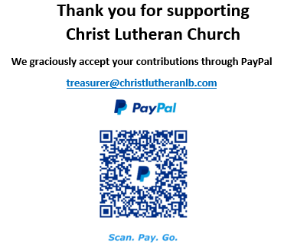

The Healing Power of the Holy Spirit

We pray for:

Members at Home or in Care Centers: Justin Bartlow, Laurie Ennen, Ione Marchael, Sydney Nichols, Don Westerhoff, and Frances Willms.

Those struggling with illness or other concerns:
Don Darnauer, Judy Haenn, Daniel Howard, Karen Koch, Sydney Nichols, Stephanie Petrbok, Bary & Janice Schlieder, Doris Weinert, Kurt Weisel, Gary & Linda Zimmerman.

*Family & Friends: Marylyn, Terry, Cheryl, Lois Brown, Zach Burkard, Byron, John Caldwell, Scott Carr, Mireya Cervantes, Jon Christopherson, Steve, Charlie and David Corm, Mary Croes, JD, Glenn Darnauer, Tamara Fitzgerald, Brechin Flournoy, Alberta Gray, Cindy Gray, Helen Hagen, Evie Holdhusen, Kylie & Crystal Huber, Ray Irwin, Doris Jung, Barb Korsmo, Katrina Lahr, Sue Lance, Lenny Lloyd, Diana Lobel, Joyce, John McCarthy, Dewey Martin, Heather Nielsen, Hudson Nunnally, Paula Pettit, Kristina & Scott Randolph, Emily Renton, Mary Kathryn Rivera, J.R. Rose, Nina Savlov, Vicki Thompson, Sharon and JT Tooman, Jessica, Steve and Jenny West.

*Names are included on the prayer list for 30 days unless specific requests are made through the office.

We also pray for the ongoing work of:

+ Christ Lutheran’s Pastoral Call Committee

+ Linda Gawthorne among the Kogi people of Colombia

+ First responders who provide safety, security, and care

+ Those serving in our nation's military, especially: Samuel Brown, Ryan Dorris,
Morgan Llewellyn, Johnny Luna, Jim Reeder, Steven, Brina and Michael Navarro.
Please provide us with names of those you would
like to include in these prayers.

+ Presiding Bishop Elizabeth Eaton, Bishop Brenda Bos, Pastors, and
elected leaders of our church.

