Please sign up at redcrossblood.org and enter 90815 for our locationto donate. Walk ins welcome.

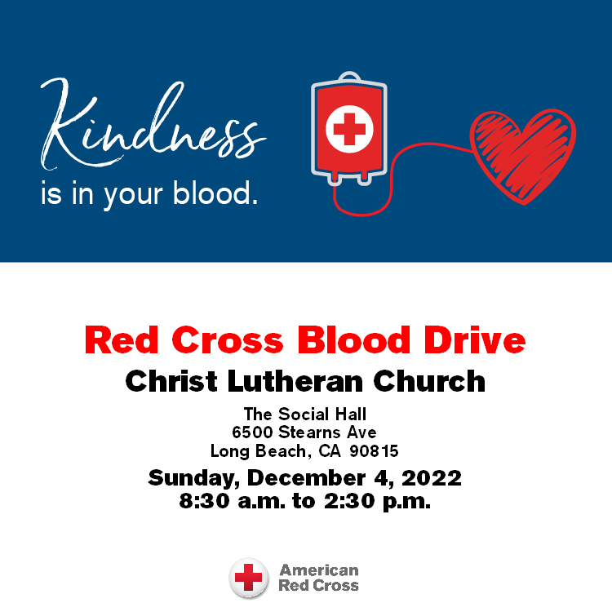

+++++++++++++++++++++++++++++++++++++

Christ Lutheran Church
Week at a Glance
December 4-December 11

Today Second Sunday of Advent
8:30am Red Cross Blood Drive
9:30am Worship -In Person & Live Streamed
Children’s Sunday school

Monday, December 5
No Events Scheduled

Tuesday, December 6
9:00 am Cover G’s
6:30pm Stephen’s Ministry
6:30pm Executive Council

Wednesday, December 7
9:45am Bible Study (Zoom format)
6:00pm Guide Dogs of American Puppy Training

Thursday, December 8
10:30am Music Makers
11:30am Preschool Chapel
12:00pm OWLs Lunch
7:00pm Choir Rehearsal

Friday, December 9
No Events Scheduled

Saturday, December 10
12:00pm Sons of Norway

Sunday, December 11
9:30am Worship-In Person & Live Streamed
Children’s Sunday School
Flowers this morning are given in thanksgiving to God by Cathy Westwood in memory of her daughter, Tanya Short.

The Flower Chart for 2023 is now available on the door to the Usher’s Room, off of the Narthex. All are invited to sign up to sponsor altar flowers in honor of birthdays, anniversaries or other special events, or in memory of a loved one. Please make checks for $45 payable to Christ Lutheran Church and place in your offering envelopes the month of your sponsorship. Thank you for helping to beautify our worship space with your gifts.

Church in Society’s Giving Focus for December will be an in gathering of items for Maritime Ministries Seafarer’s Gift Bags and Lutheran Social Services (LSS) Community Christmas party. We are gathering pajamas of any size between infant and teens. We would also like to collect books appropriate for this same variety of ages to go with each pair of pajamas. These books can be new or very gently used. See details for the Mariner gift bags on the enclosed flyer.

The Nominating Committee for the next church council will begin searching for candidates to fill some council chairs that become vacant in January. If you are approached, please consider the request with an open heart and mind. The list of those committees will be available soon.

This morning’s worship assistants:
Assisting Minister:
Reader: Kim Croes
Communion Assistants: Annette Rodrigues, Shannon and Matthew Timney
Altar Guild: Stephanie and Stephanie Petrbok
Coffee Cart: Claudia Fitzpatrick
Ushers: Jeanne and Phil Peterson, Renu Moon
Thank you all.

The Healing Power of the Holy Spirit

We pray for:

Members at Home or in Care Centers: Justin Bartlow, Laurie Ennen, Ione Marchael, Don Westerhoff, and Frances Willms.

Those struggling with illness or other concerns:
Don Darnauer, Judy Haenn, Daniel Howard, Karen Koch, Sydney Nichols, Shirley Pierce, Stephanie Petrbok, Bary & Janice Schlieder, Doris Weinert, Kurt Weisel, Gary & Linda Zimmerman.

*Family & Friends: Marylyn, Terry, Cheryl, Lois Brown, Zach Burkard, Byron, John Caldwell, Scott Carr, Jon Christopherson, Steve, Charlie and David Corm, Mary Croes, JD, Glenn Darnauer, Tamara Fitzgerald, Brechin Flournoy, Alberta Gray, Cindy Gray, Evie Holdhusen, Kylie & Crystal Huber, Ray Irwin, Doris Jung, Barb Korsmo, Katrina Lahr, Sue Lance, Lenny Lloyd, Diana Lobel, Joyce, John McCarthy, Dewey Martin, Heather Nielsen, Hudson Nunnally, Paul Perencevic, Paula Pettit, Kristina & Scott Randolph, Emily Renton, Mary Kathryn Rivera, J.R. Rose, Vicki Thompson, Sharon and JT Tooman, Jessica, Steve and Jenny West.

*Names are included on the prayer list for 30 days unless specific requests are made through the office.

Those Who Mourn: We ask that you keep Frank, Kim & Brad Croes and Amanda Johnson and her family in your prayers as they mourn the passing of Frank’s father, Max. May the Lord grant them, Frank’s mother, Mary, and his brothers and their families peace and comfort during this difficult time.

We also pray for the ongoing work of:

+ Linda Gawthorne among the Kogi people of Colombia

+ First responders who provide safety, security, and care

+ Those serving in our nation's military, especially: Samuel Brown, Ryan Dorris,
Morgan Llewellyn, Johnny Luna, Jim Reeder, Steven, Brina and Michael Navarro.
Please provide us with names of those you would
like to include in these prayers.

+ Presiding Bishop Elizabeth Eaton, Bishop Brenda Bos, Pastors, and
elected leaders of our church.

