Nativity of Our Lord II
December 25, 2022
9:30am

Christ Lutheran Church
6500 E. Stearns Street
Long Beach, California 90815
Phone 562-598-2433
www.christlutheranlb.com

Preschool 562-594-6117
www.clclb.com

Welcome to worship! We’re glad you’re here!

To assist in your worship:

bold print means we respond together
* means stand as you are able,
+ you may make the sign of the cross should you so desire.

TODAY’S worship THEME

As on the first day of creation, on this Christmas Day the Word illumines the world, shining forth to bring all things into being. Today we celebrate the incarnate Word, God becoming flesh to live among us in the person of Jesus Christ then and now. Emboldened by the good news of Christ’s birth, along with the shepherds, Mary and Joseph, and all witnesses to the light of Christ, we declare to the world that we have indeed seen and been transformed by the arrival of “the salvation of our God.” O come, let us adore!

Our liturgy is taken from:
Sundays and Seasons.com. Copyright 2022 Augsburg Fortress. All rights reserved.
Reprinted by permission under Augsburg Fortress Liturgies Annual License #20338.
Reprinted by permission under CCLI license # 230154. All rights reserved
Reprinted by permission under © 2022 One License #A-706154. All rights reserved
GATHERING
The Holy Spirit calls us together as the people of God._________________________

PRELUDE

WELCOME AND ANNOUNCEMENTS

CALL TO WORSHIP O Come, All Ye Faithful #283
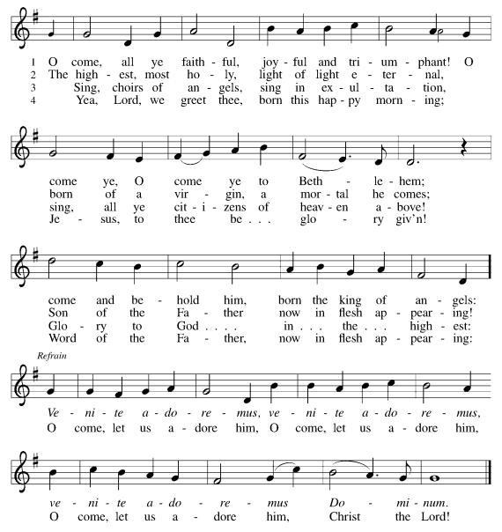

CONFESSION AND FORGIVENESS
All may make the sign of the cross, the sign that is marked at baptism, as the presiding minister begins.

Blessed be the holy Trinity, ☩ one God, the Word made flesh, our life and our salvation.
Amen.

Trusting the goodness and lovingkindness of God our Savior, let us confess our sin.

Silence is kept for reflection.

God of life,
you promise good news of great joy for all people, and call us to be messengers of your peace. We confess that too often we hoard our joy, our resources, and our security. We nurture conflict and build barriers. We neglect the needs of our neighbors and ignore the groaning of creation. Have mercy on us. Where we are self-centered, open our hearts. Where we are reluctant, give us courage. Where we are cynical, restore our trust. Renew us with your grace and give us again the hope of eternal life in you. Amen.

Hear the good news: We are children of God and heirs of God’s promises through the outpouring of the Holy Spirit. In ☩ Jesus we are forgiven and redeemed. Sing with joy, for all the ends of the earth shall know the salvation of God.
Amen.

GATHERING SONG Joy to the World #267

*GREETING
The grace of our Lord Jesus Christ, the love of God, and the communion of the Holy Spirit be with you all. And also with you.

*canticle of praise Good Christian Friends, Rejoice #288 ( vs.1-3)
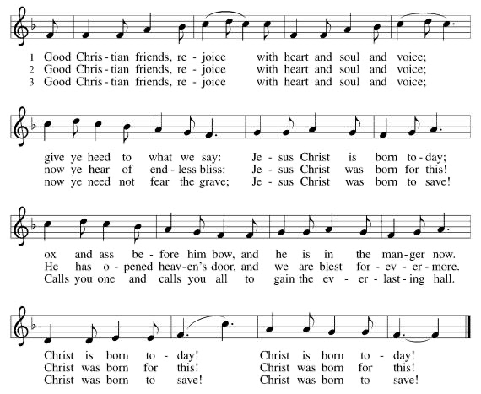

*PRAYER OF THE DAY
Let us pray. A brief silence. All-powerful and unseen God, the coming of your light into our world has brightened weary hearts with peace. Call us out of darkness, and empower us to proclaim the birth of your Son, Jesus Christ, our Savior and Lord, who lives and reigns with you and the Holy Spirit, one God, now and forever.
Amen.

WORD
God speaks to us in scripture reading, preaching, and song.______________________

CHILDREN’S MESSAGE

SCRIPTURE READING Isaiah 62:6-12 Pew Bible Old Testament Pg.769
Word of God, Word of Life. Thanks be to God.

PSALM (Responsive) Psalm 97 Pew Bible Old Testament Pg.609
¹The LORD is king! Let the earth rejoice; let the many coastlands be glad!
²Clouds and thick darkness are all around him; righteousness and justice are the foundation of his throne.
³Fire goes before him, and consumes his adversaries on every side.
⁴His lightnings light up the world; the earth sees and trembles.
⁵The mountains melt like wax before the LORD, before the LORD of all the earth.
⁶The heavens proclaim his righteousness; and all the peoples behold his glory.
⁷All worshipers of images are put to shame, those who make their boast in worthless idols; all gods bow down before him.
⁸Zion hears and is glad, and the towns of Judah rejoice, because of your judgments, O God.
⁹For you, O LORD, are most high over all the earth; you are exalted far above all gods.
¹⁰The LORD loves those who hate evil; he guards the lives of his faithful; he rescues them from the hand of the wicked.
¹¹Light dawns for the righteous, and joy for the upright in heart.
¹²Rejoice in the LORD, O you righteous, and give thanks to his holy name!

*GOSPEL ACCLAMATION Go Tell It on the Mountain #290 (vs 1-3)

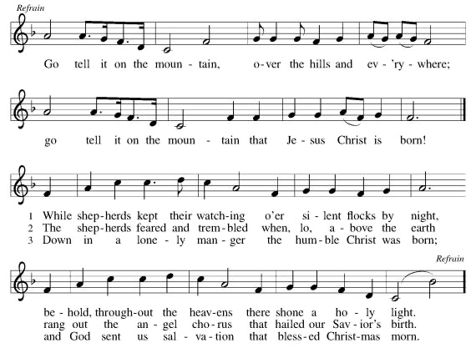
*GOSPEL Luke 2:1-20 Pew Bible New Testament Pg. 59

The Holy Gospel according to Luke, the 2nd chapter. Glory to you, O Lord.
The reading concludes: The Gospel of the Lord. Praise to you, O Christ.

SERMON Pastor Laurie Arroyo

*SERMON SONG O Little Town of Bethlehem #279

*APOSTLES’ CREED
I believe in God, the Father almighty, creator of heaven and earth.

I believe in Jesus Christ, God's only Son, our Lord, who was conceived by the Holy Spirit, born of the virgin Mary, suffered under Pontius Pilate, was crucified, died, and was buried; he descended to the dead. On the third day he rose again; he ascended into heaven, he is seated at the right hand of the Father, and he will come to judge the living and the dead.

I believe in the Holy Spirit, the holy catholic Church, the communion of saints,
the forgiveness of sins, the resurrection of the body, and the life everlasting. Amen.

PRAYERS OF THE CHURCH

As we prepare for the fullness of Christ’s presence, let us pray for a world that yearns for new hope.
A brief silence.
…God, in your mercy,
hear our prayer.

God of our longing, you know our deepest needs. By your Spirit, gather our prayers and join them with the prayers of all your children. In Jesus’ name we pray.
Amen.

*SHARING OF PEACE

The peace of the Lord be with you always. And also with you.

OFFERTORY

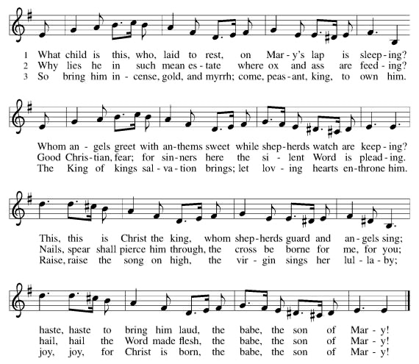
*OFFERTORY RESPONSE What Child is This #296 (vs 1-3)

*OFFERTORY PRAYER
God of abundance, receive and bless these gifts we have offered. Join our hearts with the song of the angels, and gather us at your table of celebration. Strengthen us to share with all the world the abundance of your grace upon grace, poured out in Jesus Christ, the Word made flesh. Amen.

MEAL
God feeds us with the presence of Jesus.

*THE GREAT THANKSGIVING

The Lord be with you. And also with you.
Lift up your hearts. We lift them to the Lord,
Let us give thanks to the Lord our God. It is right to give our thanks and praise.
It is indeed right, our duty and our joy … we praise your name and join their unending hymn:
*HOLY, HOLY, HOLY Love Has Come #292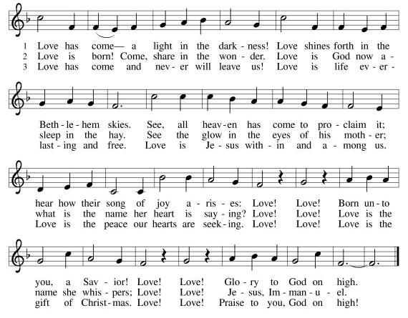

*THANKSGIVING AT THE TABLE

Blessed are you, O God...
…For as often as we eat this bread and drink this cup, we proclaim the Lord’s death until he comes. Christ has died. Christ is risen. Christ will come again.

*LORD’S PRAYER

Our Father, who art in heaven, hallowed be thy name, thy kingdom come, thy will be done, on earth as it is in heaven. Give us this day our daily bread; and forgive us our trespasses, as we forgive those who trespass against us; and lead us not into temptation, but deliver us from evil. For thine is the kingdom, and the power, and the glory, forever and ever. Amen.

INVITATION TO COMMUNION
Glory to God in the highest! Come to the table of peace. Amen.

DISTRIBUTION OF HOLY COMMUNION
We believe that this is Jesus' table. All are welcome and invited to commune. We serve communion by “intinction”; receive the bread and dip it in the chalice of red wine. Currently we are offering individual communion cups as an alternative to intinction if you so desire. Both wine and grape juice (white) are offered in the tray. Gluten free bread is available; let your server know. Should you choose not to commune, please come forward to receive a blessing. Please cross your arms across your chest.

lamb of god

COMMUNION SONG What Feast of Love #487

*PRAYER AFTER COMMUNION
Radiant God, with our eyes we have seen your salvation, and in this meal we have feasted on your grace. May your Word take flesh in us, that we may be your holy people, revealing your glory made known to us in Jesus Christ, our Savior and Lord. Amen.

SENDING
God blesses us and sends us in mission to the world.
______________________________________________________________________

*BLESSING

God bless you and keep you,☩ Jesus grant you grace and truth, and the Spirit send peace upon your hearts ,now and forever. Amen.

*SENDING The First Noel #300

*Dismissal
Christ the Savior is born! Go in peace. Proclaim the good news.
Thanks be to God.

POSTLUDE

CHRIST LUTHERAN CHURCH STAFF

Interim Pastor Rev. Laurie Arroyo, pastor@christlutheranlb.com

Office Manager Kim Croes, officemanager@christlutheranlb.com
Interim Choir Director Kim Philips, kimsings@msn.com
Preschool Director Lisa Clinton, info@clplb.com
Accompanist Roger Halvorson
Percussionist Nathan Latiolait
Missionary to Colombia Linda Gawthorne

It is our joy to worship with your whole family this morning!

CHILDCARE

We encourage everyone of all ages and abilities to worship together. If you do need to take a "time out", please do so in the narthex (gathering space at the entry), and return to worship when you are ready. A changing table is located in the restroom off the narthex. Activity bags, filled with crayons, paper and storybooks, are available in the narthex. Please ask an usher if you need any assistance.

OUR MISSION STATEMENT

Christ Is Alive!

OUR VISION STATEMENT

Christ Lutheran Church is a community of believers committed to praising our Savior Jesus Christ. With his love, we reach out to those in need and welcome all with open hearts. Our worship dynamically combines, word, song and prayer to share God’s incredible message. Having faith in this, we go forth knowing that with God and the power of the Holy Spirit, anything is possible.

LIKE us on Facebook at www.facebook.com/christlutheranlb

Write a review of Christ Lutheran Church on YELP!

