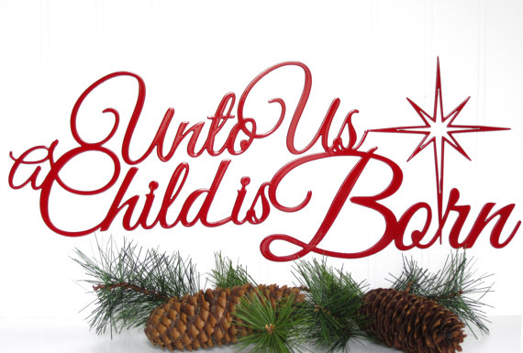

Christ Lutheran Church
Week at a Glance
December 25-January 1

Today Christmas Day
9:30am Worship -In Person & Live Streamed

Monday, December 26
Preschool Closed All Week

Tuesday, December 27
9:00am Cover G’s
11:30am DayTimer’s LunchBunch

Wednesday, December 28
9:45am Bible Study (Zoom format)
6:00pm Guide Dogs of American Puppy Training

Thursday, December 29
No Events Scheduled

Friday, December 30
No Events Scheduled

Saturday, December 31 New Year’s Eve
No Events Scheduled

Sunday, January 1 New Year’s Day
9:30am Worship-In Person & Live Streamed

Flowers this morning are given in thanksgiving to God by Robin Black in celebration of the birth of our Lord, Jesus Christ.

The Flower Chart for 2023 is now available on the door to the Usher’s Room, off of the Narthex. All are invited to sign up to sponsor altar flowers in honor of birthdays, anniversaries or other special events, or in memory of a loved one. Please make checks for $50 payable to Christ Lutheran Church and place in your offering envelopes the month of your sponsorship. Thank you for helping to beautify our worship space with your gifts.

Thank you to everyone for contributing to the gathering of pajamas and books for Lutheran Social Services and the gift bags for the Seafarer’s Center of Lutheran Maritime Ministries.

Save the date: January 14th, 2023. We will need volunteers to help take down the Christmas tree and other decorations. Please meet in the sanctuary at 10am.

This morning’s worship assistants:
Assisting Minister: Robin Black
Reader: Bryce Bonilla-Haenn
Communion Assistants: Gary Burkard,
Altar Guild: Claudia Fitzpatrick
Ushers: Jeanne and Phil Peterson, Renu Moon
Thank you all.
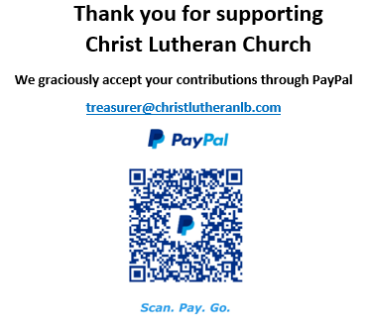

The Healing Power of the Holy Spirit

We pray for:

Members at Home or in Care Centers: Justin Bartlow, Laurie Ennen, Ione Marchael, Sydney Nichols, Don Westerhoff, and Frances Willms.

Those struggling with illness or other concerns:
Don Darnauer, Judy Haenn, Daniel Howard, Karen Koch, Sydney Nichols, , Stephanie Petrbok, Bary & Janice Schlieder, Doris Weinert, Kurt Weisel, Gary & Linda Zimmerman.

*Family & Friends: Marylyn, Terry, Cheryl, Lois Brown, Zach Burkard, Byron, John Caldwell, Scott Carr, Mireya Cervantes, Jon Christopherson, Steve, Charlie and David Corm, Mary Croes, JD, Glenn Darnauer, Tamara Fitzgerald, Brechin Flournoy, Alberta Gray, Cindy Gray, Helen Hagen, Evie Holdhusen, Kylie & Crystal Huber, Ray Irwin, Doris Jung, Barb Korsmo, Katrina Lahr, Sue Lance, Lenny Lloyd, Diana Lobel, Joyce, John McCarthy, Dewey Martin, Heather Nielsen, Hudson Nunnally, Paula Pettit, Kristina & Scott Randolph, Emily Renton, Mary Kathryn Rivera, J.R. Rose, Nina Savlov, Vicki Thompson, Sharon and JT Tooman, Jessica, Steve and Jenny West.

*Names are included on the prayer list for 30 days unless specific requests are made through the office.

We also pray for the ongoing work of:

+ Christ Lutheran’s Pastoral Call Committee

+ Linda Gawthorne among the Kogi people of Colombia

+ First responders who provide safety, security, and care

+ Those serving in our nation's military, especially: Samuel Brown, Ryan Dorris,
Morgan Llewellyn, Johnny Luna, Jim Reeder, Steven, Brina and Michael Navarro.
Please provide us with names of those you would
like to include in these prayers.

+ Congregations of the Greater Long Beach Conference.

