Fourth Sunday of Advent
December 18, 2022
9:30am

Christ Lutheran Church
6500 E. Stearns Street
Long Beach, California 90815
Phone 562-598-2433
www.christlutheranlb.com

Preschool 562-594-6117
www.clclb.com

Welcome to worship! We’re glad you’re here!

To assist in your worship:

bold print means we respond together
* means stand as you are able,
+ you may make the sign of the cross should you so desire.

TODAY’S worship THEME

Today Isaiah prophesies that a young woman will bear a son and name him Emmanuel. The gospel is Matthew’s account of the annunciation and birth of the one named Emmanuel, God-with-us. During these final days of Advent we pray, “O come, O come, Emmanuel,” a beloved hymn based on the O Antiphons, ancient prayers appointed for the seven days preceding Christmas. On this final Sunday of Advent we prepare to celebrate the birth of the one born to save us from the power of sin and death.

Our liturgy is taken from:
Sundays and Seasons.com. Copyright 2022 Augsburg Fortress. All rights reserved.
Reprinted by permission under Augsburg Fortress Liturgies Annual License #20338.
Reprinted by permission under CCLI license # 230154. All rights reserved
Reprinted by permission under © 2022 One License #A-706154. All rights reserved

GATHERING
The Holy Spirit calls us together as the people of God._________________________

PRELUDE

WELCOME AND ANNOUNCEMENTS

LIGHTING THE ADVENT WREATH
Praise to you, O God, who lives with us, sharing our flesh and bones. As Mary waited and Joseph dreamed, so we wait and dream for you. Bless us and let your face shine upon us, more radiant than these candles, and more dear than all else we seek. Restore us when we fail to refuse the evil and choose the good, and banish all our fears. We pray in the name of Emmanuel, your promised child and our Savior. Amen.

ADVENT CANDLE SONG Light One Candle to Watch for Messiah # 240 vs 4
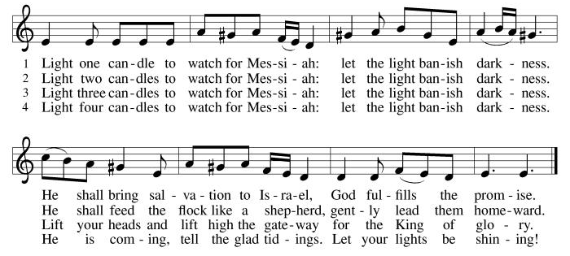

CONFESSION AND FORGIVENESS

All may make the sign of the cross, the sign that is marked at baptism, as the presiding minister begins.

Blessed be the Lord, the God of Israel, who alone does wondrous things.
Blessed be God’s name forever.
Amen.

Beloved, now is the time to wake from sleep. Let us confront our sins, and confess them to the one who is merciful and just.

Silence is kept for reflection.

God of new beginnings, we confess that we have not welcomed your holy reign. We have strayed from your paths. We prepare for war instead of peace. We dishonor one another and your creation. Purify us with your refining fire and set us again on your way of love, that we may bear fruit worthy of repentance, and welcome your coming among us.
Amen.

People of God, a new thing is growing in our midst, a tender branch, a living sign.
By water and the Spirit you are joined to this wonder. You have put on ☩ Christ,
and your sins have been washed away. Rejoice in the way of the Lord.
Amen.

GATHERING SONG O Come, O Come, Emmanuel #257 (v1-4)

*GREETING
The grace of our Lord Jesus Christ, the love of God, and the communion of the Holy Spirit be with you all. And also with you.

*canticle of praise Glory Be To God
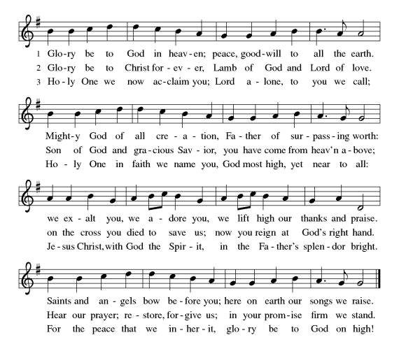

*PRAYER OF THE DAY
Let us pray. A brief silence. Stir up your power, Lord Christ, and come. With your abundant grace and might, free us from the sin that hinders our faith, that eagerly we may receive your promises, for you live and reign with the Father and the Holy Spirit, one God, now and forever. Amen.

WORD
God speaks to us in scripture reading, preaching, and song.______________________

CHILDREN’S MESSAGE

ANTHEM Mary Did You Know Chancel Choir

SCRIPTURE READING Isaiah 7:10-16 Pew Bible Old Testament Pg.705
Word of God, Word of Life. Thanks be to God.

RESPONSIVE PSALM Psalm 80:1-7,17-19 Pew Bible Old Testament Pg.598
Give ear, O Shepherd of Israel, you who lead Joseph like a flock! You who are enthroned upon the cherubim, shine forth
²before Ephraim and Benjamin and Manasseh. Stir up your might, and come to save us!
³Restore us, O God; let your face shine, that we may be saved.
⁴O Lord GOD of hosts, how long will you be angry with your people's prayers?
⁵You have fed them with the bread of tears, and given them tears to drink in full measure.
⁶You make us the scorn of our neighbors; our enemies laugh among themselves.
⁷Restore us, O God of hosts; let your face shine, that we may be saved. ¹⁷But let your hand be upon the one at your right hand, the one whom you made strong for yourself.
¹⁸Then we will never turn back from you; give us life, and we will call on your name.
¹⁹Restore us, O LORD God of hosts; let your face shine, that we may be saved.

*GOSPEL ACCLAMATION He Came Down #253

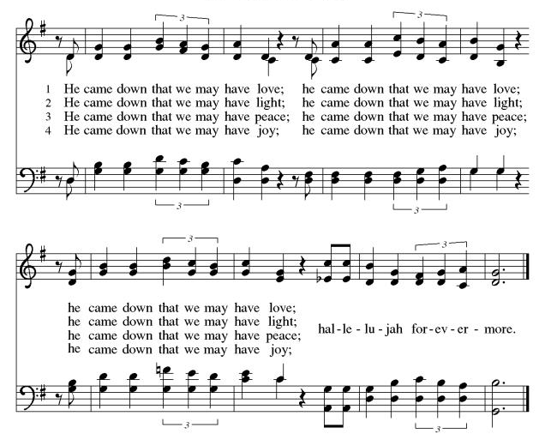

*GOSPEL Matthew 1:18-25 Pew Bible New Testament Pg. 1
The Holy Gospel according to Matthew, the 1st chapter. Glory to you, O Lord.
The reading concludes: The Gospel of the Lord. Praise to you, O Christ.

SERMON

*SERMON SONG Come, Thou Long-Expected Jesus #254

*APOSTLES’ CREED
I believe in God, the Father almighty, creator of heaven and earth.

I believe in Jesus Christ, God's only Son, our Lord, who was conceived by the Holy Spirit, born of the virgin Mary, suffered under Pontius Pilate, was crucified, died, and was buried; he descended to the dead. On the third day he rose again; he ascended into heaven, he is seated at the right hand of the Father, and he will come to judge the living and the dead.

I believe in the Holy Spirit, the holy catholic Church, the communion of saints,
the forgiveness of sins, the resurrection of the body, and the life everlasting. Amen.

PRAYERS OF THE CHURCH

As we prepare for the fullness of Christ’s presence, let us pray for a world that yearns for new hope.
A brief silence.
…God, in your mercy,
hear our prayer.

God of our longing, you know our deepest needs. By your Spirit, gather our prayers and join them with the prayers of all your children. In Jesus’ name we pray.
Amen.

*SHARING OF PEACE

The peace of the Lord be with you always. And also with you.

OFFERTORY Baby, Born a King Chancel Choir

*OFFERTORY RESPONSE Give Thanks

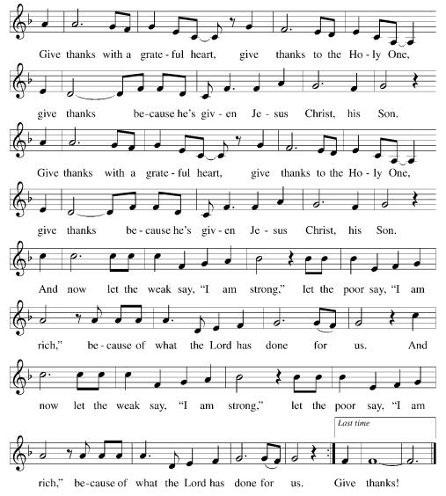

*OFFERTORY PRAYER

Let us pray, Eternal God, you make the desert bloom and send springs of water to thirsty ground. Receive these simple gifts of bread, wine, and money, and make us messengers of your mercy and love for all in need of your healing and justice. We ask this through Christ our Savior. Amen.
MEAL
God feeds us with the presence of Jesus.

*THE GREAT THANKSGIVING

The Lord be with you. And also with you.
Lift up your hearts. We lift them to the Lord,
Let us give thanks to the Lord our God. It is right to give our thanks and praise.
It is indeed right, our duty and our joy … we praise your name and join their unending hymn:
*HOLY, HOLY, HOLY

*THANKSGIVING AT THE TABLE

Blessed are you, O God...
…For as often as we eat this bread and drink this cup, we proclaim the Lord’s death until he comes. Christ has died. Christ is risen. Christ will come again.

*LORD’S PRAYER

Our Father, who art in heaven, hallowed be thy name, thy kingdom come, thy will be done, on earth as it is in heaven. Give us this day our daily bread; and forgive us our trespasses, as we forgive those who trespass against us; and lead us not into temptation, but deliver us from evil. For thine is the kingdom, and the power, and the glory, forever and ever. Amen.

INVITATION TO COMMUNION
Be strong, do not fear! Here is your God, who has come to save you.

DISTRIBUTION OF HOLY COMMUNION
We believe that this is Jesus' table. All are welcome and invited to commune. We serve communion by “intinction”; receive the bread and dip it in the chalice of red wine. Currently we are offering individual communion cups as an alternative to intinction if you so desire. Both wine and grape juice (white) are offered in the tray. Gluten free bread is available; let your server know. Should you choose not to commune, please come forward to receive a blessing. Please cross your arms across your chest.

lamb of god

COMMUNION SONG Lo, How a Rose E'er Blooming #272

*PRAYER AFTER COMMUNION
Faithful God, in this meal we have remembered your mercy, bringing heaven to earth in the body and blood of Christ. As we wait for the day when all your promises will be fulfilled, sustain us and strengthen us by this holy mystery. Guide us toward your promised future, coming to birth in Jesus Christ our Savior and Lord. Amen.

SENDING
God blesses us and sends us in mission to the world.
______________________________________________________________________

*BLESSING

God the eternal Word, who dwells with us in Jesus, and who holds us in the grace of the Holy Spirit, ☩ bless you now and forever. Amen.

*SENDING O Come, O Come, Emmanuel #257 (v5-8)

*Dismissal
Go in peace. Christ is near. Thanks be to God.

POSTLUDE

CHRIST LUTHERAN CHURCH STAFF

Interim Pastor Rev. Laurie Arroyo, pastor@christlutheranlb.com

Office Manager Kim Croes, officemanager@christlutheranlb.com
Interim Choir Director Kim Philips, kimsings@msn.com
Preschool Director Lisa Clinton, info@clplb.com
Accompanist Roger Halvorson
Percussionist Nathan Latiolait
Missionary to Colombia Linda Gawthorne

It is our joy to worship with your whole family this morning!

CHILDCARE

We encourage everyone of all ages and abilities to worship together. If you do need to take a "time out", please do so in the narthex (gathering space at the entry), and return to worship when you are ready. A changing table is located in the restroom off the narthex. Activity bags, filled with crayons, paper and storybooks, are available in the narthex. Please ask an usher if you need any assistance.

OUR MISSION STATEMENT

Christ Is Alive!

OUR VISION STATEMENT

Christ Lutheran Church is a community of believers committed to praising our Savior Jesus Christ. With his love, we reach out to those in need and welcome all with open hearts. Our worship dynamically combines, word, song and prayer to share God’s incredible message. Having faith in this, we go forth knowing that with God and the power of the Holy Spirit, anything is possible.

LIKE us on Facebook at www.facebook.com/christlutheranlb

Write a review of Christ Lutheran Church on YELP!

