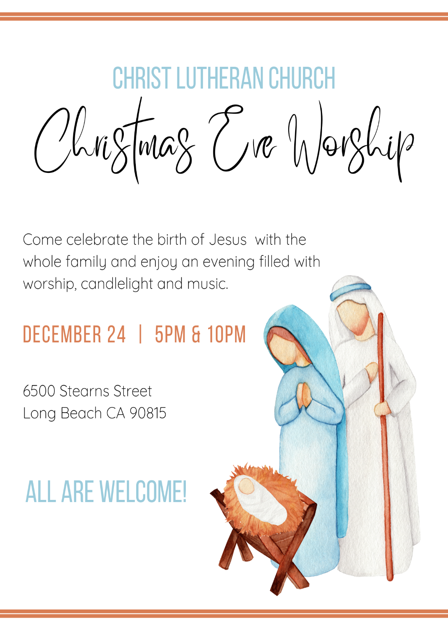

Christ Lutheran Church
Week at a Glance
December 18-December 25

Today Third Sunday of Advent
9:30am Worship -In Person & Live Streamed
Children’s Sunday school

Monday, December 19
No Events Scheduled

Tuesday, December 20
9:00 am Cover G’s

Wednesday, December 21
9:45am Bible Study (Zoom format)
6:00pm Guide Dogs of American Puppy Training

Thursday, December 22
10:30am Music Makers
11:30am Preschool Chapel
7:00pm Choir Rehearsal

Friday, December 23
Preschool Closed

Saturday, December 24 Christmas Eve
5:30pm Worship - In Person & Live Streamed
10:00pm Worship - In Person

Sunday, December 25 Christmas Day
9:30am Worship-In Person & Live Streamed

Flowers this morning are given in thanksgiving to God by Linda McGee in memory of her husband, Don McGee.

The Flower Chart for 2023 is now available on the door to the Usher’s Room, off of the Narthex. All are invited to sign up to sponsor altar flowers in honor of birthdays, anniversaries or other special events, or in memory of a loved one. Please make checks for $50 payable to Christ Lutheran Church and place in your offering envelopes the month of your sponsorship. Thank you for helping to beautify our worship space with your gifts.

Church in Society’s Giving Focus for December will be an in gathering of items for Maritime Ministries Seafarer’s Gift Bags. See details for the Mariner gift bags on the enclosed flyer.

Save the date: January 14th, 2023. We will need volunteers to help take down the Christmas tree and other decorations. Please meet in the sanctuary at 10am.

This morning’s worship assistants:
Assisting Minister: Ron Nelson
Reader: Doug Holdhusen
Communion Assistants: Claudia Fitzpatrick, Rich Oelschlaeger, Mike Maricle
Altar Guild: Matt and Rebecca Green
Ushers: Jeanne and Phil Peterson, Renu Moon
Thank you all.
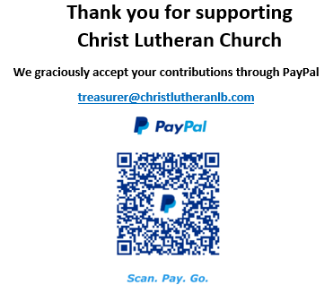

The Healing Power of the Holy Spirit

We pray for:

Members at Home or in Care Centers: Justin Bartlow, Laurie Ennen, Ione Marchael, Sydney Nichols, Don Westerhoff, and Frances Willms.

Those struggling with illness or other concerns:
Don Darnauer, Judy Haenn, Daniel Howard, Karen Koch, Sydney Nichols, , Stephanie Petrbok, Bary & Janice Schlieder, Doris Weinert, Kurt Weisel, Gary & Linda Zimmerman.

*Family & Friends: Marylyn, Terry, Cheryl, Lois Brown, Zach Burkard, Byron, John Caldwell, Scott Carr, Mireya Cervantes, Jon Christopherson, Steve, Charlie and David Corm, Mary Croes, JD, Glenn Darnauer, Tamara Fitzgerald, Brechin Flournoy, Alberta Gray, Cindy Gray, Evie Holdhusen, Kylie & Crystal Huber, Ray Irwin, Doris Jung, Barb Korsmo, Katrina Lahr, Sue Lance, Lenny Lloyd, Diana Lobel, Joyce, John McCarthy, Dewey Martin, Heather Nielsen, Hudson Nunnally, Paul Perencevic, Paula Pettit, Kristina & Scott Randolph, Emily Renton, Mary Kathryn Rivera, J.R. Rose, Vicki Thompson, Sharon and JT Tooman, Jessica, Steve and Jenny West.

*Names are included on the prayer list for 30 days unless specific requests are made through the office.

We also pray for the ongoing work of:

+ Christ Lutheran’s Pastoral Call Committee

+ Linda Gawthorne among the Kogi people of Colombia

+ First responders who provide safety, security, and care

+ Those serving in our nation's military, especially: Samuel Brown, Ryan Dorris,
Morgan Llewellyn, Johnny Luna, Jim Reeder, Steven, Brina and Michael Navarro.
Please provide us with names of those you would
like to include in these prayers.

+ Lutheran Social Services, Christian Outreach in Action, New Life Beginning.

