Please sign up at redcrossblood.org/CLCLB
to donate.

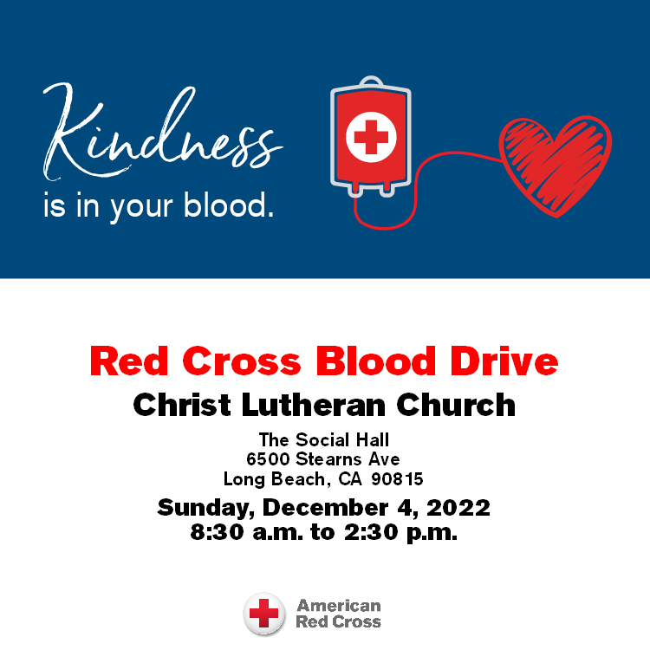

Christ Lutheran Church
Week at a Glance
November 27- December 4

Today First Sunday of Advent
9:30am Worship -In Person & Live Streamed
Children’s Sunday school

Monday, November 28
No Events Scheduled

Tuesday, November 29
9:00 am Cover G’s
11:30am DayTimer’s LunchBunch (Hof’s Hut on Bellflower Bl.)

Wednesday, November 30
9:45am Bible Study (Zoom format)
6:00pm Guide Dogs of American Puppy Training

Thursday, December 1
10:30am Music Makers
11:30am Preschool Chapel
7:00pm Choir Rehearsal

Friday, December 2
No Events Scheduled

Saturday, December 3
No Events Scheduled

Sunday, December 4
8:30am Red Cross Blood Drive
9:30am Worship-In Person & Live Streamed
Children’s Sunday School

Our Stewardship program ended last Sunday with a lovely brunch and warm fellowship time. Thank you Matt and Rebecca Green for gathering the delicious egg bakes, (thank you to the hands that lovingly prepared them) and for hosting us. It was a wonderful day.

Flowers this morning are given in thanksgiving to God by Doug Holdhusen in memory of Gerry Holdhusen.

Church in Society’s Giving Focus for December will be an in gathering of items for Maritime Ministries Seafarer’s Gift Bags and pajamas and books for the Lutheran Social Services (LSS) Community Christmas party. Details will be available next week.

The Nominating Committee for the next church council will begin searching for candidates to fill some council chairs that become vacant in January. If you are approached, please consider the request with an open heart and mind. The list of those committees will be available soon.

This morning’s worship assistants:
Assisting Minister: Lisa Cottrell
Reader: Lonnie Timney
Communion Assistants: Lonnie Timney, Rebecca Green, Matt Green
Altar Guild: Sue Bredenkamp and Claudia Fitzpatrick
Coffee Cart: Kim Croes
Ushers: Shannon and Steve Howard, Jeff Rodrigues
Thank you all.
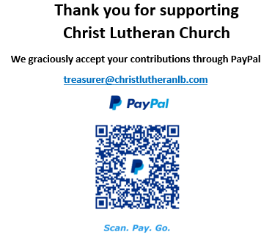

The Healing Power of the Holy Spirit

We pray for:

Members at Home or in Care Centers: Justin Bartlow, Laurie Ennen, Ione Marchael, Don Westerhoff, and Frances Willms.

Those struggling with illness or other concerns:
Don Darnauer, Judy Haenn, Daniel Howard, Karen Koch, Sydney Nichols, Shirley Pierce, Stephanie Petrbok, Bary & Janice Schlieder, Doris Weinert, Kurt Weisel, Gary & Linda Zimmerman.

*Family & Friends: Marylyn, Terry, Cheryl, Lois Brown, Zach Burkard, Byron, John Caldwell, Scott Carr, Jon Christopherson, Steve, Charlie and David Corm, Mary and Max Croes, JD, Glenn Darnauer, Tamara Fitzgerald, Brechin Flournoy, Alberta Gray, Cindy Gray, Evie Holdhusen, Kylie & Crystal Huber, Ray Irwin, Doris Jung, Jeff and Cindy Kolsin, Barb Korsmo, Katrina Lahr, Sue Lance, Lenny Lloyd, Diana Lobel, Joyce, John McCarthy, Dewey Martin, Heather Nielsen, Hudson Nunnally, Paul Perencevic, Paula Pettit, Kristina & Scott Randolph, Emily Renton, Mary Kathryn Rivera, J.R. Rose, Vicki Thompson, Sharon and JT Tooman, Addy Turchin, Jessica, Steve and Jenny West.

*Names are included on the prayer list for 30 days unless specific requests are made through the office.

The memory of Flo Bennett. Flo was the office manager for Christ Lutheran during the 1990’s. Her husband was a Pastor at Bethany Lutheran Church LCMS for many years. Flo passed away on November 2, 2022, at the age of 83 years. We remember her family and friends in prayer.

We also pray for the ongoing work of:

+ Linda Gawthorne among the Kogi people of Colombia

+ First responders who provide safety, security, and care

+ Those serving in our nation's military, especially: Samuel Brown, Ryan Dorris,
Morgan Llewellyn, Johnny Luna, Jim Reeder, Steven, Brina and Michael Navarro.
Please provide us with names of those you would
like to include in these prayers.

+ Congregations of the Greater Long Beach Conference.

