Please sign up at redcrossblood.org/CLCLB
to donate.

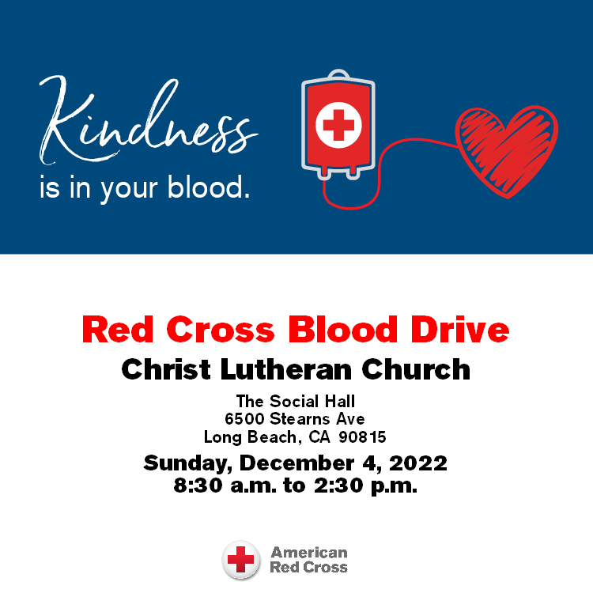

Christ Lutheran Church
Week at a Glance
November 20- November 27

Today Christ the King & Commitment Sunday
9:30am Worship -In Person & Live Streamed
Children’s Sunday school
11:00am Stewardship Brunch

Monday, November 21
No Events Scheduled

Tuesday, November 22
9:00 am Cover G’s not meeting today

Wednesday, November 23
9:45am Bible Study (Zoom format)

Thursday, November 24
10:30am Music Makers
11:30am Preschool Chapel
7:00pm Choir Rehearsal

Friday, November 25
No Events Scheduled

Saturday, November 26
No Events Scheduled

Sunday, November 27
9:30am Worship-In Person & Live Streamed
Children’s Sunday School

Our Stewardship program ends this morning with our final temple talk and delivering our pledges to the altar during communion. Join us this morning to celebrate with brunch after worship. All are welcome.

Church in Society’s Giving Focus for November is collecting food items and getting volunteers to prepare and serve a dinner meal at Christian Outreach in Action (COA) on Wednesday, November 30. Please bring your contributions to worship by next Sunday, the 27th. Shopping for additional items will happen on Monday, the 28th.

The Nominating Committee for the next church council will begin searching for candidates to fill some council chairs that become vacant in January. If you are approached, please consider the request with an open heart and mind. The list of those committees will be available soon.

This morning’s worship assistants:
Assisting Minister: Robin Black
Reader: Lisa Cottrell
Communion Assistants: Rich Oelschlaeger, Bryce Bonilla-Haenn,
Claudia Fitzpatrick
Altar Guild: Sue Bredenkamp and Stephanie Petrbok
Ushers: Shannon and Steve Howard, Jeff Rodrigues
Thank you all.
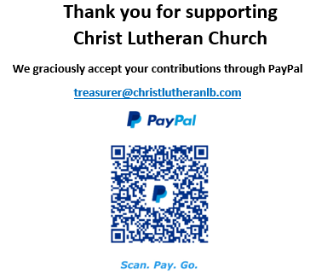

The Healing Power of the Holy Spirit

We pray for:

Members at Home or in Care Centers: Justin Bartlow, Laurie Ennen, Ione Marchael, Don Westerhoff, and Frances Willms.

Those struggling with illness or other concerns:
Don Darnauer, Judy Haenn, Daniel Howard, Karen Koch, Sydney Nichols, Shirley Pierce, Stephanie Petrbok, Bary & Janice Schlieder, Doris Weinert, Kurt Weisel, Gary & Linda Zimmerman.

*Family & Friends: Marylyn, Terry, Cheryl, Lois Brown, Zach Burkard, Byron, John Caldwell, Scott Carr, Jon Christopherson, Steve, Charlie and David Corm, Mary and Max Croes, JD, Glenn Darnauer, Tamara Fitzgerald, Brechin Flournoy, Alberta Gray, Cindy Gray, Evie Holdhusen, Kylie & Crystal Huber, Ray Irwin, Doris Jung, Barb Korsmo, Katrina Lahr, Sue Lance, Lenny Lloyd, Diana Lobel, Joyce, John McCarthy, Dewey Martin, Heather Nielsen, Hudson Nunnally, Paul Perencevic, Paula Pettit, Kristina & Scott Randolph, Emily Renton, Mary Kathryn Rivera, J.R. Rose, Vicki Thompson, Sharon and JT Tooman, Addy Turchin, Jessica, Steve and Jenny West.

*Names are included on the prayer list for 30 days unless specific requests are made through the office.

We also pray for the ongoing work of:

+ Linda Gawthorne among the Kogi people of Colombia

+ First responders who provide safety, security, and care

+ Those serving in our nation's military, especially: Samuel Brown, Ryan Dorris,
Morgan Llewellyn, Johnny Luna, Jim Reeder, Steven, Brina and Michael Navarro.
Please provide us with names of those you would
like to include in these prayers.

+ Lutheran Social Services, Christian Outreach in Action, New Life Beginnings.

