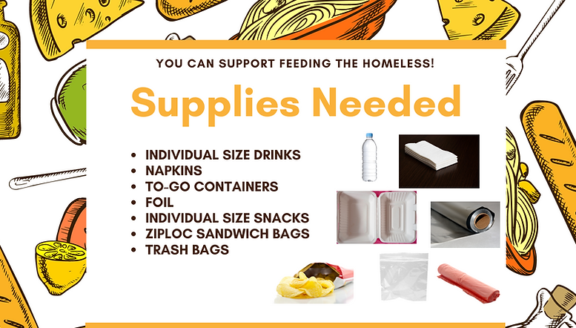

The money we collect this month will be used to purchase food to be prepared and served on Wednesday, August 31st specifically. Any funds left over will be used to purchase the above listed items which make distributing the to-go meals simpler.

Please use your regular envelope or special giving envelope and indicate what the COA amount is.

Christ Lutheran Church
Week at a Glance
August 7- August 14

Today
9:30am Worship -In Person
11:00am Event Planning meeting

Monday, August 8
No Events Scheduled

Tuesday, August 9
9:00 am Cover G’s
6:00pm Executive Committee
7:00pm Church Council

Wednesday, August 10
9:45am Bible Study (Zoom format)

Thursday, August 11
12:00pm OWLs Lunch

Friday, August 12
No Events Scheduled

Saturday, August 13
No Events Scheduled

Sunday, August 14
9:30am Worship-In Person

The Healing Power of the Holy Spirit

We pray for:
Members at Home or in Care Centers: Justin Bartlow, Laurie Ennen, Ione Marchael, Harriette Probst, Don Westerhoff, and Frances Willms.

Those struggling with illness or other concerns:
Judy Haenn, Daniel Howard, Sydney Nichols, Bary & Janice Schlieder, Gary & Linda Zimmerman.

Family & Friends: Marylyn, Terry, Cheryl, Lori, Keegan, Brandon, Erin Belk, Leah Blakeman, Lois Brown, Zach Burkard, Byron, John Caldwell, Scott Carr, Steve, Charlie and David Corm, Mary and Max Croes, Pam Croes, Noah Dodd, Dorcas, Tamara Fitzgerald, Brechin Flournoy, Alberta Gray, Cindy Gray, Michael Hardman, Evie Holdhusen, Bobbie Hoenig, Kylie & Crystal Huber, Ray Irwin, Ben Kalish, JoDee Irwin, Doris Jung, Linda Kuhn, Cindy and Jeff Kolsen, Barb Korsmo, Katrina Lahr, Sue Lance, the Lewis family, Lenny Lloyd, Diana Lobel, Janice Mackey, Heather Nielsen, Hudson Nunnally, Barb Ontiveros, Peacemaker, Paul Perencevic, Paula Pettit, Kristina & Scott Randolph, Emily Renton, Mary Kathryn Rivera, J.R. Rose, Ferdinand Segarra, Jeff Spencer, Theresia Tuer, the Watt-Morse family, Ed Weston, Teresa, Jessica, Steve and Jenny West.

We also pray for the ongoing work of:
+ Linda Gawthorne among the Kogi people of Colombia

+ First responders who provide safety, security, and care

+ Those serving in our nation's military, especially: Samuel
Brown, Ryan Dorris, Johnny Luna, Jim Reeder, Steven, Brina
and Michael Navarro. Please provide us with names of
those you would like to include in these prayers.

+ Lutheran Maritime Ministries, Christian Outreach in Action,
New Life Beginnings, Miracle Ranch.

Altar flowers this morning are given to the glory of God, by Rebecca and Matt Green in thanksgiving and honor of their 38th wedding anniversary.

The flower chart is on the door of the Usher’s Room off of the narthex if you would like to sponsor flowers in honor or memory of someone or if you’d like to commemorate a special occasion.
Each Sunday you sign up for will be $3o and you can make a check payable to Christ Lutheran. Thank you.

Please stay for a few minutes after worship this morning to attend a quick meeting focusing on some upcoming events we would like to host here at CLC. Your Outreach, Church in Society and Connection committees are working hard to honor your wishes to bring new people in to our church community. These initial activities will be open to our church members, the preschool families and our friends in the Namaste` congregation. It will take volunteers to make these dreams come true for us so please give some of your time to the ministry of CLC in our little part of the world.

Church in Society’s Giving Focus for August is collecting funds for Christian Outreach in Action (COA). We will be donating the money needed to prepare and serve dinner on Wednesday, August 31. We are still hopeful that we will be able to do the actual work of cooking and serving for the community in the near future.

This morning’s worship assistants:
Assisting Minister: Mike Maricle
Reader: Doug Holdhusen
Communion Assistants: Lisa Cottrell, Stephanie Murray
Altar Guild: Sue Bredenkamp, Tricia Latiolait
Coffee Cart Treats: Mary & Gary Thoen
Ushers: Jeanne and Phil Peterson, Renu Moon
Greeter: Doug Holdhusen
Thank you all.

