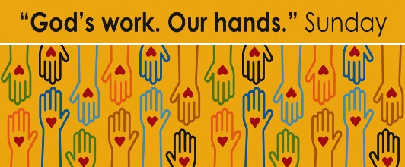
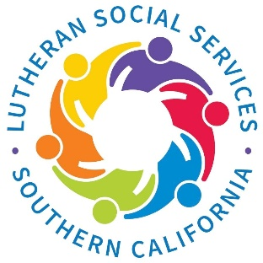
September 25, 2022

This day is an opportunity to celebrate who we are as the Evangelical Lutheran Church in America – one church, freed in Christ to serve and love our neighbor.
Service activities offer an opportunity for us to explore one of our most basic convictions as Lutherans: that all of life in Jesus Christ – every act of service, in every daily calling, in every corner of life – flows freely from a living, daring confidence in God’s grace.
The service project that has been selected by CLC’s Church in Society committee is to build “Welcome Home” baskets for those individuals leaving LSS for their own homes. These baskets will include some of the items needed when first moving into a new apartment. Throughout the month of September, we will be collecting the items listed below and on Sunday, the 25th we will fill laundry baskets with these necessities.
These supplies can be purchased from dollar stores, club stores or other discount outlets. Please donate only the items on this list so that the baskets are uniform for all recipients.

Service for two:
Melamine plates and bowls Spray Air Freshener
Acrylic or plastic drinking cups Toilet Paper
Flatware: forks, knives and spoons 409 Type Cleanser
Coffee Cups Toilet Bowl Cleaner
Dish Soap Toilet Brush and Holder
Sponges Oven Mitts
Dish Towels Pump hand Soap
Paper Towels Glass Cleaner
Soft Scrub

Christ Lutheran Church
Week at a Glance
August 28- September 4

Today
9:30am Worship -In Person & Live Streamed

Monday, August 29
Preschool Fall Session begins

Tuesday, August 30
9:00 am Cover G’s
11:30am DayTimer’s LunchBunch

Wednesday, August 31
9:45am Bible Study (Zoom format)

Thursday, September 1
No Events Scheduled

Friday, September 2
No Events Scheduled

Saturday, September 3
12:00pm Sons of Norway

Sunday, September 4
9:30am Worship-In Person & Live Streamed

The Healing Power of the Holy Spirit

We pray for:

Members at Home or in Care Centers: Justin Bartlow, Laurie Ennen, Ione Marchael, Don Westerhoff, and Frances Willms.

Those struggling with illness or other concerns:
Don Darnauer, Judy Haenn, Daniel Howard, Karen Koch, Sydney Nichols, Bary & Janice Schlieder, Gary & Linda Zimmerman.

Family & Friends: Marylyn, Terry, Cheryl, Lori, Keegan, Brandon, Erin Belk, Leah Blakeman, Lois Brown, Zach Burkard, Byron, John Caldwell, Scott Carr, Steve, Charlie and David Corm, Mary and Max Croes, Pam Croes, Glenn Darnauer, Noah Dodd, Dorcas, Tamara Fitzgerald, Brechin Flournoy, Alberta Gray, Cindy Gray, Michael Hardman, Evie Holdhusen, Bobbie Hoenig, Kylie & Crystal Huber, Ray Irwin, Diana Johnson and family, Ben Kalish, JoDee Irwin, Doris Jung, Linda Kuhn, Cindy and Jeff Kolsen, Barb Korsmo, Katrina Lahr, Sue Lance, the Lewis family, Lenny Lloyd, Diana Lobel, Terri Lujan, Janice Mackey, Heather Nielsen, Hudson Nunnally, Barb Ontiveros, Peacemaker, Paul Perencevic, Paula Pettit, Kristina & Scott Randolph, Emily Renton, Mary Kathryn Rivera, J.R. Rose, Ferdinand Segarra, Jeff Spencer, Theresia Tuer, the Watt-Morse family, Ed Weston, Teresa, Jessica, Steve and Jenny West.

We also pray for the ongoing work of:

+ Linda Gawthorne among the Kogi people of Colombia

+ First responders who provide safety, security, and care

+ Those serving in our nation's military, especially: Samuel
Brown, Ryan Dorris, Morgan Llewellyn, Johnny Luna,
Jim Reeder, Steven, Brina and Michael Navarro.
Please provide us with names of those you would
like to include in these prayers.

+ Congregations of the Greater Long Beach Conference.

Altar flowers this morning are given to the glory of God, by Beverly Koenen in memory of her husband, Donald Koenen.

Church in Society’s Giving Focus for August is collecting funds for Christian Outreach in Action (COA). We will be donating the money needed to prepare and serve dinner on Wednesday, August 31. We are still hopeful that we will be able to do the actual work of cooking and serving for the community in the near future.

The memorial service for Harriette Probst has been set for Saturday, September 10th at 2pm here at Christ Lutheran. Her service will be followed by coffee and dessert in the social hall.

Christmas Market & Craft Faire is already being planned for this year. It will be held on Saturday, November 19. If you or anyone you know would like to be a vendor at this event, please have them contact Kim 562 598-2433, Lisa 562 968-8941, or Claudia 562 706-2488 for details and to reserve a space.

Save these dates:
Sept. 18 – Rally Sunday, Teacher Installation, First day of
Sunday School
September 25 – Congregation Meeting and Assembling
Welcome Home baskets for God’s Work. Our Hands.

This morning’s worship assistants:
Assisting Minister: Robin Black
Reader: Lonnie Timney
Communion Assistants: Lisa Cottrell, Lonnie Timney
Altar Guild: Pat Barnett, Annette Rodrigues
Coffee Cart Treats: Nicole Halvorson
Greeter: Sue Bredenkamp
Ushers: Jeanne and Phil Peterson, Renu Moon
Thank you all.

