Eighth Sunday After Pentecost
July 31, 2022
9:30am

Christ Lutheran Church
6500 E. Stearns Street
Long Beach, California 90815
Phone 562-598-2433
www.christlutheranlb.com

Preschool 562-594-6117
www.clclb.com

Welcome to worship! We’re glad you’re here!

To assist in your worship: * means stand as you are able, bold print means we respond together, + you may make the sign of the cross should you so desire.

TODAY’S worship THEME

Today’s texts offer instruction and encouragement for all who are occasionally overwhelmed by the “unhappy business” of life. Jesus urges us to take care and be on guard against all kinds of greed. We who have died with Christ in holy baptism have also been raised with him and are encouraged to elevate our thinking, seeking the “things that are above.” To that end we seek the sustenance of the Lord’s supper and the encouragement of God’s word.

Our liturgy is taken from:
Sundays and Seasons.com. Copyright 2022 Augsburg Fortress. All rights reserved.
Reprinted by permission under Augsburg Fortress Liturgies Annual License #20338.
Reprinted by permission under CCLI license # 230154. All rights reserved
Reprinted by permission under © 2022 One License #A-706154. All rights reserved

GATHERING
The Holy Spirit calls us together as the people of God.

PRELUDE

WELCOME AND ANNOUNCEMENTS

CONFESSION AND FORGIVENESS

All may make the sign of the cross, the sign that is marked at baptism, as the presiding minister begins.

Blessed be the holy Trinity,☩ one God,
whose steadfast love endures forever.
Amen.
Let us confess our sin in the presence of God and of one another.
Silence is kept for reflection.

Merciful God,
we confess that we have not followed your path
but have chosen our own way.
Instead of putting others before ourselves,
we long to take the best seats at the table.
When met by those in need,
we have too often passed by on the other side.
Set us again on the path of life.
Save us from ourselves
and free us to love our neighbors.
Amen.

Hear the good news!
God does not deal with us according to our sins
but delights in granting pardon and mercy.
In the name of ☩ Jesus Christ, your sins are forgiven.
You are free to love as God loves.
Amen.

*GATHERING SONG Gather Us In #532
*GREETING

The grace of our Lord Jesus Christ, the love of God and the communion of the Holy Spirit be with you all. And also with you.

*HYMN OF PRAISE Now the Feast and Celebration

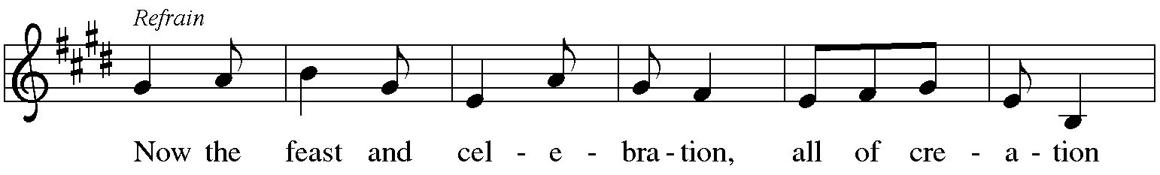
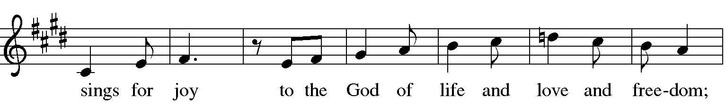
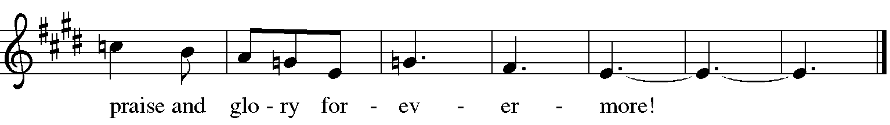
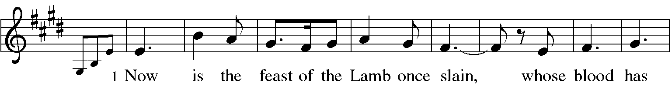
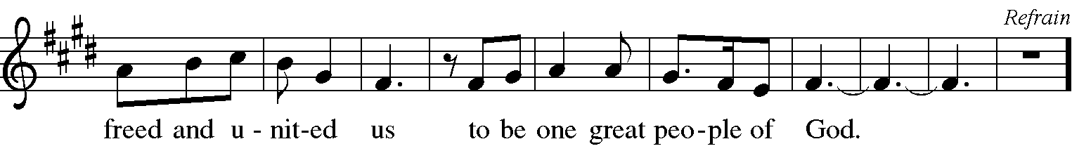
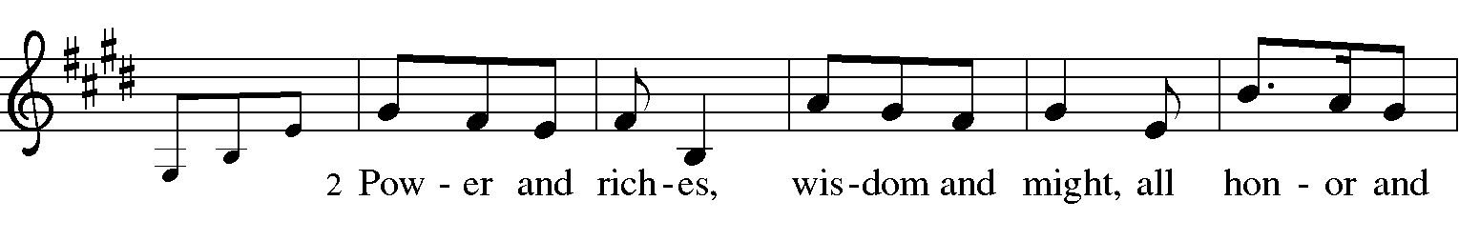
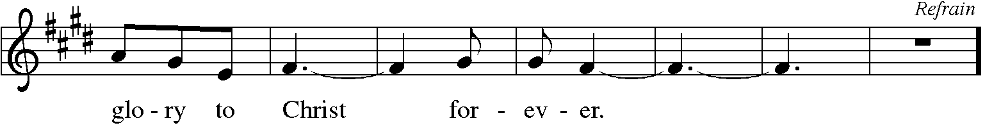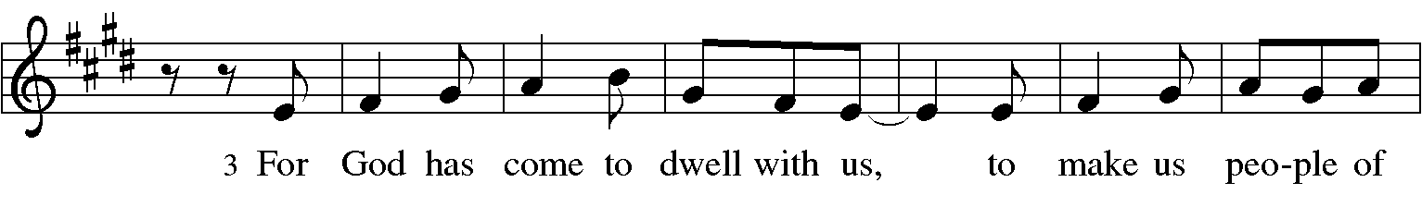
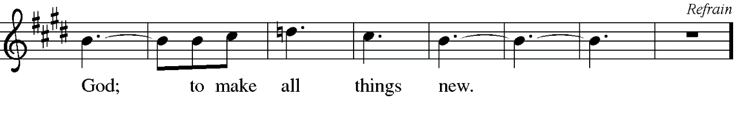

*PRAYER OF THE DAY
Let us pray. A brief silence. Benevolent God, you are the source, the guide, and the goal of our lives. Teach us to love what is worth loving, to reject what is offensive to you, and to treasure what is precious in your sight, through Jesus Christ, our Savior and Lord. Amen.

WORD
God speaks to us in scripture reading, preaching, and song.

SCRIPTURE READING Psalm 49:1-12 Pew Bible Old Testament Pg. 573
The Word of the Lord. Thanks be to God

*GOSPEL ACCLAMATION

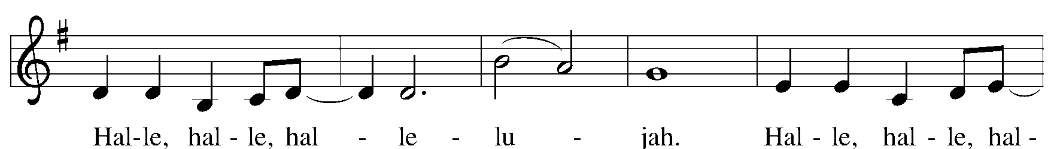
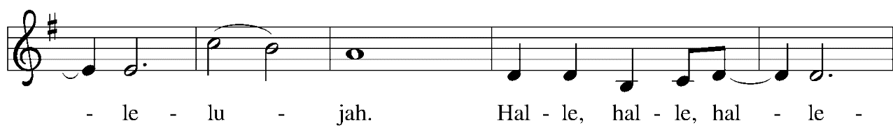

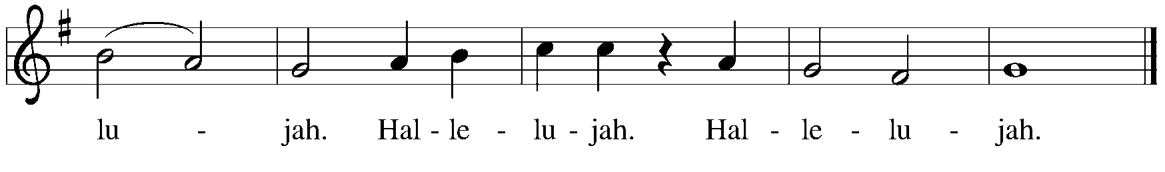

*GOSPEL Luke 12:13-21 Pew Bible New Testament Pg. 76

The Holy Gospel according to Luke the11thchapter. Glory to you, O Lord.

The reading concludes: The Gospel of the Lord. Praise to you, O Christ.

CHILDREN’S MESSAGE

SERMON

*SERMON SONG Word of God, Come Down on Earth # 510

*APOSTLES’ CREED

I believe in God, the Father almighty, creator of heaven and earth.

I believe in Jesus Christ, God's only Son, our Lord, who was conceived by the Holy Spirit, born of the virgin Mary, suffered under Pontius Pilate, was crucified, died, and was buried; he descended to the dead. On the third day he rose again; he ascended into heaven, he is seated at the right hand of the Father, and he will come to judge the living and the dead.

I believe in the Holy Spirit, the holy catholic Church, the communion of saints,
the forgiveness of sins, the resurrection of the body, and the life everlasting. Amen.

PRAYERS OF THE CHURCH

Trusting in God’s extraordinary love, let us come near to the Holy One in prayer.

Merciful God, receive our prayer.

Receive the prayers of your children, merciful God, and hold us forever in your steadfast love, through Jesus Christ, our holy Wisdom. Amen.

*SHARING OF PEACE

The peace of the Lord be with you always. And also with you.

OFFERTORY

*OFFERTORY RESPONSE As the Grains of Wheat

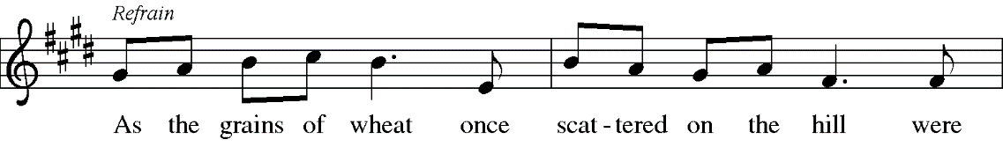
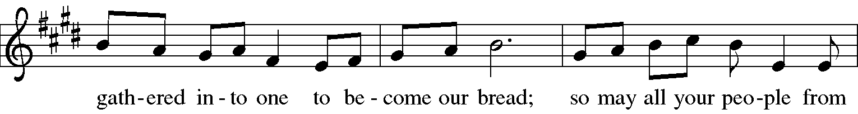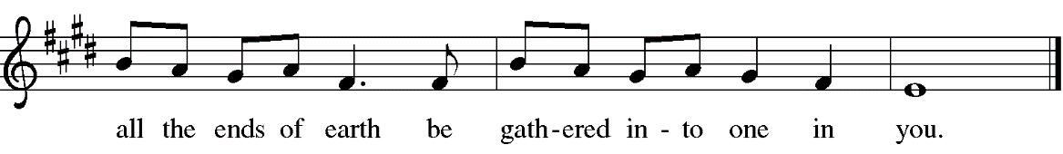
*OFFERTORY PRAYER

Let us pray, God of abundance: you have set before us a plentiful harvest. As we feast on your goodness, strengthen us to labor in your field, and equip us to bear fruit for the good of all in the name of Jesus. Amen.

MEAL
God feeds us with the presence of Jesus.

*THE GREAT THANKSGIVING

The Lord be with you. And also with you.
Lift up your hearts. We lift them to the Lord,
Let us give thanks to the Lord our God. It is right to give our thanks and praise.
It is indeed right, our duty and our joy … we praise your name and join their unending hymn:
*HOLY, HOLY, HOLY

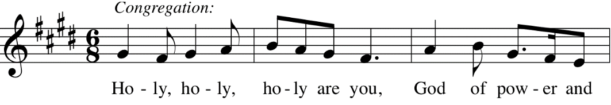
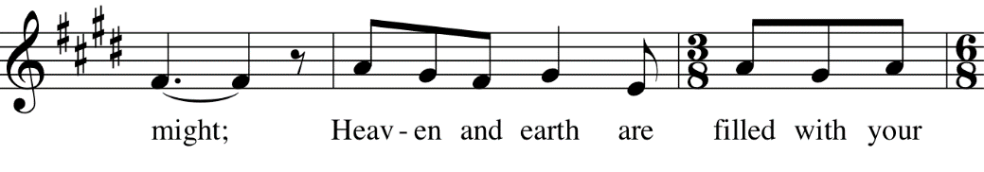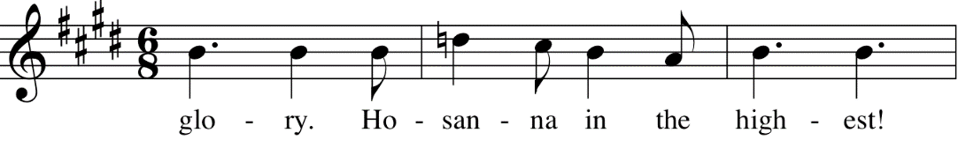

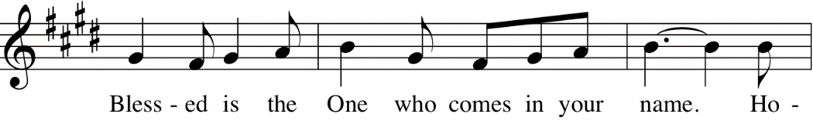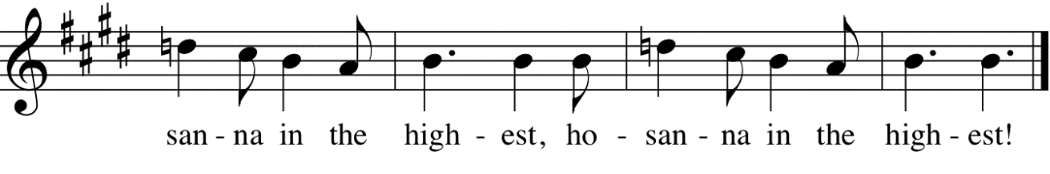

*THANKSGIVING AT THE TABLE

O God most mighty, O God most merciful...

Remembering his death, we cry out Amen. Amen.
Celebrating his resurrection, we shout Amen. Amen.
Trusting his presence in every time and place, we plead Amen. Amen.

*LORD’S PRAYER

Our Father, who art in heaven, hallowed be thy name, thy kingdom come, thy will be done, on earth as it is in heaven. Give us this day our daily bread; and forgive us our trespasses, as we forgive those who trespass against us; and lead us not into temptation, but deliver us from evil. For thine is the kingdom, and the power, and the glory, forever and ever. Amen.

DISTRIBUTION OF HOLY COMMUNION
We believe that this is Jesus' table. All are welcome and invited to commune. We serve communion by “intinction”; receive the bread and dip it in either the red wine or white grape juice. Currently we are offering individual communion cups as an alternative to intinction if you so desire. Gluten free bread is available; let your server know. Should you choose that your child not commune, please have them come forward with you to receive a blessing. If you choose not to commune, you are welcome to come forward for a blessing. Please cross your arms across your chest.

lamb of god

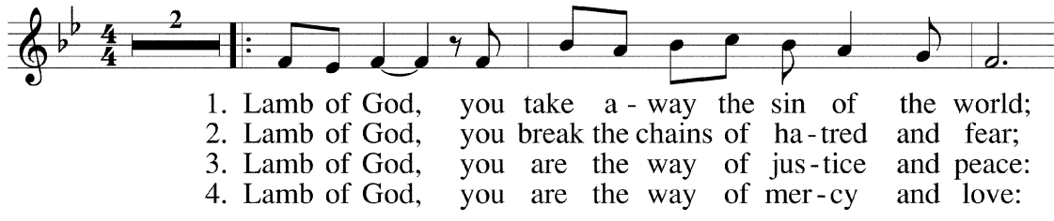
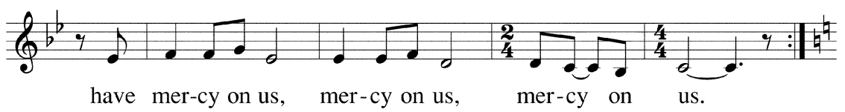
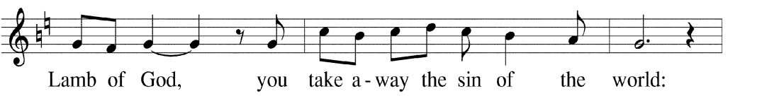
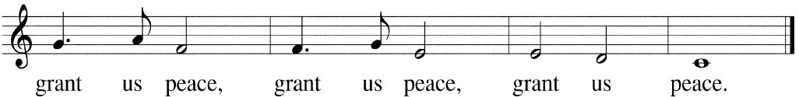

COMMUNION SONG Here is Bread # 483

*PRAYER AFTER COMMUNION
Life-giving God, through this meal you have bandaged our wounds and fed us with your mercy. Now send us forth to live for others, both friend and stranger,
that all may come to know your love. This we pray in the name of Jesus.
Amen.

*THANKS BE TO YOU 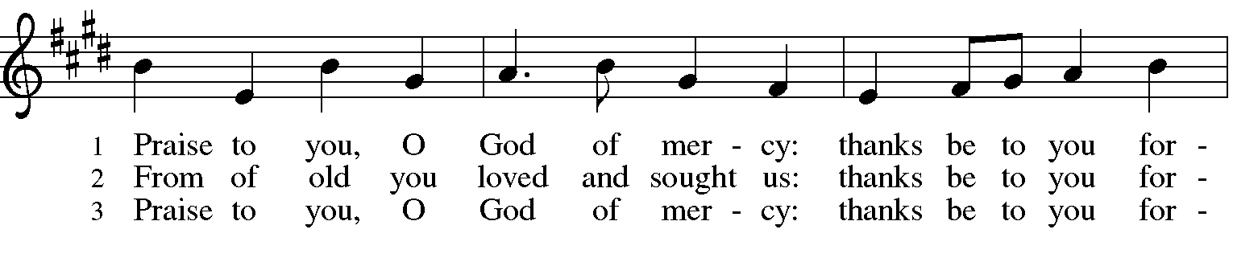
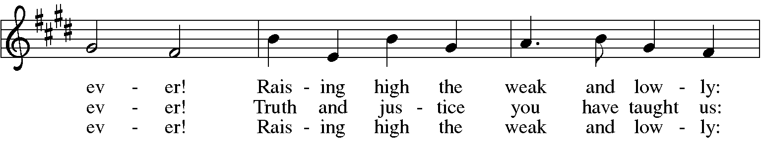
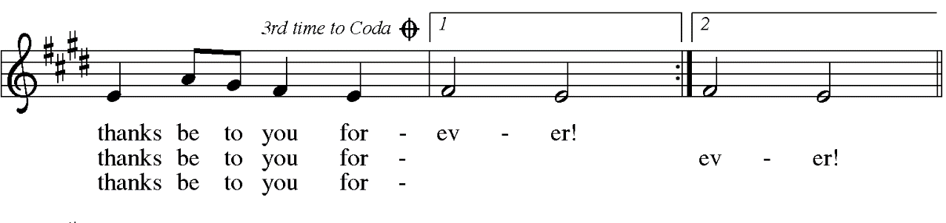
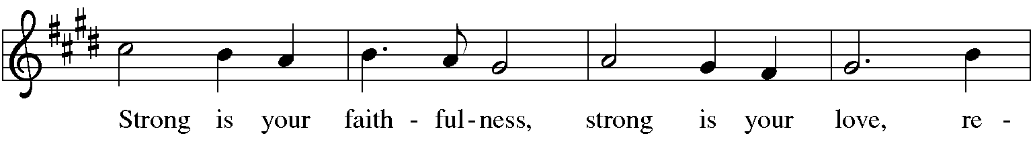
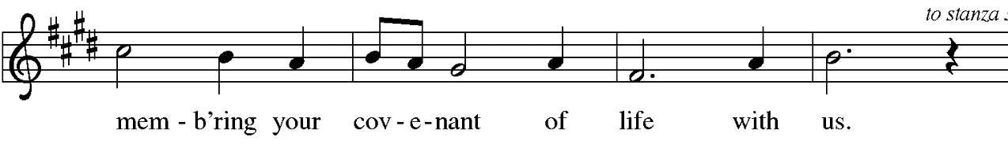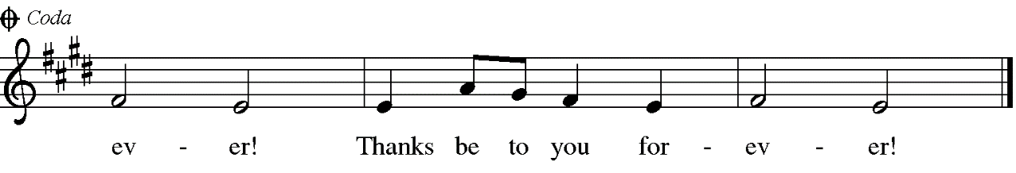

SENDING
God blesses us and sends us in mission to the world.

*BLESSING

*SENDING HYMN Here I Am Lord #574

*Dismissal

Go in peace. Love your neighbor. Thanks be to God!

POSTLUDE

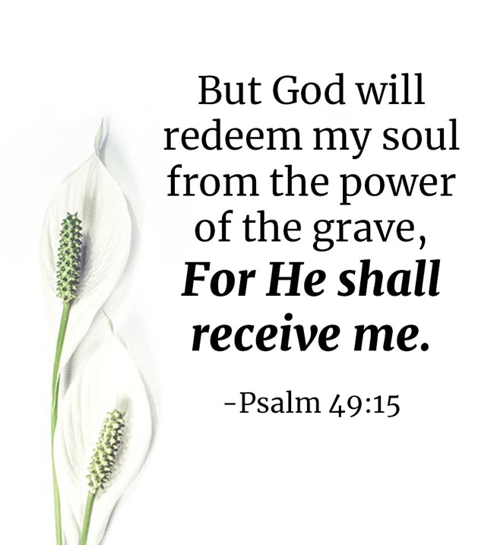

CHRIST LUTHERAN CHURCH STAFF

Interim Pastor Rev. Laurie Arroyo, lauriethere@msn.com
Office Manager Kim Croes, officemanager@christlutheranlb.com
Preschool Director Lisa Clinton, info@clplb.com
Accompanist Roger Halvorson
Percussionist Nathan Latiolait
Missionary to Colombia Linda Gawthorne

It is our joy to worship with your whole family this morning!

CHILDCARE

We encourage everyone of all ages and abilities to worship together. If you do need to take a "time out", please do so in the narthex (gathering space at the entry), and return to worship when you are ready. A changing table is located in the restroom off the narthex. Activity bags, filled with crayons, paper and storybooks, are available in the narthex. Please ask an usher if you need any assistance.

OUR MISSION STATEMENT

Christ Is Alive!

OUR VISION STATEMENT

Christ Lutheran Church is a community of believers committed to praising our Savior Jesus Christ. With his love, we reach out to those in need and welcome all with open hearts. Our worship dynamically combines, word, song and prayer to share God’s incredible message. Having faith in this, we go forth knowing that with God and the power of the Holy Spirit, anything is possible.

LIKE us on Facebook at www.facebook.com/christlutheranlb

Write a review of Christ Lutheran Church on YELP!

