

**Pastor Pam’s Pennings**

**October 2018**

**Volume 62, Issue 10**

*For everything there is a season, and a time for every matter under heaven:* Ecclesiastes 3:1

**It’s pumpkin spice time! Have you noticed that as soon as fall even hints at arriving, things start arriving in pumpkin spice flavor? I love it, but sometimes I think it’s getting a bit out of hand! But, grab it while you can, for soon peppermint flavors will be upon us!**

**Fall season is upon us as October begins to stretch the length of our nights. It’s the season for shorter days to begin. I’m noticing that, are you?**

**It’s Stewardship season for us at CLC! We will be blessed to hear stewardship temple talks each week this month from a different member as they talk about how they are *Recognizing God’s Grace*.**

**Sunday Education is in full swing for the season. I hope you have taken the schedule, put it on your refrigerator, and marked those Sundays you won’t want to miss! Please note, it’s SUNDAY EDUATION, not Adult Education anymore! Deborah Otterson and I are very determined that these events be as inclusive of ages as possible! Families are welcome to attend!**

**Also, I am pleased that Pastor Dawn Haas will be leading our Grief Group beginning on October 7. Pastor Dawn specializes in Grief and Bereavement Counseling, and she will lead you with excellence. Pastor Dawn and I were colleagues back in Chicago and I am very happy she is here!**

**Confirmation will be on Sunday, October 28. We have five young people who will be confirmed on that day: Joaquin Alfonso, Seth Elliott, Ariel Joubert-Honacki, Jack Rollins, and Faith Timney. They will be with the Congregation Council members and me for a retreat on October 13 at church as they contemplate what it means to be a member of this congregation and an even bigger part of the body of Christ.**

**We will have our Reformation celebration on October 28 as well! Beer, brats, confirmation cake, and our stewardship pledges - what can be better?!?!**

**God is good! Pastor Pam**

[](https://www.google.com/url?sa=i&rct=j&q=&esrc=s&source=images&cd=&cad=rja&uact=8&ved=0ahUKEwi5n4LKwe7VAhVM7SYKHTsxAHkQjRwIBw&url=https://www.dreamstime.com/royalty-free-stock-photos-worship-word-cut-out-magazine-letters-pinned-to-cork-notice-board-image31875288&psig=AFQjCNHtQNftiCbphbpqEfe3vi_44OplFg&ust=1503616741266411)[](https://www.google.com/url?sa=i&rct=j&q=&esrc=s&source=images&cd=&cad=rja&uact=8&ved=0ahUKEwjD44Xn_5bYAhWDKiYKHZT5CRsQjRwIBw&url=https://rfclipart.com/custom-ampersand-symbol-92754-vector-clipart.html&psig=AOvVaw0YzYmaLRsyQX0SW3ekUeon&ust=1513804608059279)[](https://www.google.com/url?sa=i&rct=j&q=&esrc=s&source=images&cd=&cad=rja&uact=8&ved=0ahUKEwi87Njpvu7VAhVEQCYKHRspCxgQjRwIBw&url=https://www.pinterest.com/pin/206321226655487895/&psig=AFQjCNGC2Zlf6Ho9jizSTqZctweosf9gRA&ust=1503616652887332)

**Greetings!**

**Fall! Yay! My second favorite season (I’m a summer guy). I cannot believe it is already October. We start the month off with our ‘blessing of the animal’s and finish the month with Reformation Sunday—complete with Confirmation, wonderful music, and beer and brats (sorry confirmands but no beer for you!). Halloween is always a blast around here with Trunk-or-Treat…as the little ones dress up and go around the parking lot collecting candies and goodies from our cars. Like I said, I love the fall.**

**Youth Music News!!!!**

**Musicmakers meet on Tuesdays @11:00. These four year olds are just beginning their musical journey that hopefully leads to Kaleidoscope next year. So cute!**

**Kaleidoscope I** **is on Tuesdays from 4:30-5:00.** **Kaleidoscope I** **is for those new to the group; Kaleidoscope II meets from 5:00-5:30. This is for the returning children from last year and/or those with prior music experience. Please notify me before coming so I can choose the best fit for your child**. We will now be meeting upstairs in Room 8. I am very excited for we have 12 kids this year and growing. Yay!!!!!

**Youth Band** **is on hold. The kids currently have schedule conflicts and are working alone until they can come together again and practice. At their current playing level, they still should be able to perform at the Christmas Concert.**

**The Music Teams** **are already beginning to look towards Christmas music. We need new members to keep these groups strong. To make sure we have enough singers (in the choir) and ringers (in the bell choir), please consider joining us this season.**

**Worship Report: Everything concerning the piano, bells, and organ has been fixed (until a new problem occurs). We have had a lot of changes this year so please contact the church office before throwing away any items from around the church campus, including items in the attic…no matter how old they look. Some of these items may look un-important but are very important.**

**Once again, thank you for your time, talents, and treasures…as well as your love and support.**

**Your humble Director,**

**Brian Madigan**

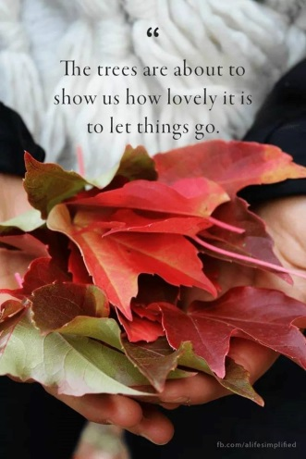**High School and Young Adult Ministries**

***“I would rather sit on a pumpkin and have it all to myself than be crowded on a velvet cushion.” ~ Henry David Thoreau.***

**October is upon us (how did THAT happen?!) and so begins my most favorite time of year – pumpkin everything galore, Halloween, Thanksgiving, Christmas… and a bit of homesickness for apple picking and trees that change into these wonderful hues of orange and red and yellow. With the trees beginning to shed their leaves, what will you “let go” of that is keeping you from building a relationship with God?**

**THANK YOU!**

Rally Sunday was a huge success! Thank you to everyone who attended and volunteered!

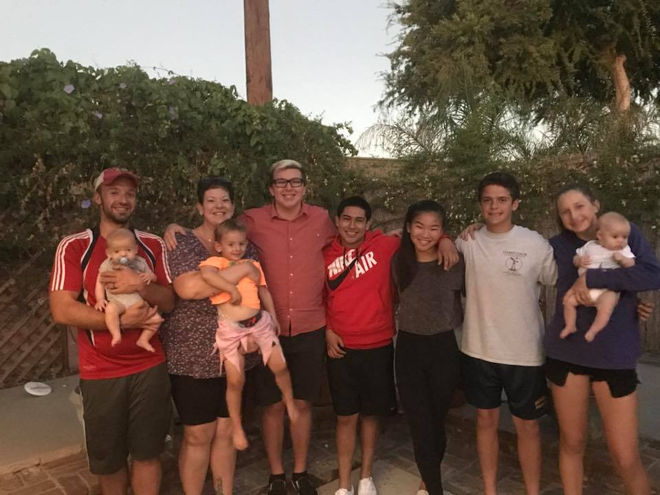



**LOFT**

We had a wonderful kick-off BBQ on Sunday, September 16! Here’s to another wonderful year together!

**Sunday, October 7; 11 a.m. – 1 p.m.: LIVING: Mindful Faith.** What does it mean to have mindful faith? How can we be more present with each other and with Christ?

**Sunday, October 14, 2018; 11 a.m. – 1 p.m.: OUT: BBQ at Brian Madigan’s House.**

**Sunday, October 21, 2018; 11 a.m. – 1 p.m.: FAITH:** This week, we will have another OUT Sunday as I will be in Chicago to celebrate Frances and Caleb’s baptism. Laurel Elliott will be taking participants to an ice-skating rink in Lakewood. They have open skate from 1:40 – 3:40 p.m. Laurel can fit 7 people in her car. Please have participants bring $20-25 for lunch and skating. Laurel will drive everyone home after skating is done.

**Sunday, October 28, 2018; NO LOFT!** Confirmation/Reformation Sunday! Be sure to stay after church to celebrate our confirmands!

[](http://www.clipartof.com/portfolio/bnpdesignstudio/illustration/group-of-diverse-kids-looking-up-433029.html)**Preschool News**

**Our fall session began on Monday, August 27 and we are off to a smooth start.**

**Our teachers were installed during worship on Rally Sunday, September 9th and then some stayed for the food truck and fun after. Several Preschool families came for the Community Fair as well! We had Back to School night on Monday, September 10th and got to know some of our new families a little better.**

[](http://www.oakes.k12.nd.us/2018/09/10/picture-days-911-912/)

**Now as we move in to October, we will have our school picture days on October 16 and 17. We will be closed on Thursday, October 18 for a staff development day. Our staff will be going to Huntington Beach for a conference on art, promoting critical thinking and developmentally appropriate math skills with guest speaker John Funk.**

[](https://www.google.com/url?sa=i&rct=j&q=&esrc=s&source=images&cd=&cad=rja&uact=8&ved=2ahUKEwi11cnQhsjdAhUORKwKHYt6DMQQjRx6BAgBEAU&url=https://clipartxtras.com/categories/view/339bbdb151879d41fd2d6b67508ea0e0e9adfb91/harvest-festival-clipart-free.html&psig=AOvVaw1igT2J-BpJg-IwLwjNMfcy&ust=1537480287927648)

[](https://www.google.com/url?sa=i&rct=j&q=&esrc=s&source=images&cd=&cad=rja&uact=8&ved=2ahUKEwiFldqEh8jdAhUOLKwKHTpmCvQQjRx6BAgBEAU&url=https://za.pinterest.com/pin/218072806937182725/&psig=AOvVaw3GrIia9ws24mzjgwco9kpi&ust=1537480353665505)**We will end our month with our Harvest Fest and Trunk-or-Treating celebration on Wednesday, October 31st. The children love dressing up and going trunk to trunk to get treats and then playing all of the special games on the yard.**

**It is always amazing to see our parents’ creativity shine as you decorate your trunks! If you would like to decorate your trunk and pass out treats to the kids, you are welcome to come! The cars need to be set up by 11:30am and have enough treats for 60 children.**

**Blessings for a beautiful fall!**

**Lisa Clinton**

[](http://www.google.com/url?sa=i&rct=j&q=&esrc=s&source=images&cd=&cad=rja&uact=8&ved=2ahUKEwjfwYXQh9fdAhVJlKwKHV5nAYcQjRx6BAgBEAU&url=http://www.clipartpanda.com/categories/pet-clipart&psig=AOvVaw2luYWTS98P7XTLMIBKoBk3&ust=1537995952839303)**OWLs in the Nest** This regular fellowship time is an opportunity to enjoy a potluck meal, conversations with each other, Pastor Pam and maybe interesting visitors, play cards or other types of games, etc**. Make sure to be at the next meeting on Thursday, October 11th, at 12:30pm in the social hall** everyone else who attends is asked to bring a salad or dessert to share. If you have any questions, please contact Harriette Probst at 562 430-9448; leave a message and say that you are from Christ Lutheran.

**++++++++++++++++++++++++**

[](https://www.google.com/url?sa=i&source=images&cd=&cad=rja&uact=8&ved=2ahUKEwiHg9-X-JzbAhUr0YMKHZjiBbIQjRx6BAgBEAU&url=http://sacredhearterie.org/home/bible-study/&psig=AOvVaw3mrVjEfvfbScxlHif00CAO&ust=1527202849794818)**Adult Bible Study** is now meeting on the second and fourth Wednesdays of each month at 7:15pm in the home of Phil and Jeanne Peterson. The current study is on *Heaven*. Everyone is invited and welcome to join in. **The October meetings are on the 10th and the 24th.**Please contact Phil or Jeanne for more information, 562 429-3093.

**+++++++++++++++++++++++++++**

**Bible 101 meets on the 4th Tuesday of every month at 7:15pm. Everyone is invited to spend some time getting to know the Bible; bring your questions to try and stump Pastor Pam—betcha can’t! No previous experience required! Join us on October 23rd.**

**+++++++++++++++++++++++**

**Men’s Bible Study**

**Meets the second Monday of each month at 7pm. Men of all ages are encouraged to come to the conference room for a time of study and fellowship. Next meeting is Monday, October 8th at 7pm.**

**Blessing of the Pets – October 7**

**Bring your furry, feathery, scaly or slimy pets to church this Sunday. They may be in worship with us if they are calm and/or contained. Pastor Pam will bless your non-human family members on the patio immediatelty after worship.**

**[](http://all-free-download.com/free-vector/vector-clip-art/jean_victor_balin_dove_clip_art_22251.html)+++++++++++++++++++++++++**

**Pray for Peace in the Middle East**

**Join Pastor Pam in the Sanctuary on the 24th of each month at 7pm to pray for peace in this fragile and volatile area of the world. Raising our voices together in hope for respect and resolution is one way that we can support our brothers and sisters in this region.**

**+++++++++++++++++**



**The Sons of Norway meet in CLC’s Social Hall at noon on the second Saturday of each month. Everyone is welcome to attend their meetings to see what this cultural group is all about. The October meeting is Saturday the 13th.**

**++++++++++++++++++++++++++++**

[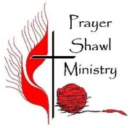](http://www.google.com/url?sa=i&rct=j&q=&esrc=s&source=images&cd=&cad=rja&uact=8&ved=2ahUKEwiG1I-96bjcAhWGdN8KHX_7Am4QjRx6BAgBEAU&url=http://www.gocumc.org/?cat%3D2929&psig=AOvVaw3E5tfBXVfTefgpWArixJtM&ust=1532558880972342)

**Prayer Shawl Ministry meets every 2nd and 4th Monday evening at 630pm on the church campus. If you enjoy knitting and/or crocheting, please think about using your talent to create prayer shawls for those in our congregation and within our community.**

**REMEMBER IN PRAYER**

**We remember in our prayers…**

**Members at Home or in Care Centers**: Justin Bartlow, Ione Marchael and Pat Nell.

**Those struggling with illness or other concerns:** BJ Anthony, Carol Goller, Judy Haenn, Daniel Howard, Donna Johnson, the Joseph family, Dave Nell, Bary & Janice Schlieder, Lonnie Timney and Cathy Westwood.

**Family & Friends:** Jeri Cooper Alacano, Carlos and Marianela Atencio, Lisa Briedis, Lois Brown, Wynn Burkard, John Byron, Clara Caldwell, Jeff and Alice Chan, Charlie Corm, David Corm, Jim Edwards, Cheri and Fernando de Gomez, Alberta Gray, Paul Hayes, Evie Holdhusen, Bobbie Hoenig, Leslie Hoskins, Kylie & Crystal Huber, Doris Jung, Mary Keenan, Katrina Lahr, Jane McInnis, Steve Nelson, Don Norris, Ian Ollie, Kristina & Scott Randolph, Alicia Saldana, Tracy Sanchez, Marian Smith, Anna Watt-Morse, Jenny & Steve West, Ken Yokoyama and Gary Zimmerman.

**We pray for the ongoing work of:**

+Linda Gawthorne among the Kogi people of Colombia.

+Those serving in our nation's military; especially Rachel & Victor Colon, Michael Cote, Aaron Crayton, William Eaton, Nicholas Flournoy, Gabriel Gallegos, Richard Gallegos, Chandler Hoover, John Lamberton, Brittany Graham, Davis McElwain, Morgan Llewellyn, Haley Fessenden, Johnny Luna, Shawn McRae, Emily Merritt, Steven Andrew Navarro, Michael Joseph Navarro, Jim Reeder, Sophie Schade, Douglas Steelhammer, Dominic Vancini, Jonah Westcott, Joshua Wauchope and Collin White.

***Happy Anniversary***

***10/1 Kristine and Andy Trost***

***10/3 Teresa and Greg Lowther***

***10/10 Kathy and Bill Mitchell***

***10/12 Annette and Jeff Rodrigues***

***10/14 Sara and Sean Benoit***

***10/27 Chris and Kathy Klute Nelson***

Clipart - thing, object, 
celebration, congratulation, 
birthday, placard. 
fotosearch - search 
clipart, illustration 
posters, drawings 
and vector eps 
graphics images

***10/2 Lucas Hood***

***10/4 James Innes***

***10/6 Justin Swagler***

***10/7 Daniel Howard***

***10/7 Maggie Sutton***

***10/8 Lauren Trost***

***10/11 Chris Nelson***

***10/13 Aina Bornemann***

***10/18 Seth Elliott***

***10/18 Lonnie Timney***

***10/20 Sheryl Hunter***

***10/24 Wanda Cleland***

***10/27 Austin Naud***

***10/30 Grant Green***

***10/31 Roger Bredenkamp***

***10/31 Zach Petrbok***

**[](http://www.google.com/url?sa=i&rct=j&q=&esrc=s&source=images&cd=&cad=rja&uact=8&ved=2ahUKEwiy_vPkisjdAhUEZKwKHTNbAFkQjRx6BAgBEAU&url=http://www.crumc.com/ministries.asp&psig=AOvVaw2x2sZhQNlqgjzOuDBvzQ4F&ust=1537481409713469)A Stephen’s Ministry Minute**

**What a blessing it is for me to be involved in a congregation like ours that is so active! Almost three years ago, I answered a call to take the Stephen Ministry Leader training and although, like you, I have been involved in many volunteer activities both within and outside the church, this by far, has exceeded my expectations. It is though, high commitment, but high reward!**

**As you have listened to a few of our Stephen Ministers tell their story of how they became involved and what being a Stephen Minister is like and how it has changed them, I hope that you would be inspired to take this journey also. The training is 50 hours, but that is spread out over several months. The commitment to serve is 2 years. The relationships formed and the personal and spiritual growth is immeasurable.**

**There is a need right now for more trained Stephen Ministers for one-to-one caring and listening for those who are home bound, ill or grieving. Our next training class will, hopefully, be starting in January.**

**Please speak to Pastor Pam or myself (Chris Panos) for an application or for more information.**